Snow Cover Monitoring
September 2013


National Climate Center
China Meteorological Administration
Northern Hemisphere
In September 2013, the area of snow cover was larger than normal in the Northern Hemisphere, Eurasia and North America (Fig.1).
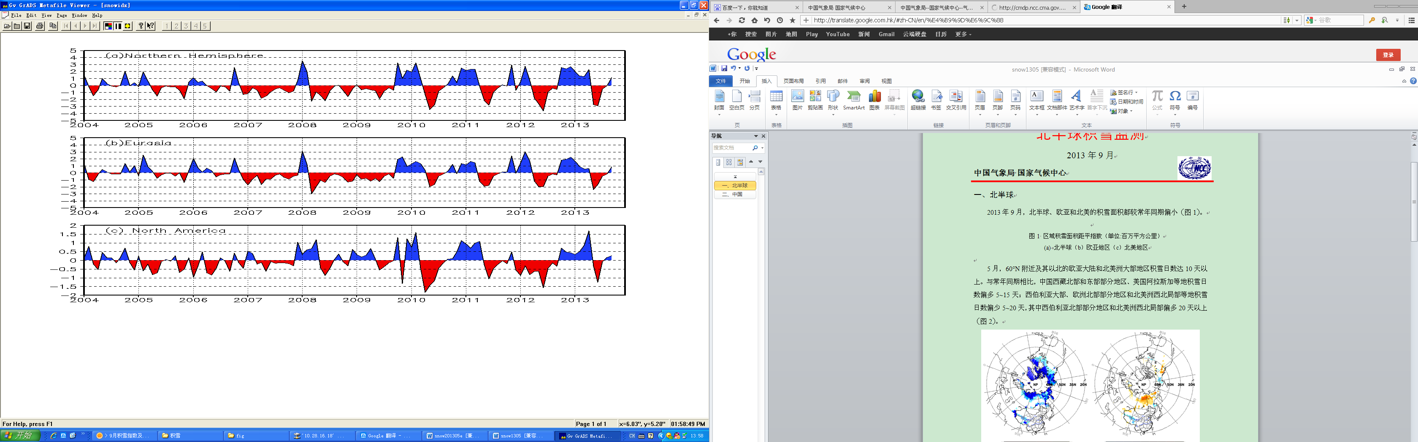
Fig.1 Regional Snow Cover Anomaly Indices (Unit: 10⁶ km²)
- Northern Hemisphere (b) Eurasia (c) North America

For the month, numbers of day with snow cover (NDSC) were over 10 days in most of northern Eurasia and northern North America around and northward of 65°N. NDSC were 5-15 days more than normal in parts of the central and western Siberia, locations of the northern Mongolia, locations of the northern Qinghai-Tibet Plateau and locations of northeastern North America. Meanwhile, NDSC were 5-15 days less than normal in the western boundary of China, locations of northwestern North America (Fig.2).
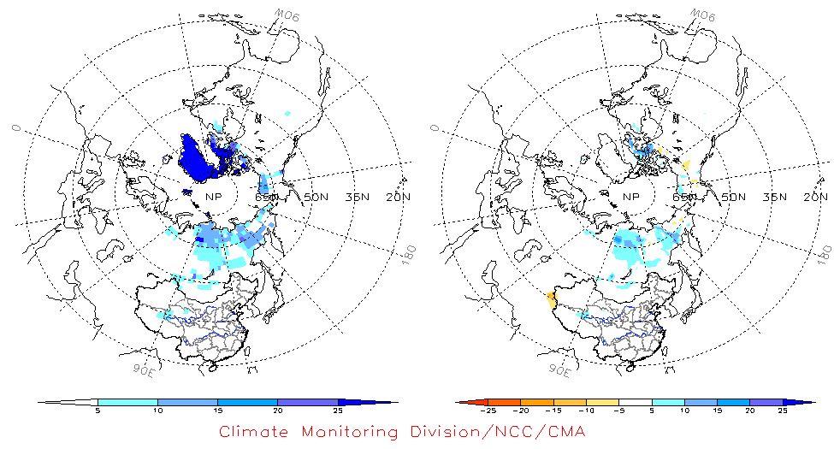
Fig.2 Number of Days with Snow Cover (left) and Anomalies (right)
in the Northern Hemisphere during September 2013 (Unit: day)
China
During September 2013, the total area of snow cover was slightly below normal in whole China. The snow cover area was slightly below normal in the Tibetan Plateau and northern Xinjiang respectively, and near normal in Northeastern China(including eastern Inner Mongolia)(Fig.3).
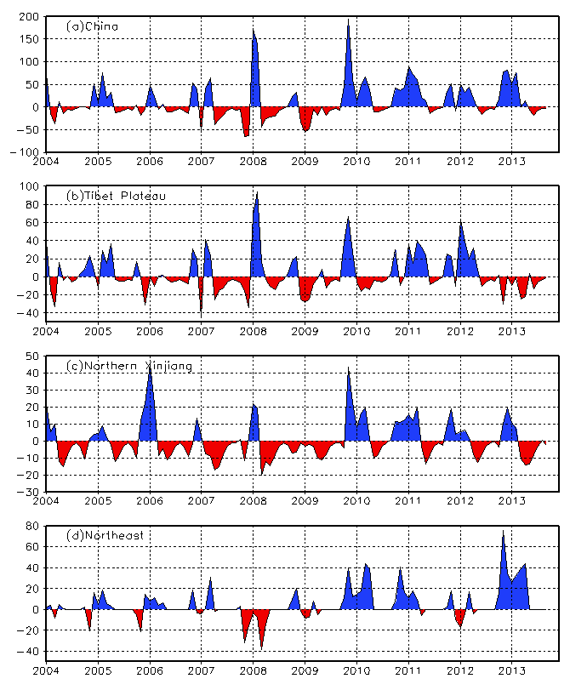
Fig. 3 Regional Snow Cover Anomaly Indices (Unit: 10⁴ km²)
- China (b) Tibetan Plateau (c) Northern Xinjiang (d) Northeast China
For the month, NDSC were 5-10 days in locations of the northern Qinghai-Tibet Plateau and northern Xinjiang. NDSC were 5-10 days above normal in locations of the northern Qinghai-Tibet Plateau, while NDSC were 5-15 days less than normal in locations of the western Tibet and Xinjiang (Fig.4).
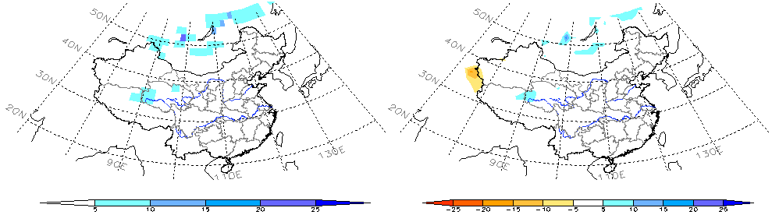
Fig.4 Number of Days with Snow Cover (left) and Anomalies (right)
in China during September 2013 (Unit: day)

Remark: Original data are from http://climate.rutgers.edu/snowcover/.
Analyst: Climate Monitoring Division/National Climate Center/CMA
Climatological fields are from the 1981-2010 base period means.

Reference
Guo Yanjun, Li Wei , Chen Qianjin, An Operational Monitoring and Diagnosing System for Snow Cover in the Northern Hemisphere (in Chinese), Meteorological Monthly, 30 (11): 24-26 (In Chinese)

Editor: Wang Yanjiao Chief Editor: Zhou Bing

