Snow Cover Monitoring
April 2013


National Climate Center
China Meteorological Administration
Northern Hemisphere
In April 2013, the area of snow cover was larger than normal in the Northern Hemisphere, Eurasia and North America (Fig.1).
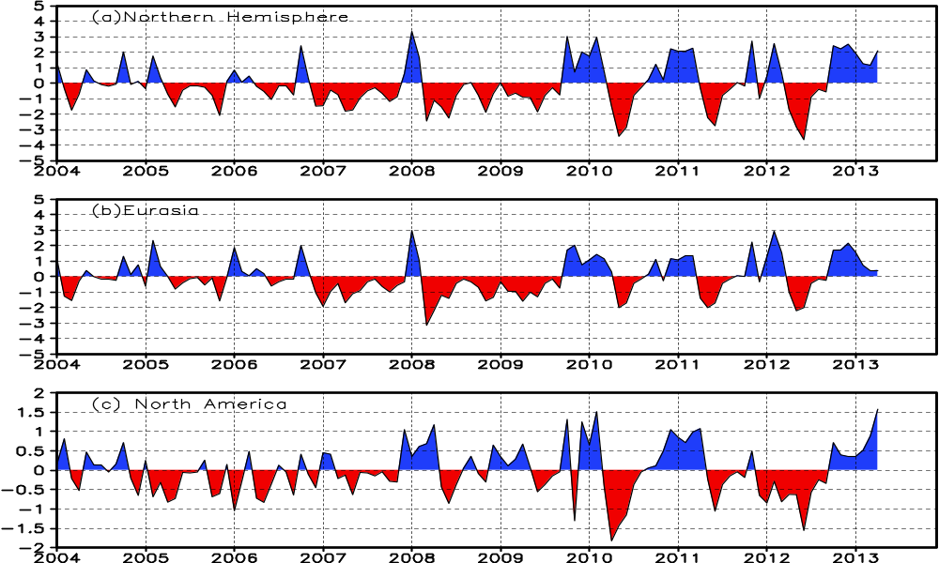

Fig.1 Regional Snow Cover Anomaly Indices (Unit: 10⁶ km²)
- Northern Hemisphere (b) Eurasia (c) North America
For the month, numbers of day with snow cover (NDSC) were over 10 days in most of northern Eurasia and northern North America north of 50°N. NDSC were 5-20 days more than normal in parts of northern Europe,eastern Mongolia, northeastern China and north-central North America, with central values over 20 days in central North America. Meanwhile, NDSC were 5-15 days less than normal in parts of Central Asia, northern and western Xinjiang in China, and parts of western North America (Fig.2).

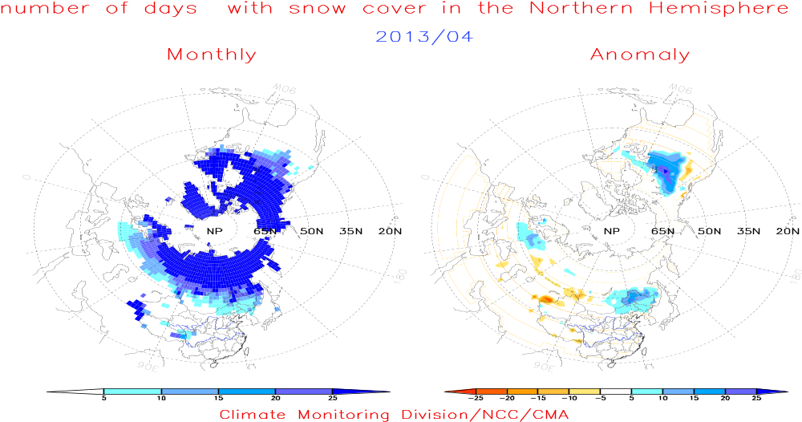
Fig.2 Number of Days with Snow Cover (left) and Anomalies (right)
in the Northern Hemisphere during April 2013 (Unit: day)
China
During April 2013, the total area of snow cover was slightly larger than normal in whole China. The snow cover area was obviously above normal in Northeastern China and below normal in the Tibetan Plateau and northern Xinjiang (Fig.3).
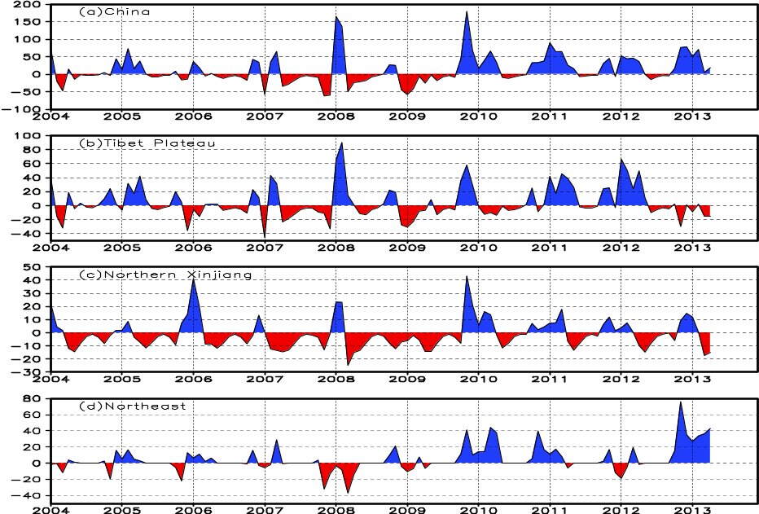
Fig. 3 Regional Snow Cover Anomaly Indices (Unit: 10⁴ km²)
- China (b) Tibetan Plateau (c) Northern Xinjiang (d) Northeast China

For the month, NDSC were 5-25 days in most of Northeast China, eastern Inner Mongolia, northern and western Xinjiang and in parts of the Tibetan Plateau, with more than 25 days in locations. NDSC were 5-20 days above normal in most of Northeast China, eastern Inner Mongolia, while NDSC were 5-15 days less than normal in western and northern Xinjiang as well as locations of Tibet (Fig.4).
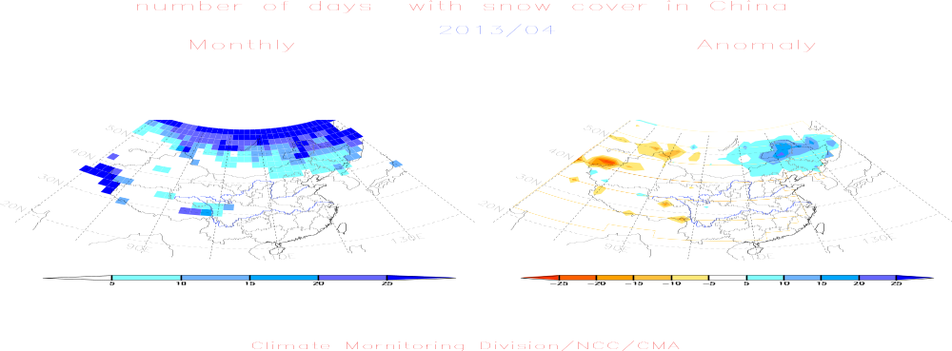
Fig.4 Number of Days with Snow Cover (left) and Anomalies (right)
in China during April 2013 (Unit: day)

Remark: Original data are from http://climate.rutgers.edu/snowcover/.
Analyst: Climate Monitoring Division/National Climate Center/CMA
Climatological fields are from the 1981-2010 base period means.

Reference
Guo Yanjun, Li Wei , Chen Qianjin, An Operational Monitoring and Diagnosing System for Snow Cover in the Northern Hemisphere (in Chinese), Meteorological Monthly, 30 (11): 24-26 (In Chinese)

Editor: Guo Yanjun Chief Editor: Liu Yanju

