Snow Cover Monitoring
January 2012


Beijing Climate Center
China Meteorological Administration
Northern Hemisphere
In January, the number of snow cover days (NSCD) was 5-20 days more than normal in central and southern Europe, Central Asia, central and western China and Japan, with 20-25 days above normal in locations. Meanwhile, NSCD was 5-15 days less than normal in parts of central North America and Northeast China, with 15-20 days below normal in locations (Fig.1).

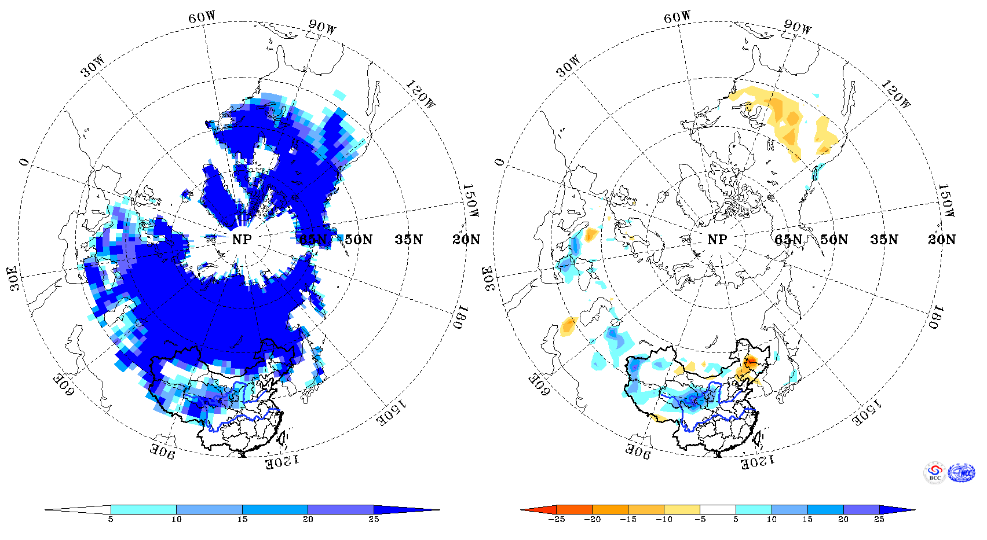
Fig. 1 Number of Days with Snow Cover (left) and Anomalies (right) in the Northern Hemisphere during January 2012 (Unit: day)

China
In January, NSCD was 5-25 days in the Tibetan Plateau, northern and western Xinjiang, eastern Northwest China, eastern Inner Mongolia and northern Northeast China, with more than 25 days in locations (Fig.2, left). NSCD was 5-15 days more than normal in northern and western Xinjiang, eastern Northwest China, the northeastern and western Tibetan Plateau, with at least 20 days above normal in locations. While, NSCD was 5-15 days less than normal in eastern Northeast China, eastern Inner Mongolia and parts of Southwest China, with at least 20 days below normal in locations (Fig.2, right). In comparison with the climatic means, the areas of snowpack in China, the Tibetan Plateau, northern Xinjiang was 14.3%, 50.5%, 10.6% larger than normal respectively, while in Northeast China, it was 13.9% smaller than normal (Fig.3).

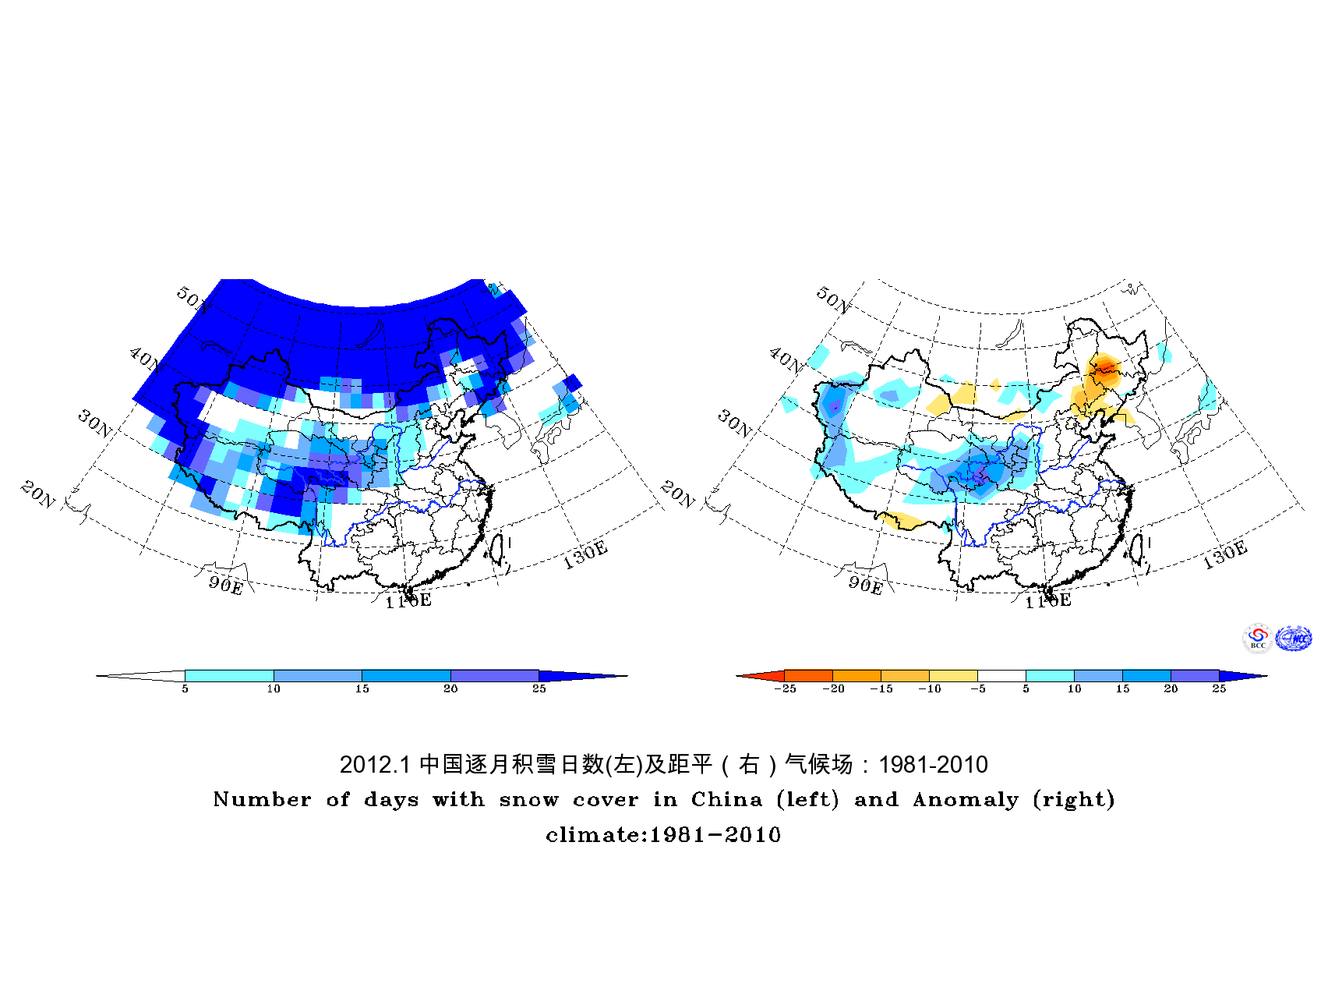
Fig.2 Number of Days with Snow Cover (left) and Anomalies (right)
in China during January 2012 (Unit: day)

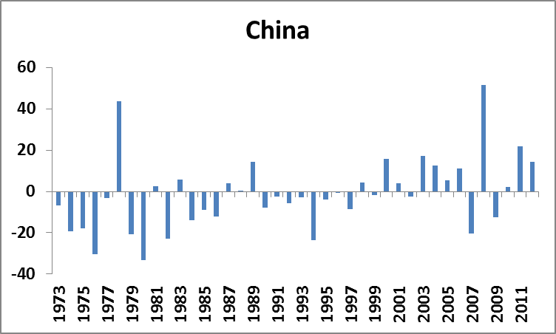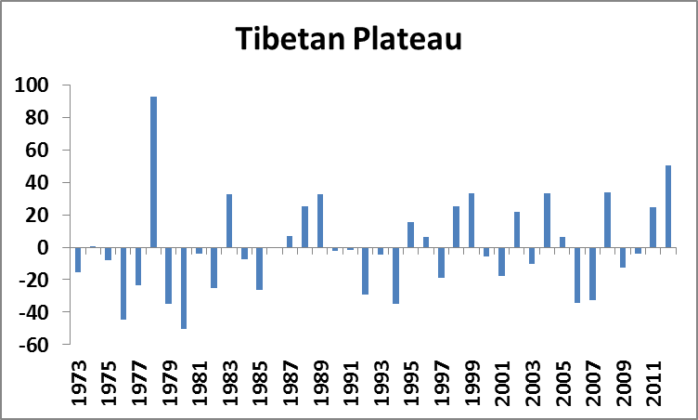
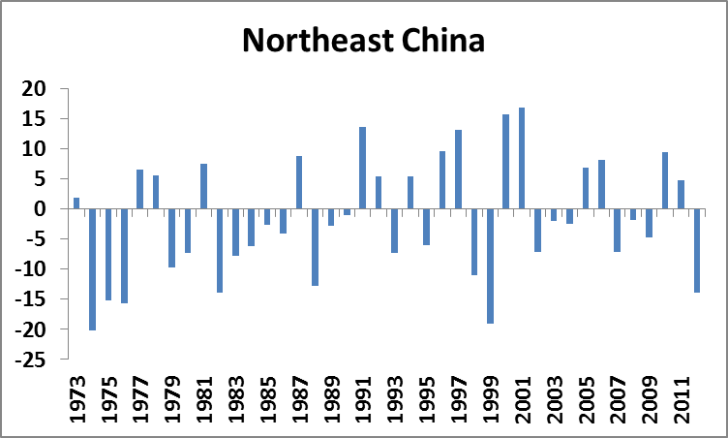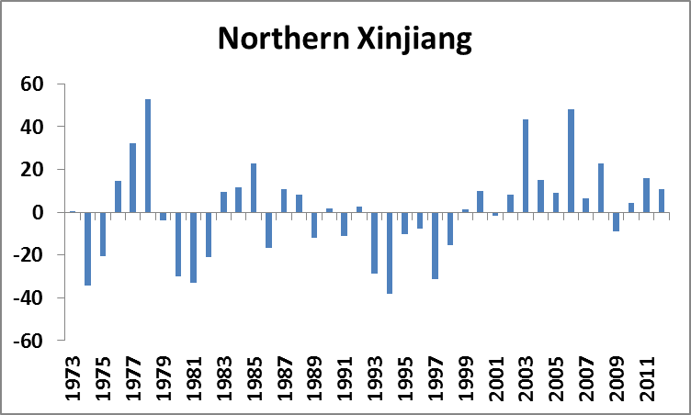
Fig. 3 Regional Snow Cover Anomaly Percentages during January (Unit :%)

Remark: Original data are from http://climate.rutgers.edu/snowcover/.
Analyst: Climate System Diagnostics Division/National Climate Center/CMA
Climatologic fields are from the 1981-2010 base period means.

Reference
Guo Yanjun, Li Wei , Chen Qianjin, An Operational Monitoring and Diagnosing System for Snow Cover in the Northern Hemisphere (in Chinese), Meteorological Monthly, 30 (11): 24-26

Editor: Dong Si Chief Editor: Qiyi Wang Technical assistant: Jinyue Tang

