Snow Cover Monitoring
May 2010


Beijing Climate Center
China Meteorological Administration
Northern Hemisphere
During May 2010, the total area of snow cover was much smaller than normal in the Northern Hemisphere in which it was smaller than normal in Eurasia and North America (Fig.1).
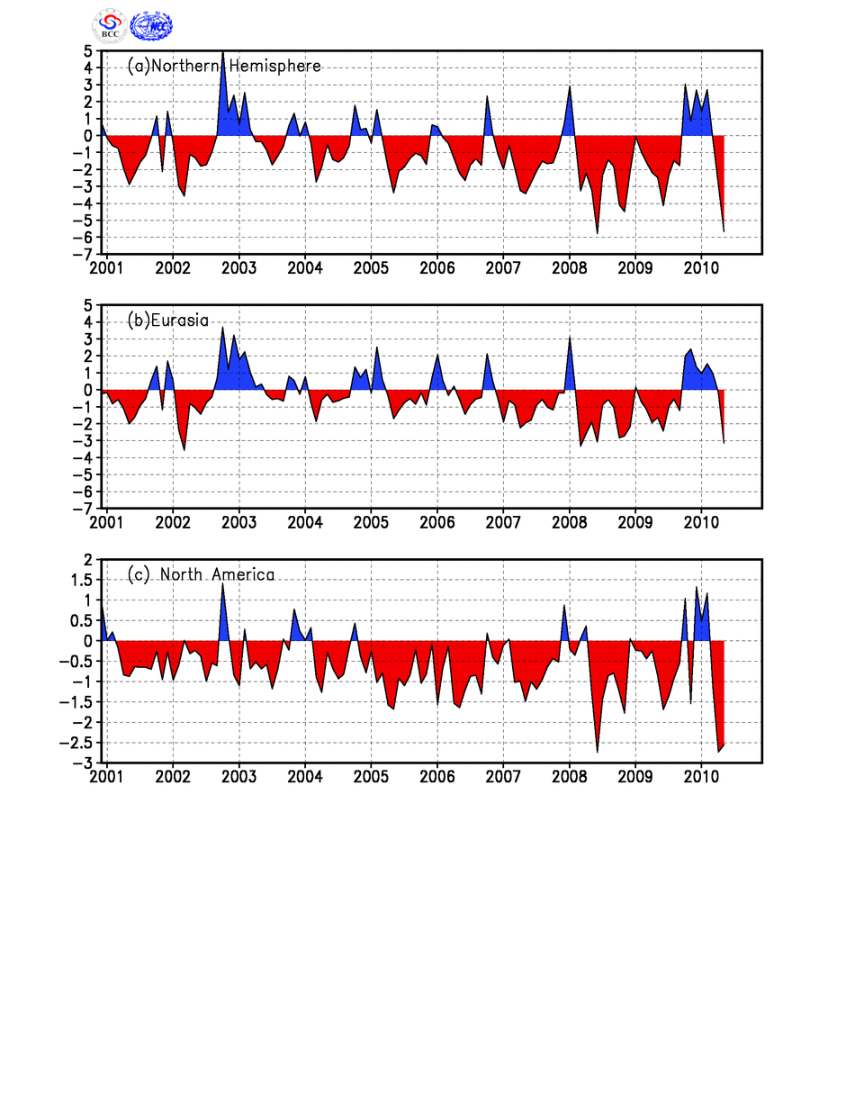
Fig.1 Regional Snow Cover Anomaly Indices (Unit: 10⁶km²)
- Northern Hemisphere (b) Eurasia (c) North America

During May, the number of days with snow cover (NDSC) was above 20 days on regions north of 65°N of northern Eurasia and northern North America. NDSC was observed 5-10 days more than normal in the southeastern and northern Tibetan plateau. Meanwhile, NDSC was 5-20 days less than normal in elsewhere, with NDSC less than 20 days in partly northeastern North America and partly eastern Central Asia(Fig.2).

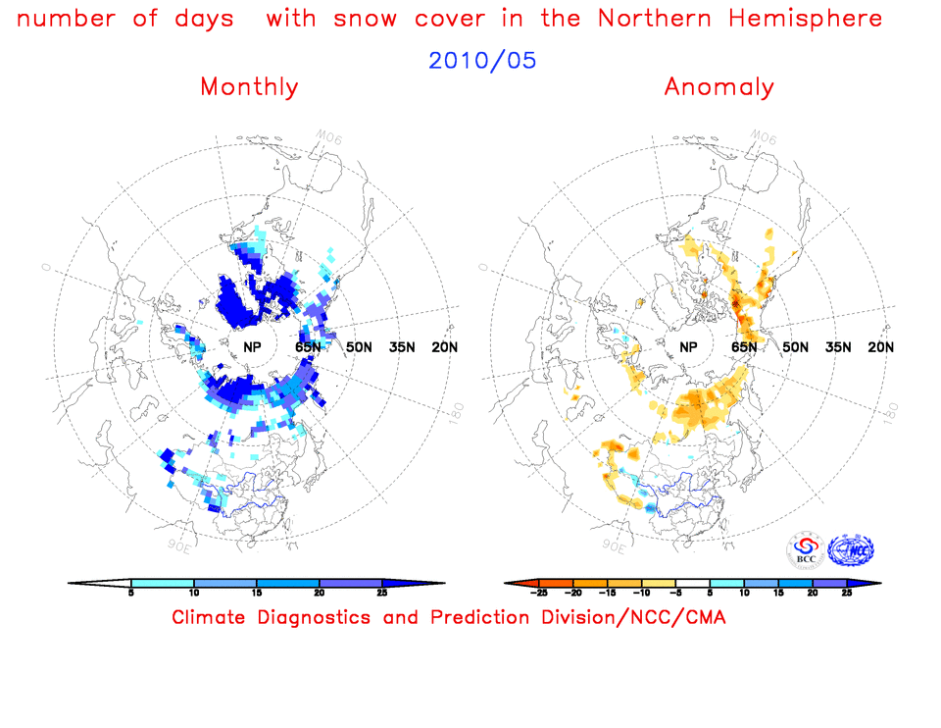

Fig.2 Number of Days with Snow Cover (left) and Anomalies (right)
in the Northern Hemisphere during May 2010 (Unit: day)

China
During May 2010, the total area of snow cover was slightly smaller than normal in China in which the area was near normal in Northeast China, but it was smaller than normal in the Tibetan Plateau and northern Xinjiang(Fig.3).
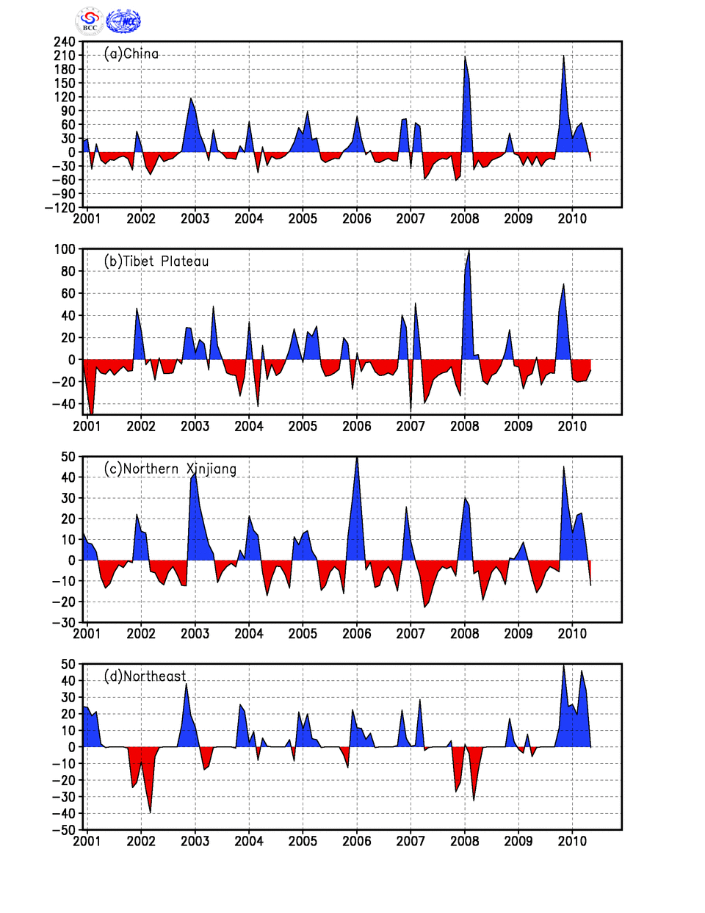
Fig. 3 Regional Snow Cover Anomaly Indices (Unit: 10⁴km²)
(a) China (b) Tibetan Plateau (c) Northern Xinjiang (d) Northeast China

For the month, NDSC was above 10 days in northern and southwestern Xinjiang, the western and eastern Tibetan Plateau. NDSC was observed 5-15 days more than normal in parts of southeastern and northern Tibetan Plateau. Meanwhile, NDSC was 5-15 days less than normal in southern and western Tibetan plateau and southwestern Xinjiang(Fig.4).
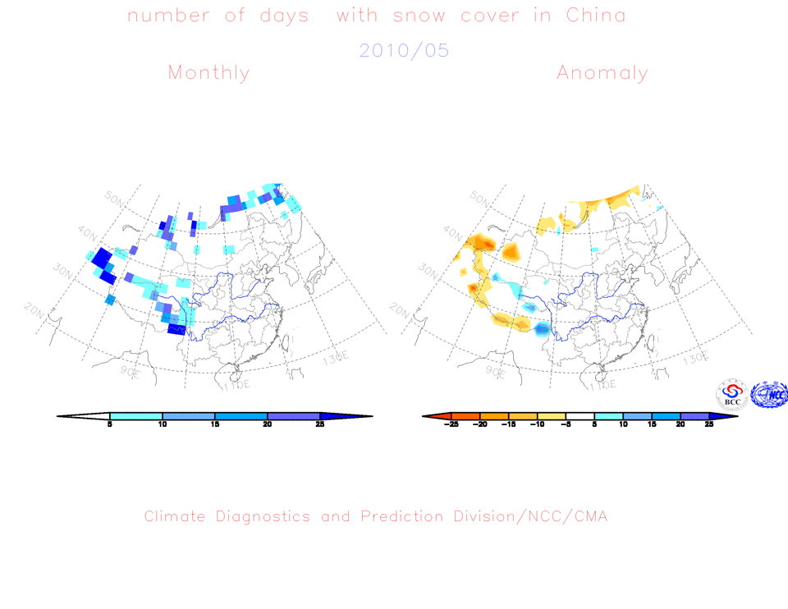
Fig.4 Number of Days with Snow Cover (left) and Anomalies (right)
in China during May 2010 (Unit: day)

Remark: Original data are from http://www.cpc.ncep.noaa.gov/data/snow/.
Analyst: Climate System Diagnostics and Prediction Division/National Climate Center/CMA
Climatologic fields are from the 1973-2002 base period means.

Reference
Guo Yanjun, Li Wei , Chen Qianjin, An Operational Monitoring and Diagnosing System for Snow Cover in the Northern Hemisphere (in Chinese), Meteorological Monthly, 30 (11): 24-26

Editor: Chen Xianyan Chief Editor: Ren Fumin Technical assistant: Tang Jinyue

