Snow Cover Monitoring
April 2010


Beijing Climate Center
China Meteorological Administration
Northern Hemisphere
During April 2010, the total area of snow cover was smaller than normal in the Northern Hemisphere in which it was near normal in Eurasia and was smaller than normal in North America (Fig.1).
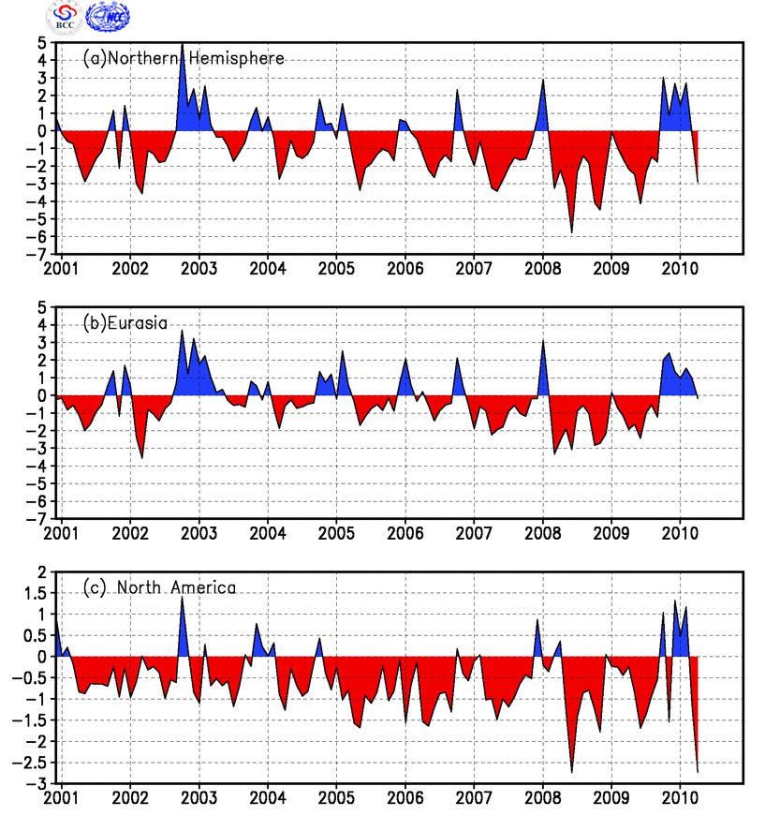
Fig.1 Regional Snow Cover Anomaly Indices (Unit: 10⁶km²)
- Northern Hemisphere (b) Eurasia (c) North America

During April, the number of days with snow cover (NDSC) was above 25 days on regions north of 50°N of northern Eurasia and northern North America. NDSC was observed 5-15 days more than normal in Northeast China, the eastern Tibetan plateau, northern Mongolia and northeastern Central Asia. Meanwhile, NDSC was 5-20 days less than normal in eastern Europe, northern West Asia, the western and southern Tibetan plateau and parts of northern North America, with NDSC less than 20 days in partly northeastern North America (Fig.2).

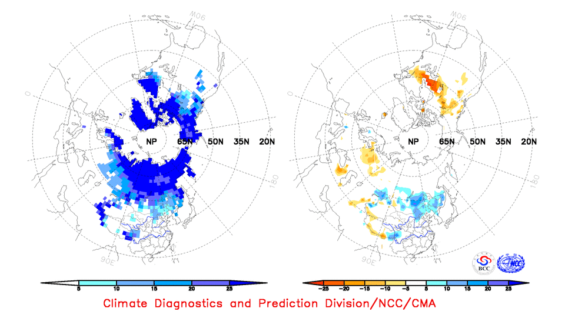

Fig.2 Number of Days with Snow Cover (left) and Anomalies (right)
in the Northern Hemisphere during April 2010 (Unit: day)

China
During April 2010, the total area of snow cover was larger than normal in China in which the areas were larger than normal both in Northeast China and Northern Xinjiang, but it was smaller than normal in the Tibetan Plateau (Fig.3).
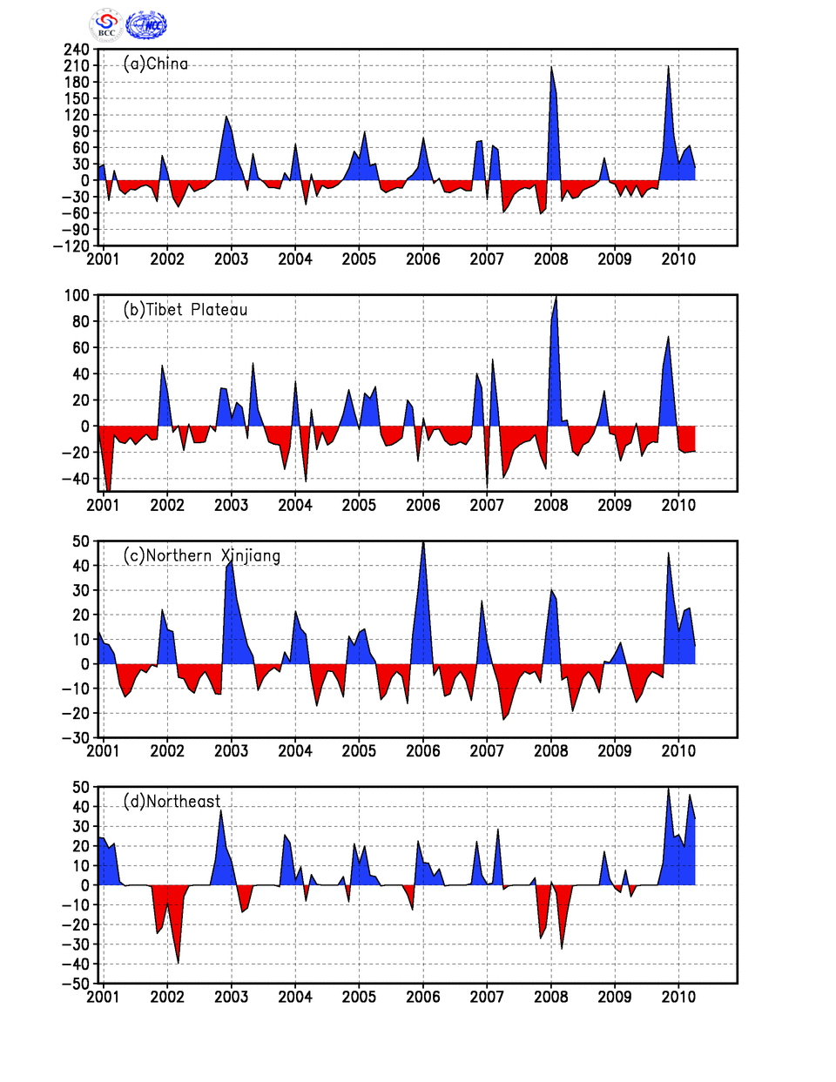
Fig. 3 Regional Snow Cover Anomaly Indices (Unit: 10⁴km²)
(a) China (b) Tibetan Plateau (c) Northern Xinjiang (d) Northeast China

For the month, NDSC was above 25 days in northeastern China, northern and southwestern Xinjiang, the western and partly southeastern Tibetan Plateau. NDSC was observed 5-15 days more than normal in northeastern China, central and eastern Inner Mongolia, parts of westnorthern Xinjiang and locations in the southeastern Tibetan plateau. Meanwhile, NDSC was 5-15 days less than normal in southern and westnorthern Tibetan plateau (Fig.4).
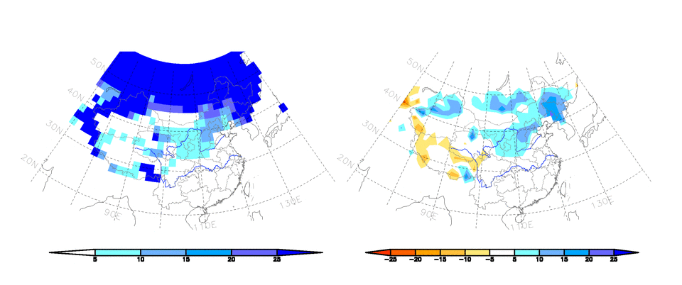
Fig.4 Number of Days with Snow Cover (left) and Anomalies (right)
in China during April 2010 (Unit: day)

Remark: Original data are from http://www.cpc.ncep.noaa.gov/data/snow/.
Analyst: Climate System Diagnostics and Prediction Division/National Climate Center/CMA
Climatologic fields are from the 1973-2002 base period means.

Reference
Guo Yanjun, Li Wei , Chen Qianjin, An Operational Monitoring and Diagnosing System for Snow Cover in the Northern Hemisphere (in Chinese), Meteorological Monthly, 30 (11): 24-26

Editor: Chen, Xianyan Chief Editor: Wang, Qiyi Technical assistant: Yan, Jinghui

