Snow Cover Monitoring
February 2010


National Climate Center
China Meteorological Administration
Northern Hemisphere
During February 2010, the total area of snow cover was obviously larger (the 4th large value) than normal in the Northern Hemisphere, which was both lager than normal in Eurasia and North America (Fig.1).
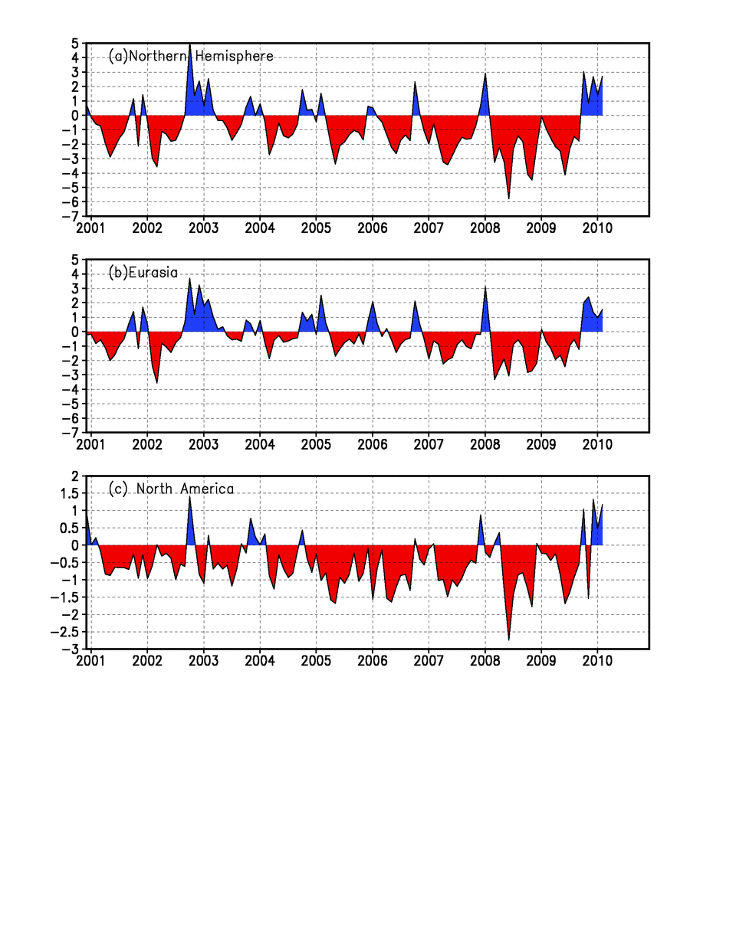
Fig.1 Regional Snow Cover Anomaly Indices (Unit: 10⁶km²)
- Northern Hemisphere (b) Eurasia (c) North America

For the month, the number of days with snow cover (NDSC) was above 25 days in middle and high latitude in Eurasia, central and northern North America.
NDSC was observed 5~20 days more than normal in central Europe, most regions of north to Yangtze River in China and central America, with above 20 days more than normal in locations. However, NDSC was 5~15 days less than normal in part of northern West Asia and southern Central Asia, most Tibet (Fig.2).

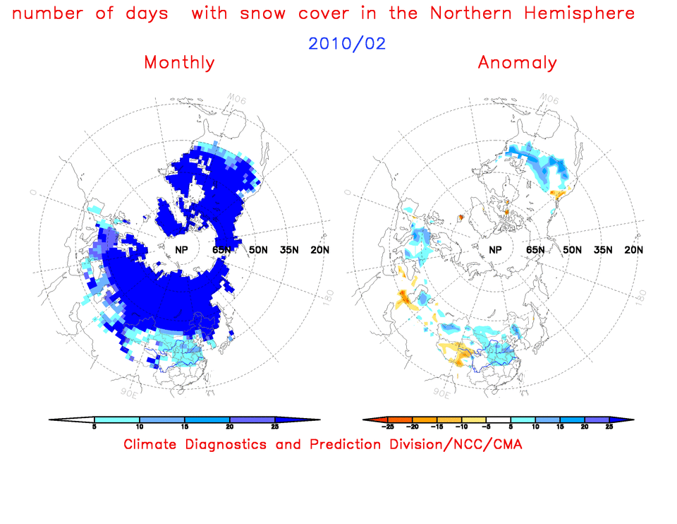
Fig.2 Number of Days with Snow Cover (left) and Anomalies (right)
in the Northern Hemisphere during February 2010 (Unit: day)
China
During February 2010, the total area of snow cover was larger than normal in China, with areas obviously larger (the 5th large value) than normal in Northeast China and northern Xinjiang, but less than normal in Tibetan Plateau (Fig.3).

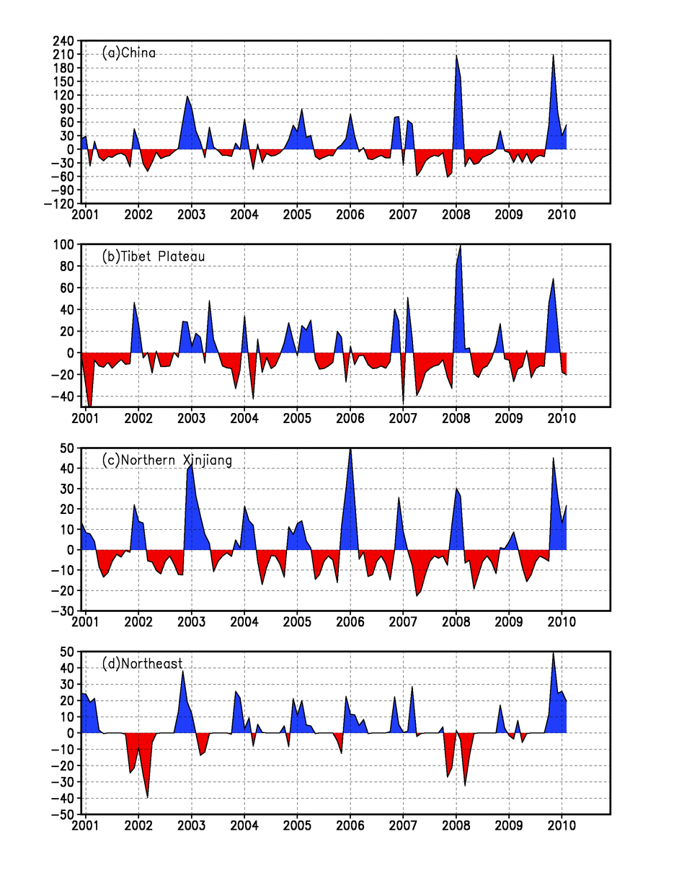
Fig. 3 Regional Snow Cover Anomaly Indices (Unit: 10⁴km²)
(a) China (b) Tibetan Plateau (c) Northern Xinjiang (d) Northeast China

For the month, NDSC was above 25 days in northern and western Xinjiang, central and northern Northeast China, central and eastern Inner Mongolia, the southeastern and locations of western Tibetan Plateau. NDSC was observed 5-15 days more than normal in most regions of north to Yangtze River. However, NDSC was 5-15 days less than normal in most Tibet (Fig.4).

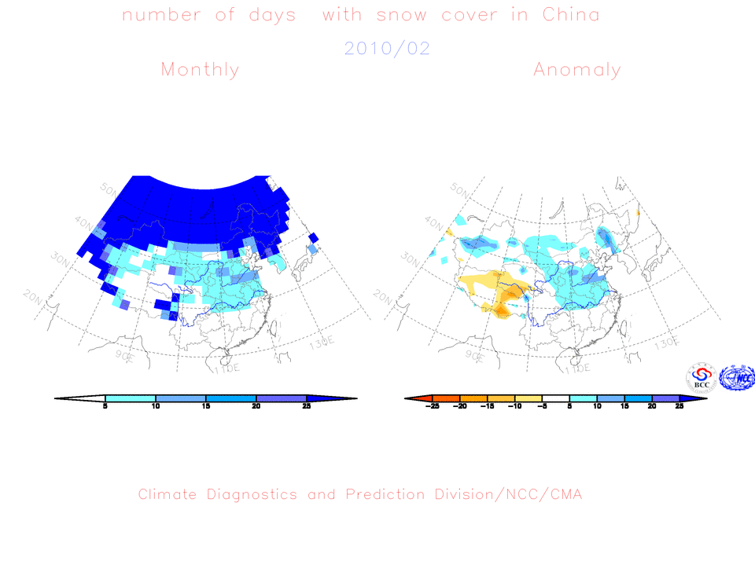
Fig.4 Number of Days with Snow Cover (left) and Anomalies (right)
in China during February 2010 (Unit: day)

Remark: Original data are from http://www.cpc.ncep.noaa.gov/data/snow/.
Analyst: Climate System Diagnostics and Prediction Division/National Climate Center/CMA
Climatologic fields are from the 1973-2002 base period means.

Reference
Guo Yanjun, Li Wei , Chen Qianjin, An Operational Monitoring and Diagnosing System for Snow Cover in the Northern Hemisphere (in Chinese), Meteorological Monthly, 30 (11): 24-26

Editor: Gao Rong Chief Editor: Zhu, Yanfeng Technical assistant: Tang, Jinyue

