Snow Cover in the Northern Hemisphere
(January 2008)
Northern Hemisphere
During January 2008, the total area of snow cover in the Northern Hemisphere was observed above normal with areas more than average in Eurasia while near normal in North America (Fig.1).
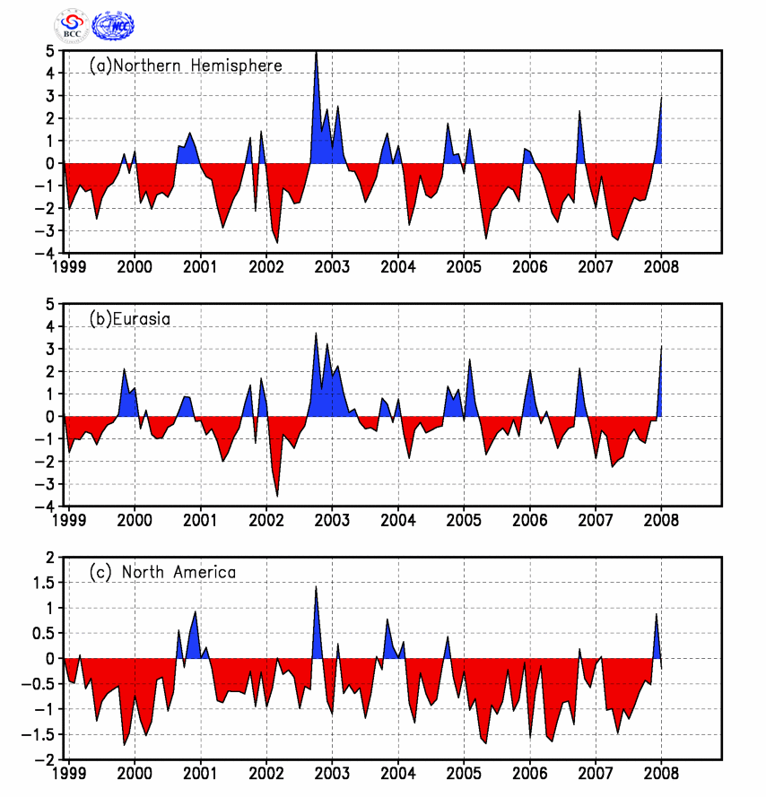
Fig.1 Regional Snow Cover Anomaly Indices (Unit: 10⁶km²)
- Northern Hemisphere (b) Eurasia (c) North America

For the month, the number of days with snow cover (NDSC) was generally 5-25 days in most Eurasia north to 35°N, southern Central Asia, the regions north to the Yangtze River in China and most North America north to 35°N. NDSC was observed 5-15 days more than average in most Asia between 30°N to 45°N, parts of western and central America, with more than 20 days in locations of Central Asia and central China. Meanwhile, NDSC was observed 5-10 days below normal in central Europe, the eastern Tibetan Plateau and parts of central-eastern America (Fig.2).

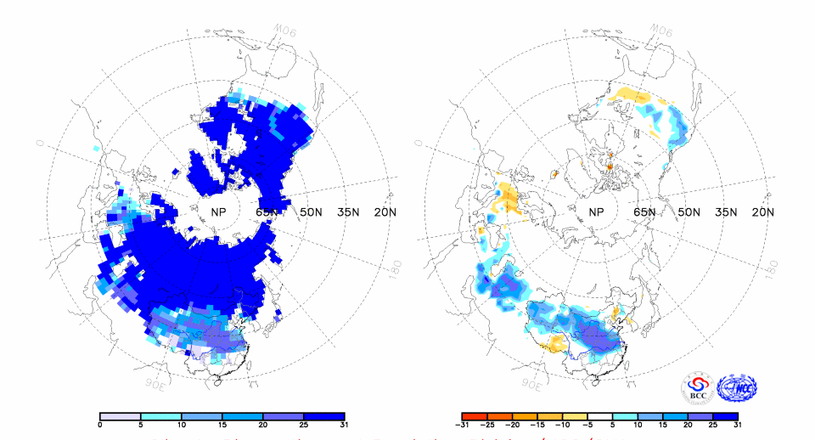
Fig.2 Number of Days with Snow Cover (left) and Anomalies (right)
in the Northern Hemisphere during January 2008 (Unit: day)
China
During January 2008, the total area of snow cover was found obviously above normal in China, with areas more than average in the Tibetan Plateau and northern Xinjiang. Meanwhile, the area of snow cover in Northeast China was near normal (Fig.3).
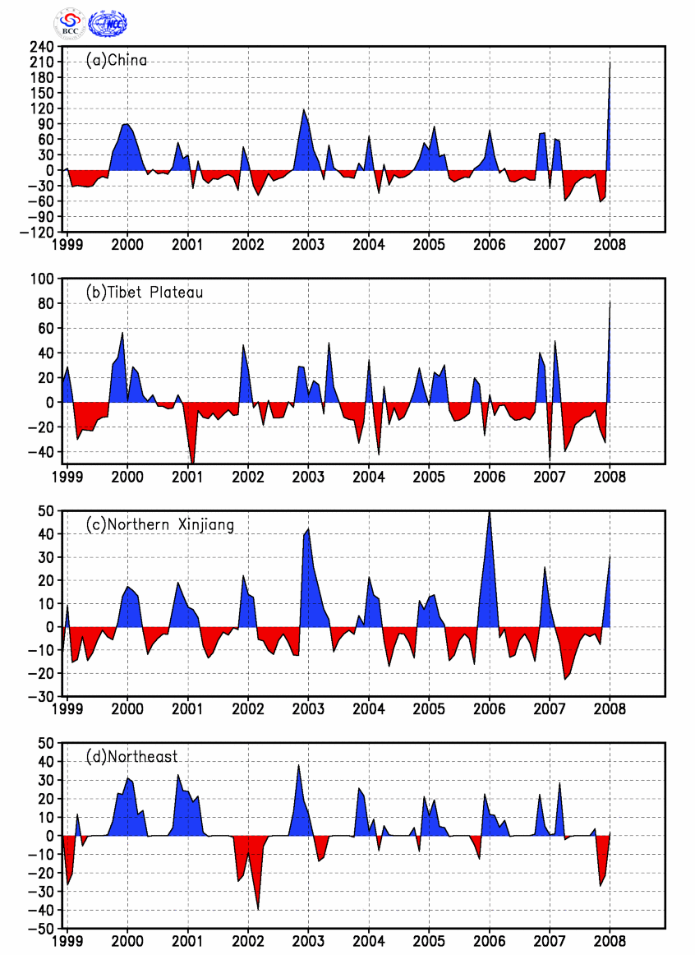
Fig. 3 Regional Snow Cover Anomaly Indices (Unit: 10⁴km²)
- China (b) Tibetan Plateau (c) Northern Xinjiang (d) Northeast China

For the month, the number of days with snow cover was observed 5-25 days in most of the regions north to the Yangtze River and northern Jiangnan with over 25 days in locations. NDSCs were observed 5-20 days more than average in most above regions with over 20 days in most of the regions between the Yangtze River and the Yellow River. Meanwhile, NDSCs were observed 5-15 days below normal in the eastern Tibetan Plateau and eastern Inner Mongolia(Fig.4).

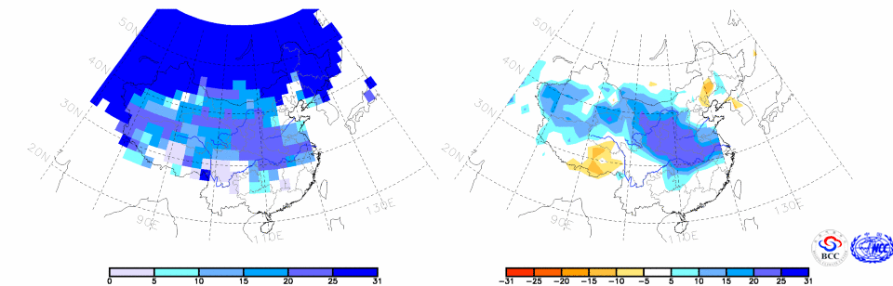
Fig.4 Number of Days with Snow Cover (left) and Anomalies (right)
in China during January 2008 (Unit: day)

Remark: Original data are from http://www.cpc.ncep.noaa.gov/data/snow/.
Analyst: Climate System Diagnostics and Prediction Division/National Climate Center/CMA
Climatologic fields are from the 1973-2002 base period means.

Reference
[1]Guo Yanjun, Li Wei , Chen Qianjin, An Operational Monitoring and Diagnosing System for Snow Cover in the Northern Hemisphere (in Chinese), Meteorological Monthly, 30 (11): 24-26

