Snow Cover in the Northern Hemisphere
(November 2007)
Northern Hemisphere
During November 2007, areas of snow cover were observed below normal in the Northern Hemisphere, Eurasia and North America (Fig.1).
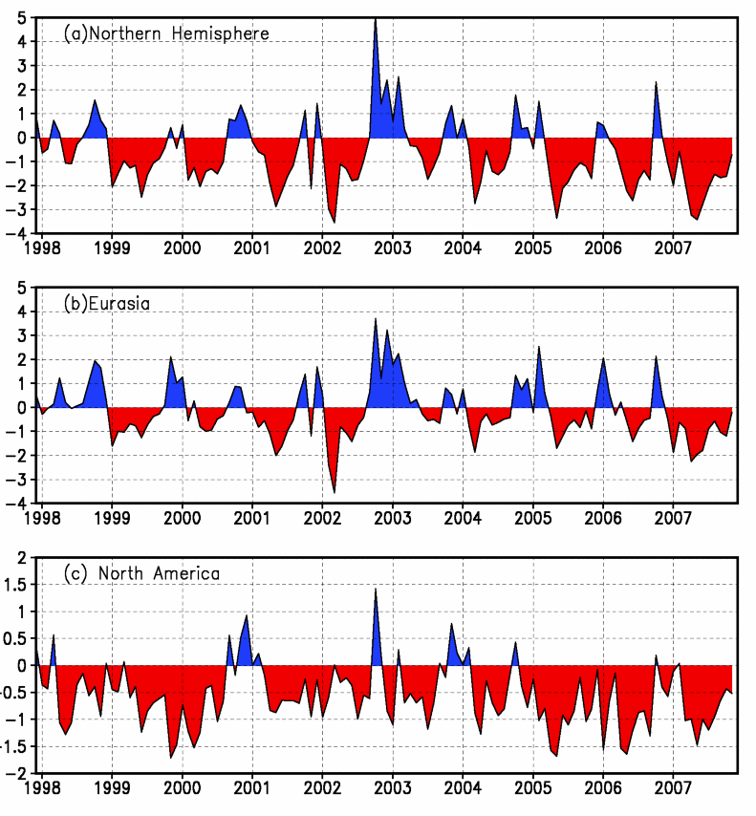
Fig.1 Regional Snow Cover Anomaly Indices (Unit: 10⁶km²)
- Northern Hemisphere (b) Eurasia (c) North America

For the month, the number of days with snow cover (NDSC) was more than 25 days in most of areas north of 50ºN in Eurasia and North America. The NDSC was 5-15 days in the remainders of both Eurasia and North America, eastern Tibet Plateau, eastern Inner Mongolia, northern Northeast China, parts of Central Asia, northern West Asia and the Greenland Island, with no snow cover in the remainder of above areas. NDSC was observed 5-15 days more than average in central Europe, parts of northern Europe, parts of Central Asia, central Tibet Plateau, locations of North America. Meanwhile, NDSC was observed 5-15 days below average in western Mongolia, mid-northern Northeast China, the boundaries of western China and central North America, with 20 days below average in locations of above areas (Fig.2).
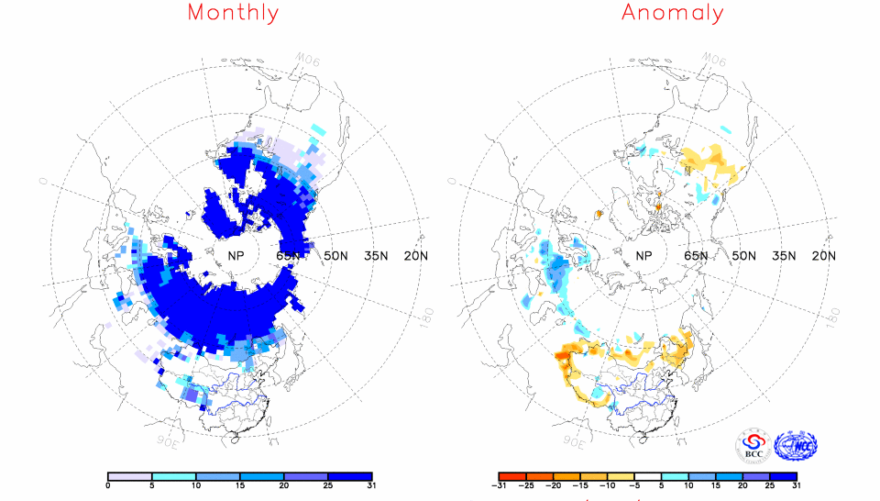
Fig.2 Number of Days with Snow Cover (left) and Anomalies (right)
in the Northern Hemisphere during November 2007 (Unit: day)

China
During November 2007, areas of snow cover were found below average in China, with areas smaller than average in the Tibetan Plateau, northern Xinjiang and Northeast China (Fig.3).
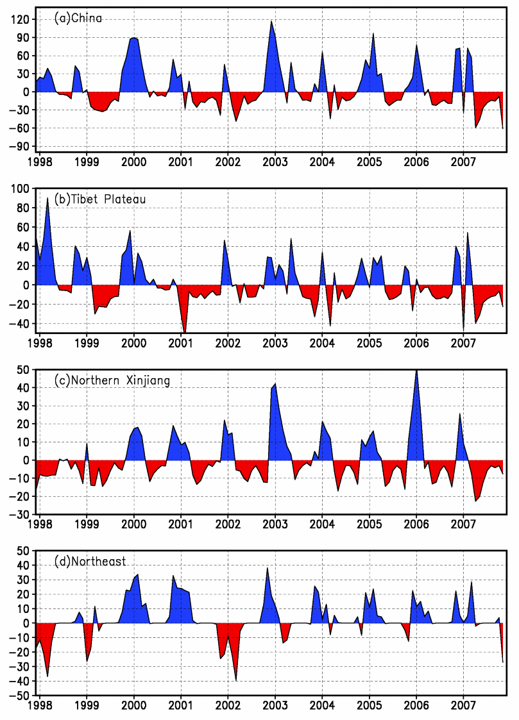
Fig. 3 Regional Snow Cover Anomaly Indices (Unit: 10⁴km²)
- China (b) Tibetan Plateau (c) Northern Xinjiang (d) Northeast China

For the month, the number of days with snow cover was observed 5-10 days in northern Xinjiang, eastern Tibet, eastern Inner Mongolia and parts of northern Northeast, with more than 10 days in locations of above areas. NSDCs were observed 5-15 days below average in northern Xinjiang, eastern Northeast and the boundaries of western China. Meanwhile, NSDCs were observed 5-15 days above average in central and southeastern Tibet Plateau.

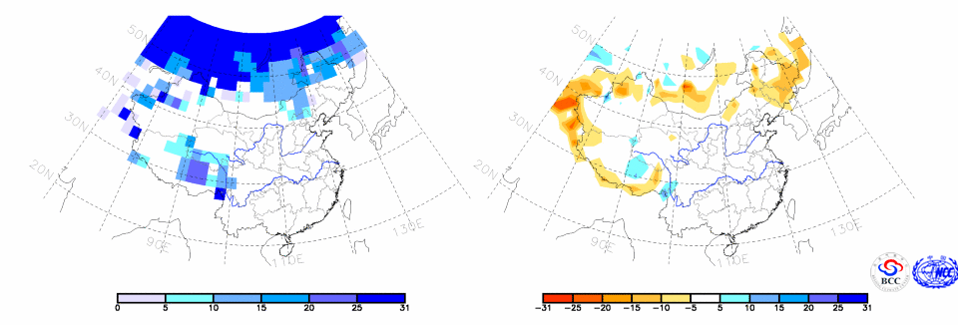
Fig.4 Number of Days with Snow Cover (left) and Anomalies (right)
in China during November 2007 (Unit: day)

Remark: Original data are from http://www.cpc.ncep.noaa.gov/data/snow/.
Analyst: Climate System Diagnostics and Prediction Division/National Climate Center/CMA
Climatologic fields are from the 1973-2002 base period means.

Reference
[1]Guo Yanjun, Li Wei , Chen Qianjin, An Operational Monitoring and Diagnosing System for Snow Cover in the Northern Hemisphere (in Chinese), Meteorological Monthly, 30 (11): 24-26

