Snow Cover in the Northern Hemisphere

（October 2005）

Northern Hemisphere
During October, areas of snow cover were observed smaller than average in the Northern Hemisphere, Eurasia and North America (Fig.1).

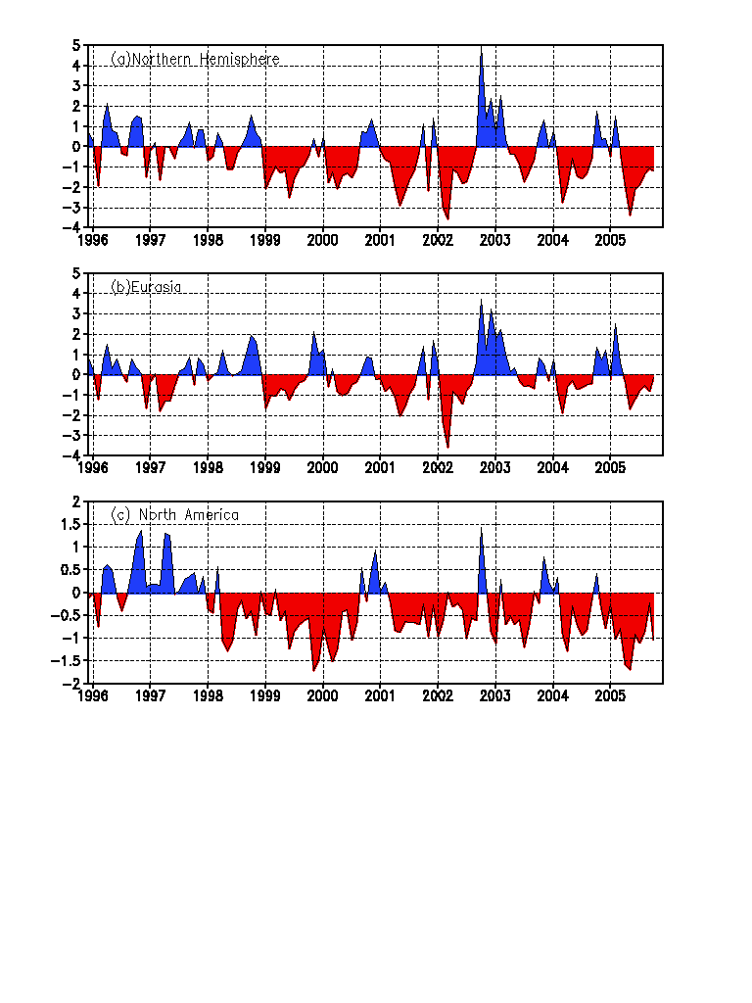
Fig.1 Regional Snow Cover Anomaly Indices (Unit: 10⁶km²)
- Northern Hemisphere (b) Eurasia (c) North America

For the month, number of days with snow cover (NDSC) was above 20 in north-central Russia, parts of the Tibetan Plateau, Greenland and northern Canada. NDSC was 5～15 more than average in central Russia and northwestern Canada. NDSC was 5～20 more than average in the south-central Tibetan Plateau. Meanwhile, NDSC was 5～15 less than average in parts of Russia, parts of western frontier of China and parts of Canada (Fig.2).

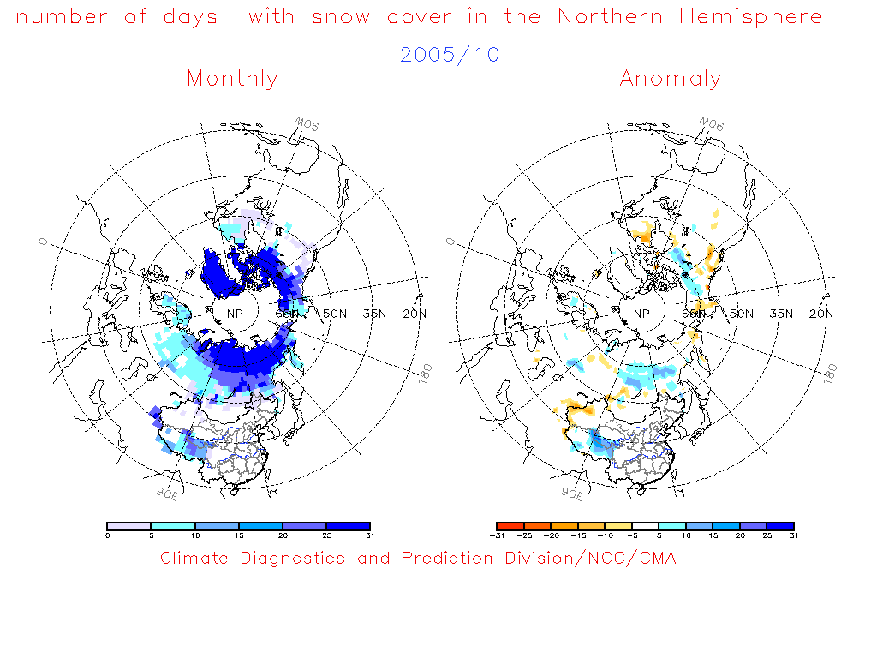
Fig.2 Number of Days with Snow Cover (left) and Anomalies (right)
in the Northern Hemisphere during October 2005 (Unit: day)

China
During October, area of snow cover was near normal in China, area of snow cover was more than average in the Tibetan Plateau, and area of snow cover was less than average in northern Xinjiang and Northeastern China (Fig.3).
For the month, NDSC was 5～20 in the south-central Tibetan Plateau and parts of Xinjiang. NDSC was 5～20 above normal in the south-central Tibetan Plateau. Meanwhile, NDSC was 5～20 below normal in western Xinjiang and parts of western frontier of China (Fig.4).

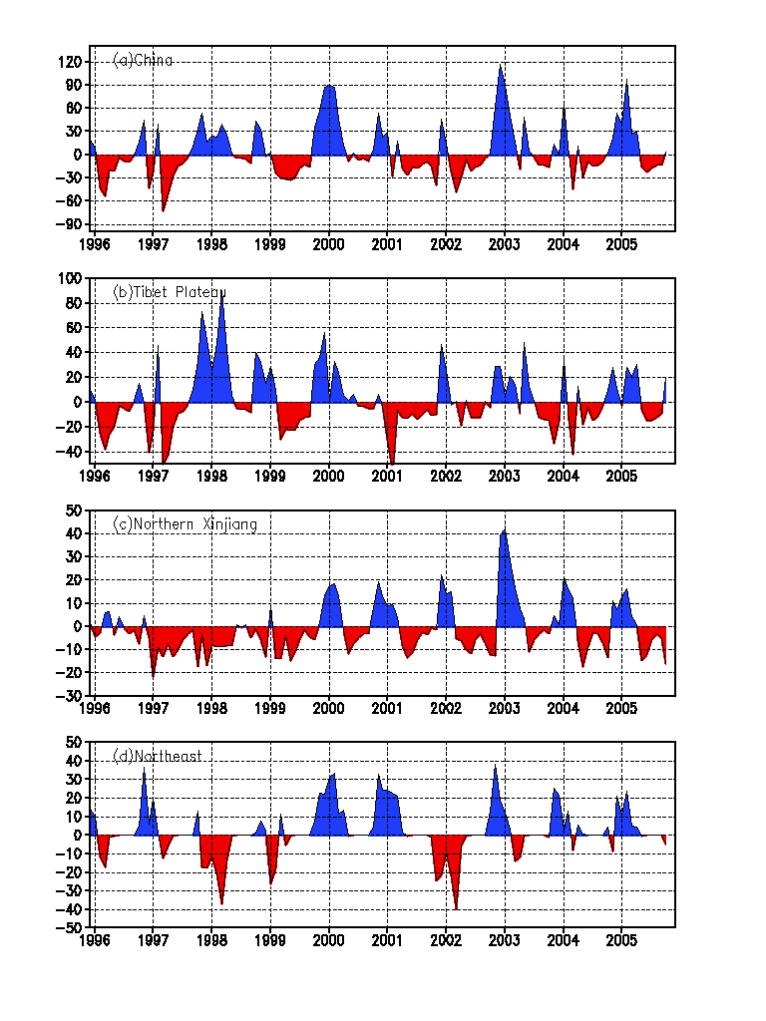
Fig. 3 Regional Snow Cover Anomaly Indices (Unit: 10⁴km²)
- China (b) Tibetan Plateau (c) Northern Xinjiang (d) Northeast China

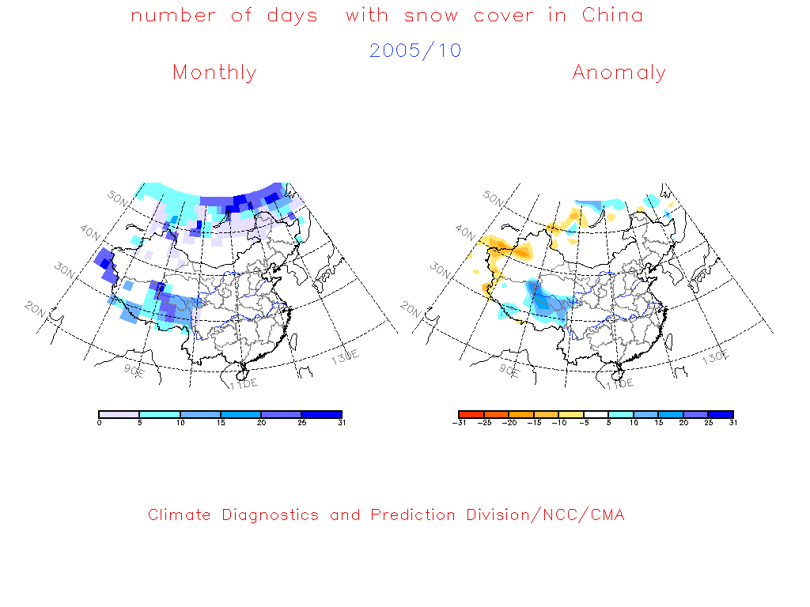

Fig.4 Number of Days with Snow Cover (left) and Anomalies (right)
in China during October 2005 (Unit: day)

Remark: Original data are from http://www.cpc.ncep.noaa.gov/data/snow/.
Analyst: Climate System Diagnostics and Prediction Division/National Climate Center/CMA
Climatologic fields are from the 1973-2002 base period means.

