Sea Ice Monitoring

October 2012


Beijing Climate Center

China Meteorological Administration

Northern Hemisphere
During October 2012, Arctic sea ice concentrations were significantly lower than normal. Sea ice concentrations were 20-40% below normal in most of the Barents Sea, the Kara Sea, the Laptev Sea, the East Siberian Sea, and the Beaufort Sea, with at least 60% below normal in the Beaufort Sea and most of the Barents Sea. Meanwhile, sea ice concentrations were 10-20% above normal in locations of the western Greenland Sea (Fig.1).
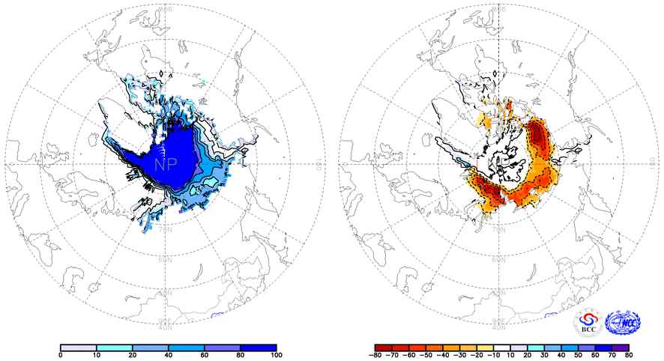
Fig. 1 Monthly Sea Ice Concentrations (left) and Anomalies (right) in the Northern Hemisphere (unit: %) 2012.10
solid line----positive value dashed line:---- negative value isolines interval----20%

Southern Hemisphere
During October 2012, sea ice concentrations were near or above normal in the sea areas around Antarctica, with 20-40% above normal in the southern South Indian basin, southern Atlantic-Indian basin and most Southeast Pacific basin, with center values above 40% in locations (Fig.2).
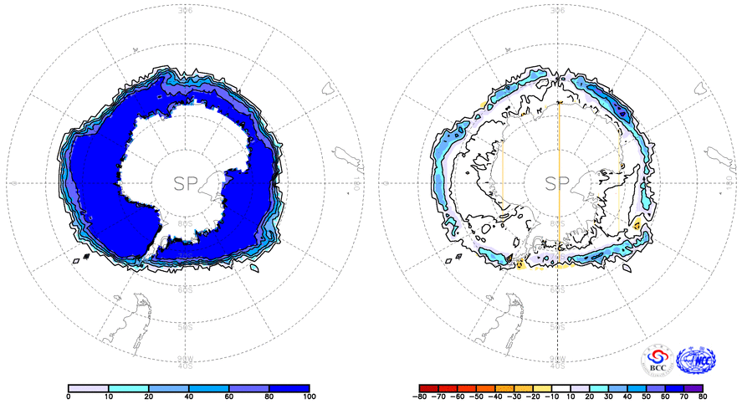
Fig. 2 Monthly Sea Ice Concentrations (left) and Anomalies (right) in the Southern Hemisphere (unit: %) 2012.10
solid line----positive value dashed line: ---- negative value isolines interval----20%

We will closely monitor and update sea ice conditions and provide related information in time.

Remark: Original data are obtained from the OI.v2 Monthly SST Analysis and climatological fields are from the 1982-2010 base period means.

Reference
Reynolds, R.W., N.A. Rayner, T.M. Smith, D.C. Stokes, and W. Wang, 2002: An Improved In Situ and Satellite SST Analysis for Climate, J. Climate, 15 (13): 1609-1625.

Editor: Yuan Yuan Chief Editor: Sun Leng Technical assistant: Tang Jinyue

