Sea Ice Monitoring

November 2010


Beijing Climate Center

China Meteorological Administration

Northern Hemisphere
During November 2010, sea ice concentrations were above 80% in the Arctic and the Greenland Sea. The sea ice concentrations were mainly below normal in the Northern Hemisphere, with concentrations at least 20% below normal in the Baffin Bay, the Fox Bay, the Hudson Bay, the Chukchi Sea, the Kara Sea and the Barents Sea.

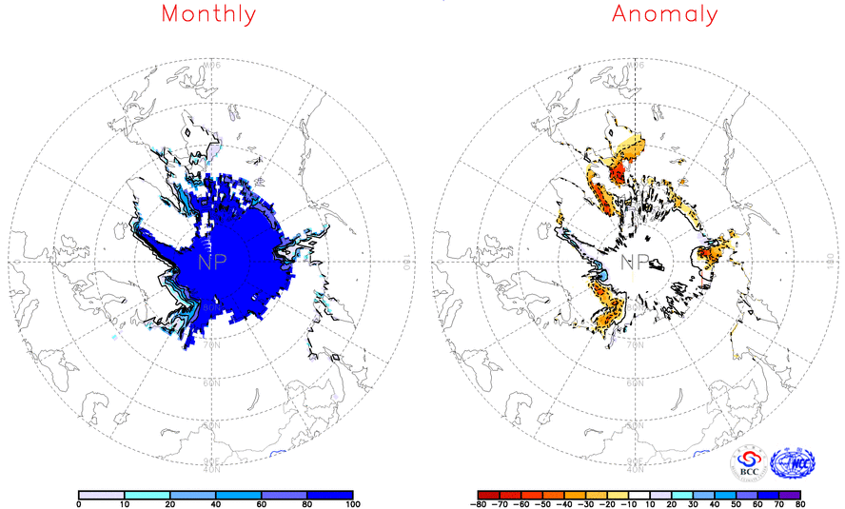
Fig. 1 Monthly Sea Ice Concentrations (left) and Anomalies (right) in the Northern Hemisphere (unit :%) 2010.11
Solid line----positive value dashed line: ---- negative value isoclines interval----20%

Southern Hemisphere
During November 2010, sea ice concentrations were above 80% in seas around Antarctic. The sea ice concentrations were 20-60% above normal in the south part of the Atlantic-Indian Ocean basin, seas from southeastern Pacific basin to the Antarctic-Pacific Ridge and the eastern part of southern Indian basin, with 60-80% above normal in parts of above regions. Meanwhile, sea ice concentrations were 10-30% below normal in the Bellingshausen Sea, the southern part of Weddell Sea and the western Indian Ocean basin, with 30-40% below normal in parts of above regions (Fig.2).
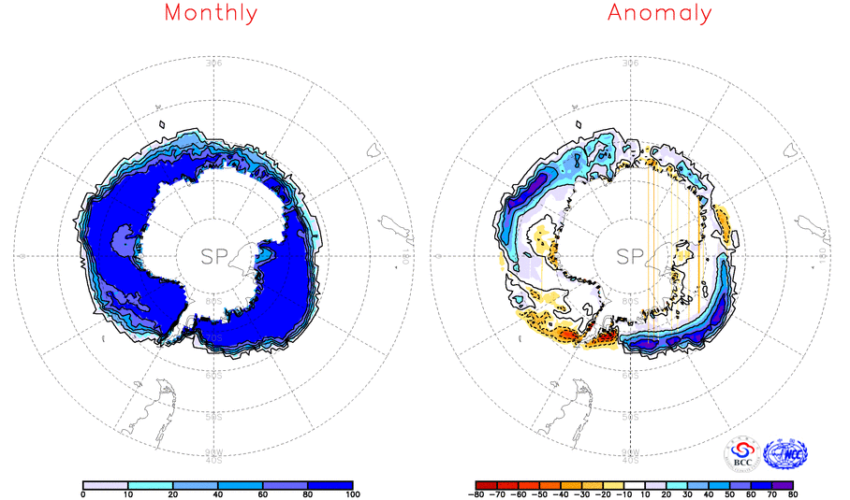
Fig. 2 Monthly Sea Ice Concentrations (left) and Anomalies (right) in the Southern Hemisphere (unit :%) 2010.11
Solid line----positive value dashed line: ---- negative value isoclines interval----20%

We will closely monitor and update sea ice conditions and provide related information in time.

Remark: Original data are obtained from the OI.v2 Monthly SST Analysis and climatologic fields are from the 1982-2004 base period means.

Analyst: Climate Prediction Division/National Climate Center/CMA

Reference
Reynolds, R.W., N.A. Rayner, T.M. Smith, D.C. Stokes, and W. Wang, 2002: An Improved In Situ and Satellite SST Analysis for Climate, J. Climate, 15 (13): 1609-1625.

Editor: Yuyu, Ren Chief Editor: Fumin, Ren Technical assistant: Chaoyang, Sun

