Sea Ice Monitoring

December 2009


National Climate Center

China Meteorological Administration

Northern Hemisphere
During December 2009, sea ice concentrations were in general near or less than normal in the Northern Hemisphere, with 20-60% less than normal in the northern Barents Sea and the most central-northern Hudson Bay, except for 20-40% more than normal in locations of sea areas south to the Bering Strait(Fig.1).

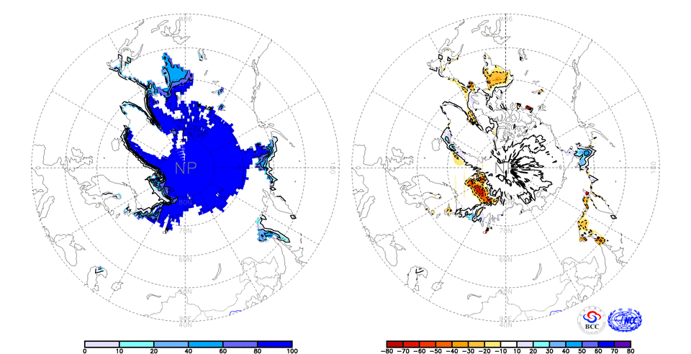
Fig. 1 Monthly Sea Ice Concentrations (left) and Anomalies (right) in the Northern Hemisphere (unit:%) 2009.12
solid line----positive value dashed line:---- negative value isoclines interval----20%

Southern Hemisphere
During December 2009, sea ice concentrations were mainly 10-40% more than normal in most high-latitude sea areas of the Southern Hemisphere, with 60% above normal in locations of above regions, except for 20-40% less than normal in locations of the southern South Atlantic Ocean and locations of the southern South Pacific Ocean (Fig.2).

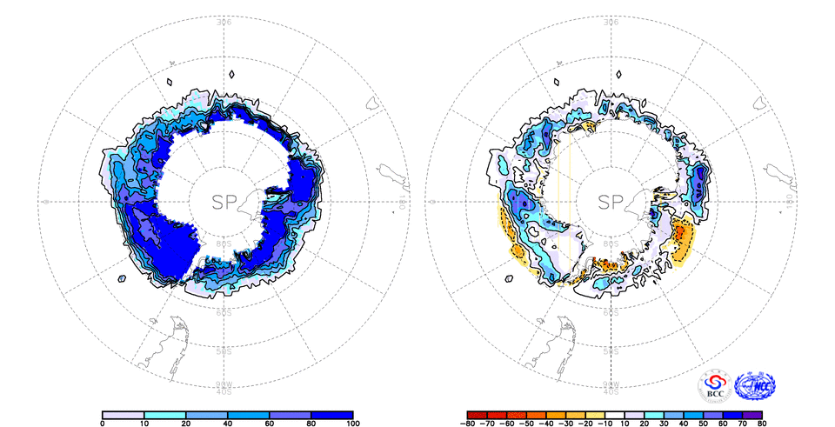
Fig. 2 Monthly Sea Ice Concentrations (left) and Anomalies (right) in the Southern Hemisphere (unit:%) 2009.12
solid line----positive value dashed line:---- negative value isoclines interval----20%

We will closely monitor and update sea ice conditions and provide related information in time.

Remark: Original data are from the OI.v2 Monthly SST Analysis and climatologic fields are from the 1982-2002 base period means.

Analyst: Climate Prediction Division/National Climate Center/CMA

Reference
Reynolds, R.W., N.A. Rayner, T.M. Smith, D.C. Stokes, and W. Wang, 2002: An Improved In Situ and Satellite SST Analysis for Climate, J. Climate, Vol 15.

Editor: Wang, Yanjiao Chief Editor: Ren, Fumin Technical assistant: Gong, Zhiqiang

