Sea Ice Monitoring

September 2009


National Climate Center

China Meteorological Administration

Northern Hemisphere
During September 2009, sea ice concentrations were mainly less than normal in the Northern Hemisphere. Sea ice concentrations were observed 20-50% above normal in the northern Greenland Sea and the northern Barents Sea. Meanwhile, sea ice concentrations were 20-70% blow normal in regions from 60°E eastward to 140°W around the Arctic Ocean, with more than 70% above normal in locations.
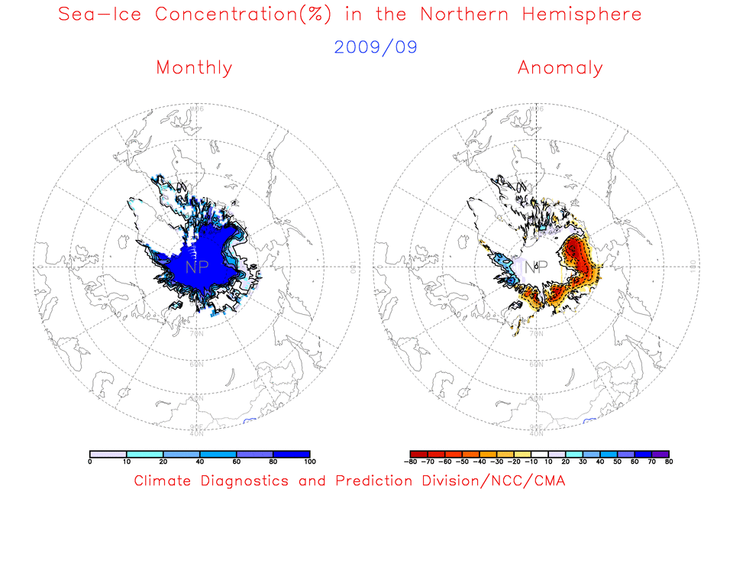
Fig. 1 Monthly Sea Ice Concentrations (left) and Anomalies (right) in the Northern Hemisphere (unit:%) 2009.09
solid line----positive value dashed line:---- negative value isoclines interval----20%

Southern Hemisphere
During September 2009, sea ice concentrations were mainly more than normal in the Southern Hemisphere. While sea ice concentrations were about 20% blow normal in locations of the southern South Atlantic Ocean and the southern South India Ocean, sea ice concentrations were observed 20-60% above normal in most of rest regions along 60°S, with more than 60% above normal in locations.
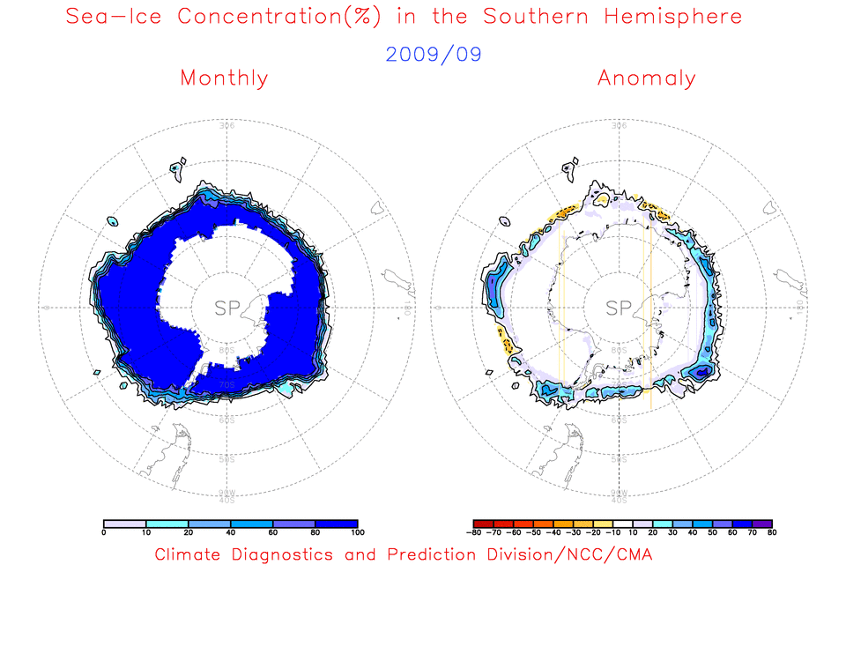
Fig. 2 Monthly Sea Ice Concentrations (left) and Anomalies (right) in the Southern Hemisphere (unit:%) 2009.09
solid line----positive value dashed line:---- negative value isoclines interval----20%

We will closely monitor and update sea ice conditions and provide related information in time.

Remark: Original data are from the OI.v2 Monthly SST Analysis and climatologic fields are from the 1982-2002 base period means.

Analyst: Climate Prediction Division/National Climate Center/CMA

Reference
Reynolds, R.W., N.A. Rayner, T.M. Smith, D.C. Stokes, and W. Wang, 2002: An Improved In Situ and Satellite SST Analysis for Climate, J. Climate, Vol 15.

Editor: Wang, Yanjiao Chief Editor: Ren, Fumin Technical assistant: Liu, Yunyun

