Monthly Sea Ice Monitoring (experimental)
August 2009
Northern Hemisphere:
During August 2009, anomalies of sea ice concentrations were observed 20-50% above normal in northern of Greenland Sea and Barents Sea. Meanwhile, the 20-50% low centers located in Kaka Sea, Laptev Sea, East Siberian Sea and Chukot Sea respectively and some areas less than 60%. In general, sea ice concentrations were negative in the northern hemisphere.

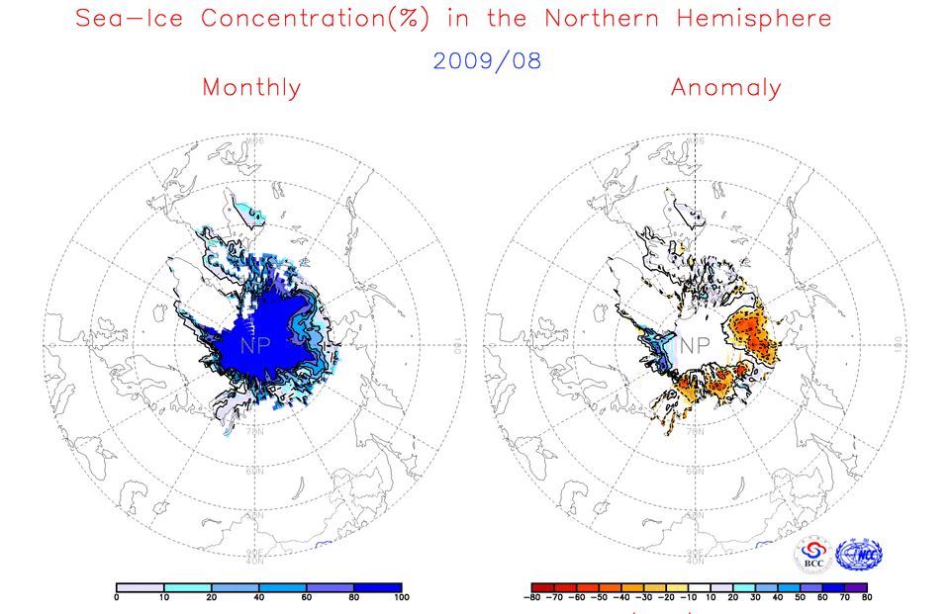
Fig. 1 Monthly Sea Ice Concentrations (left) and Anomalies (right) in the Northern Hemisphere (unit:%) 2009.08
solid line----positive value dashed line:---- negative value isoclines interval----20%

Southern Hemisphere:
During August 2009, positive anomalies of sea ice concentration were 20%-40% in part of the eastern South Atlantic Ocean and the eastern South India Ocean around 60°S. Meanwhile, sea ice concentrations were near or above normal in the rest sea. Negative anomalies about 40-70%were observed in the southern Atlantic round 60°S in the southern Pacific around 150°W,60°S and the southern Atlantic Ocean around 50°W 60°S. In general, sea ice concentrations were positive in the southern hemisphere.

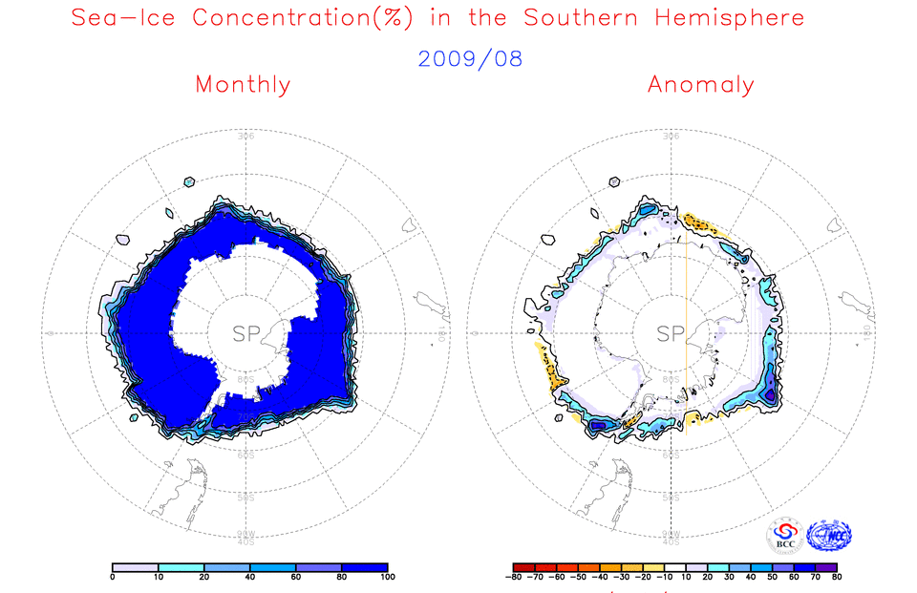
Fig. 2 Monthly Sea Ice Concentrations (left) and Anomalies (right) in the Southern Hemisphere (unit:%) 2009.08
solid line----positive value dashed line:---- negative value isoclines interval----20%

We will closely monitor and update sea ice conditions and provide related information in time.

Remark: Original data are from the OI.v2 Monthly SST Analysis and climatologic fields are from the 1982-2002 base period means.
Analyst: Climate Prediction Division/National Climate Center/CMA
Reference
Reynolds, R.W., N.A. Rayner, T.M. Smith, D.C. Stokes, and W. Wang, 2002: An Improved In Situ and Satellite SST Analysis for Climate, J. Climate, Vol 15.

