Monthly Sea Ice Monitoring (experimental)
Northern Hemisphere: During November 2008, sea ice concentrations were over 80% in the Arctic Ocean and adjacent seas. Sea ice concentrations were near normal in most seas of the Arctic Ocean, but 20~60% below normal in Kaka Sea, northern Barents Sea, northern Hudson Bay and Chukchi Sea.

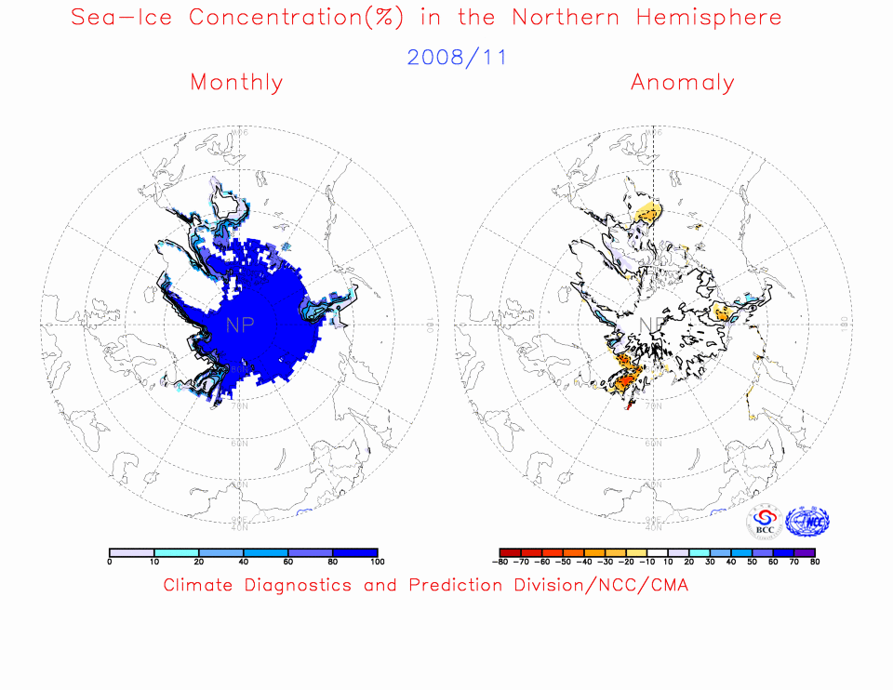

Fig. 1 Monthly Sea Ice Concentrations (left) and Anomalies (right) in the Northern Hemisphere (unit:%) 2008.11
solid line----positive value dashed line:---- negative value isoclines interval----20%

Southern Hemisphere: For the month, sea ice concentrations were at least 80% in most seas around Antarctica. Sea ice concentrations were observed 20~60% above normal in most seas around the Antarctica, with concentrations at least 60% more than normal in parts of the seas, but 20~80% below normal in northern Weddell Sea and Bellingshausen Sea.

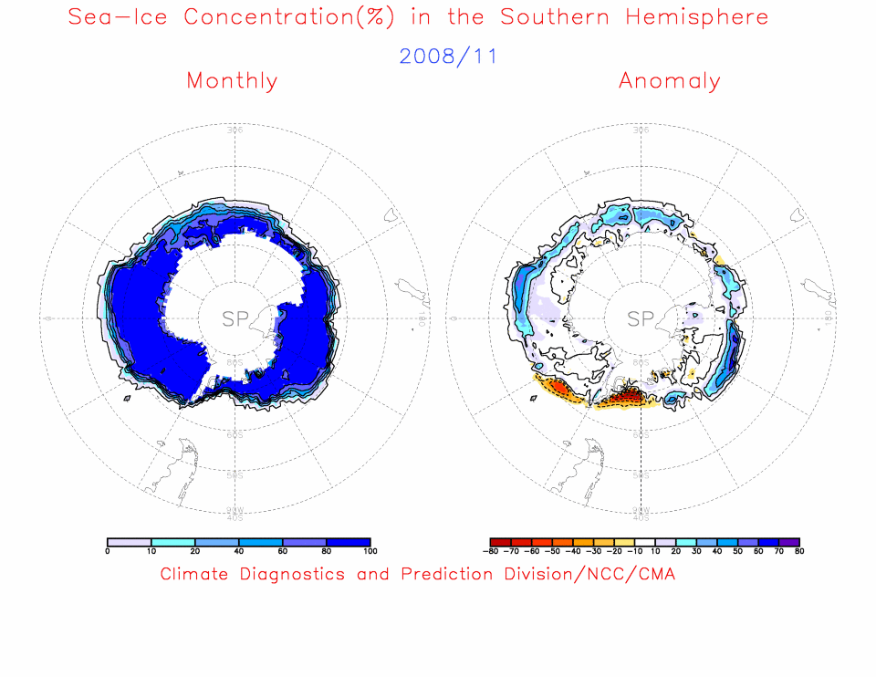

Fig. 2 Monthly Sea Ice Concentrations (left) and Anomalies (right) in the Southern Hemisphere (unit:%) 2008.11
solid line----positive value dashed line---- negative value isoclines interval----20%

Remark: Original data are from the OI.v2 Monthly SST Analysis
Analyst: Climate System Diagnostics and Prediction Division/National Climate Center/CMA

Reference：Reynolds, R.W., N.A. Rayner, T.M. Smith, D.C. Stokes, and W. Wang, 2002: An Improved In Situ and Satellite SST Analysis for Climate, J. Climate, Vol 15.
Climatologic fields are from the 1982-2002 base period means.

