Monthly Sea Ice Monitoring (experimental)
Northern Hemisphere:
During July 2008, sea ice concentrations were found at least 80% over the Arctic Ocean. Sea ice concentrations were observed 20-40% more than average in parts of the Greenland Sea and the Laptevykh Sea. Meanwhile, sea ice concentrations were observed 20-60% less than average in the Beaufort Sea, the Barents Sea and the Karskoye Sea.

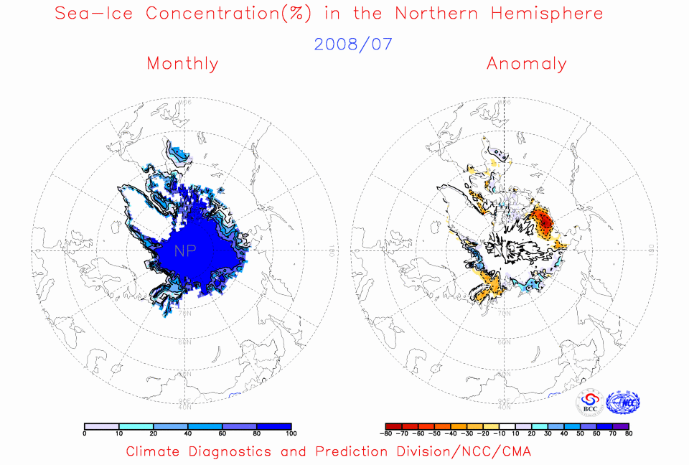
Fig. 1 Monthly Sea Ice Concentrations (left) and Anomalies (right) in the Northern Hemisphere (unit:%) 2008.07
solid line----positive value dashed line:---- negative value isoclines interval----20%

Southern Hemisphere:
For the month, sea ice concentrations were observed at least 80% in most seas around Antarctica. Sea ice concentrations were 20-40% less than average in the Bellingshausen Sea and the Scotia Sea. Meanwhile, sea ice concentrations were 20-50% more than average in the seas from 20°E to 110°E and from 140°E to 110° W around Antarctica.

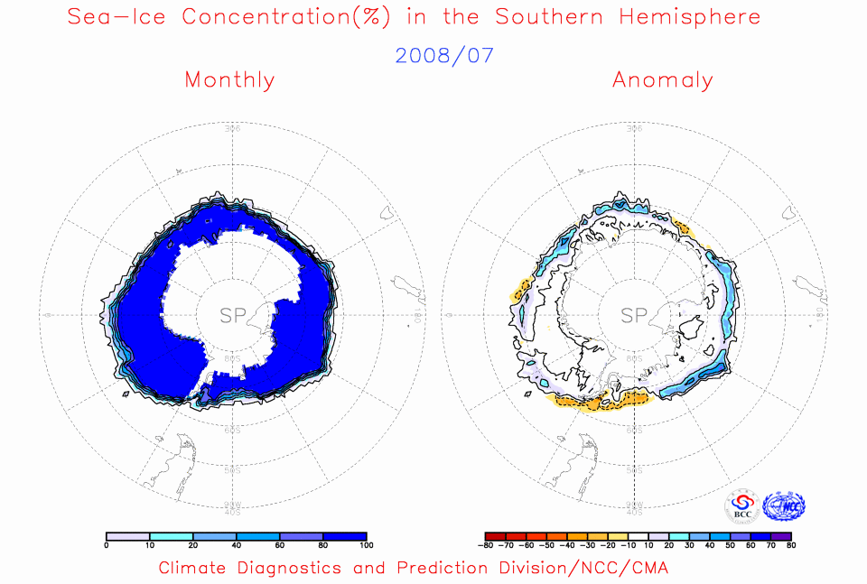
Fig. 2 Monthly Sea Ice Concentrations (left) and Anomalies (right) in the Southern Hemisphere (unit:%) 2008.07
solid line----positive value dashed line---- negative value isoclines interval----20%

Remark: Original data are from the OI.v2 Monthly SST Analysis
Analyst: Climate System Diagnostics and Prediction Division/National Climate Center/CMA

Reference：Reynolds, R.W., N.A. Rayner, T.M. Smith, D.C. Stokes, and W. Wang, 2002: An Improved In Situ and Satellite SST Analysis for Climate, J. Climate, Vol 15.
Climatologic fields are from the 1982-2002 base period means.

