Monthly Sea Ice Monitoring (experimental)
During October, Sea Ice Concentration was higher than 80% in the central Arctic Ocean north to 80°N, and the Arctic Ocean north to 70°N was covered by sea ice concentration above 20%. Sea ice concentration was 20~80%below normal in the Ocean north to Navaya Zemlya and more than 40% below normal in Laprev Sea and East Siberian Sea.(see fig.1)
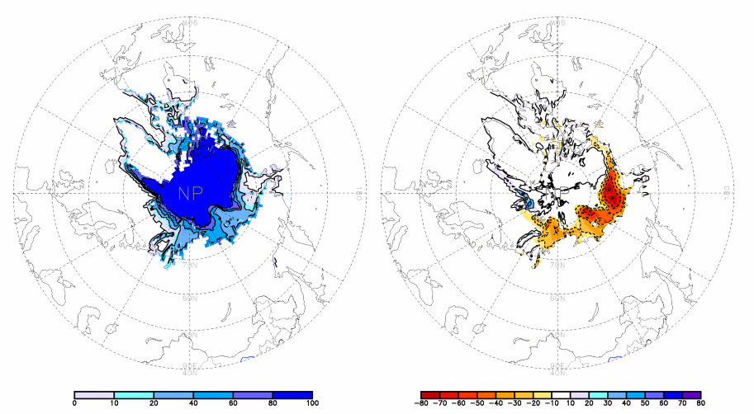
fig. 1 Monthly Sea Ice Concentration (left) and Anomalies in the northern hemisphere (right) (unit:%) 2005.10
solid line----positive value dashed line:---- negative value isoline interval----20%

During October, sea ice concentration was above 60% in the oceans south to 60°S except parts of the southeastern South Pacific. Sea ice concentration in Bellingshausen Sea was 20%~60% `below normal and in other ocean around 60°S was 20%~40% above normal.
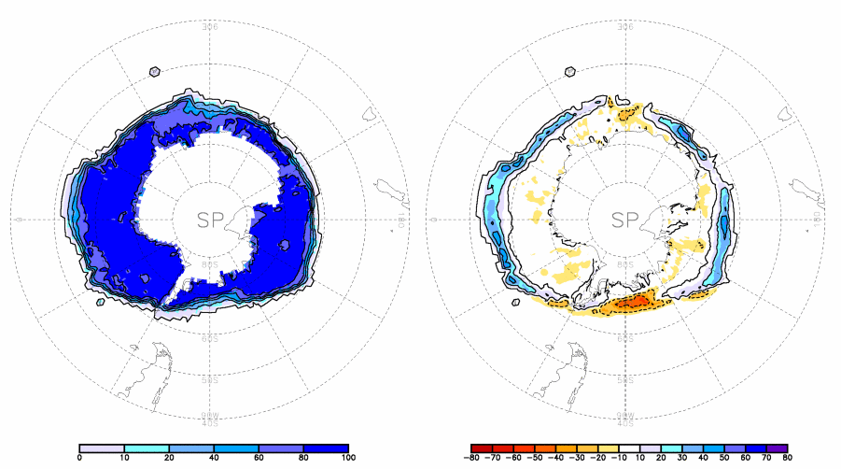

fig. 2 Monthly Sea Ice Concentration (left) and Anomalies (right) in the southern hemisphere (unit:%) 2005.10
solid line----positive value dashed line---- negative value isoclines interval----20%

Remark: Original data are from the OI.v2 Monthly SST Analysis
Analyst: Climate System Diagnostics and Prediction Division/National Climate Center/CMA
Reference：Reynolds, R.W., N.A. Rayner, T.M. Smith, D.C. Stokes, and W. Wang, 2002: An Improved In Situ and Satellite SST Analysis for Climate, J. Climate, Vol 15.
Climatologic fields are from the 1982-2002 base period means.

