ENSO REPORT

No. 52
June 6, 2014

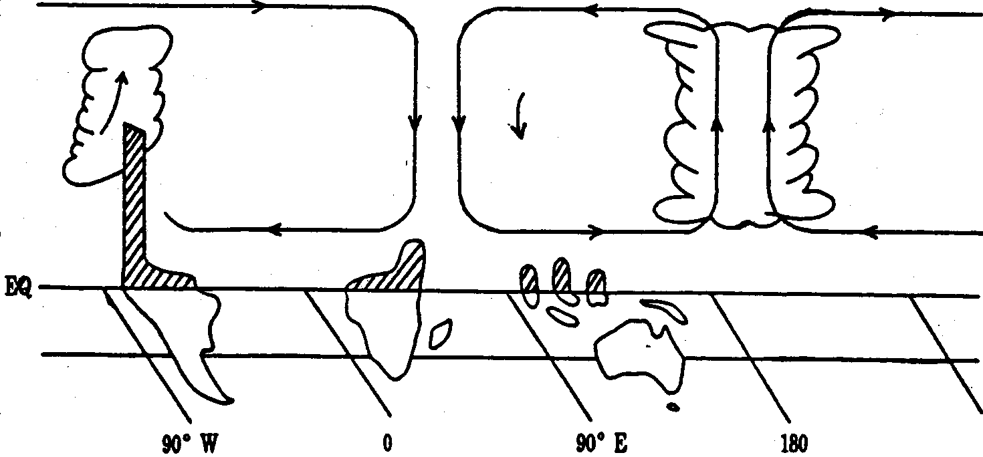

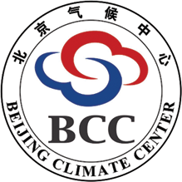
East Asian Monsoon Activity Center
CAS，World Meteorological Organization
Beijing Climate Center
China Meteorological Administration

El Nino conditions occurred in the equatorial Pacific in May 2014 and an El Nino event will form in the future

In May 2014, Nino Z index was 0.7℃ and the anomalously warm subsurface water enhanced in the equatorial central and eastern Pacific. El Nino conditions occurred in this month and an El Nino event will form in near future.

1. Recent monitoring on ENSO evolution
a) Sea surface temperature anomalies (SSTA)
In April 2014, SSTA increased swiftly over the equatorial central-eastern Pacific and ENSO-neutral conditions turned into warm conditions. In May 2015, Nino Z index was 0.7℃(Fig. 1). Nino 1+2, Nino 3, Nino 4 and Nino 3.4 indices were 1.3℃, 0.6℃, 0.8℃ and 0.5℃, respectively. SSTA was over 0.5℃ in most equatorial central-eastern Pacific, especially above 1℃ in the equatorial central Pacific and above 1.5℃ in the equatorial eastern Pacific along the coastal areas of South America (Fig. 2).
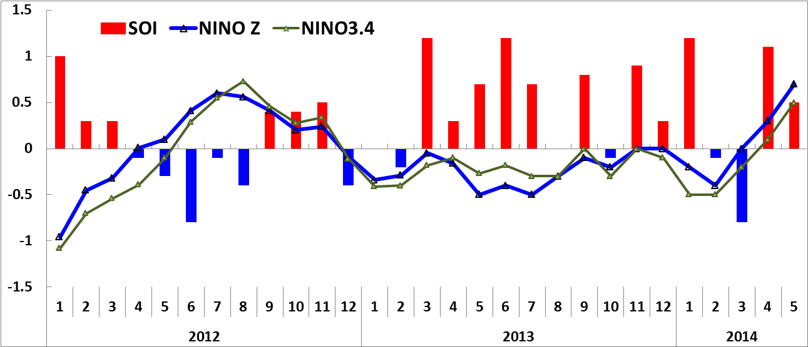
Fig.1 Evolution of Nino Z, Nino 3.4 SSTA indices (unit: ℃) and SOI
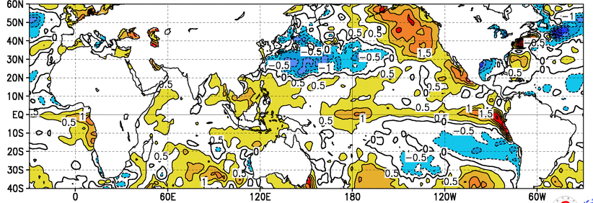
Fig.2 Monthly mean sea surface temperature anomalies (unit: ℃) in May 2014

b) Subsurface Temperatures
In May 2014, the anomalously warm subsurface water enhanced in the central and eastern equatorial Pacific and upwelled to the surface (Fig. 3).
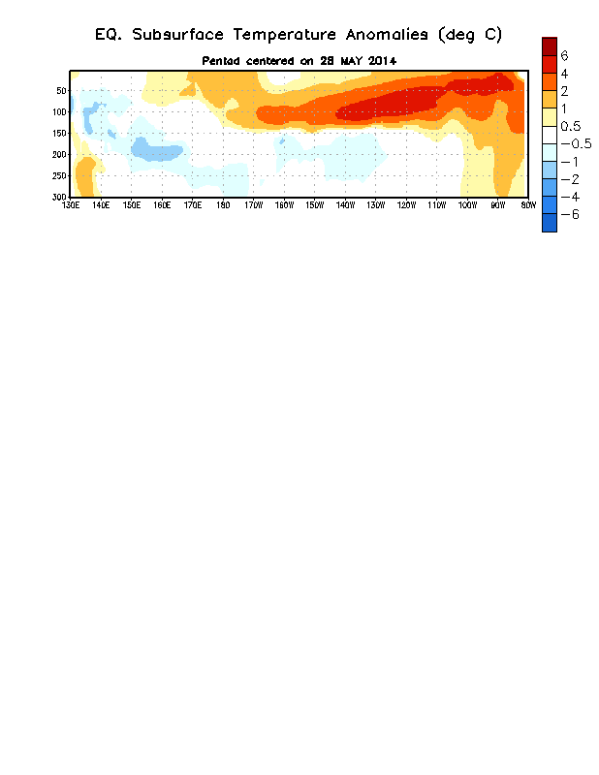
Fig.3 Subsurface temperature anomalies in the equatorial Pacific in the fourth week of May 2014 (unit: ℃, from NOAA)
c) Southern Oscillation
The Southern Oscillation Index (SOI) was 0.5 in May 2014, which decreased significantly from last month.
d) 850hPa Zonal wind

During mid-late January 2014 and from late February to early March, two eastward propagations of westerly anomalies occurred in the equatorial western Pacific. In early April, the westerly anomalies intensified again in the equatorial Indian Ocean and propagated eastward to the equatorial central Pacific. Through the oceanic warm Kelvin waves, they favored the continuous eastward propagation of subsurface warm water from the equatorial western Pacific to the eastern Pacific. As a result, SSTA increased rapidly over the equatorial central and eastern Pacific. Since May, westerly anomalies have controlled the equatorial central-eastern Pacific, indicating reduced trade wind along the equator. Westerly anomalies not only restrained the upwelling of surface cold water in equatorial eastern Pacific, but also intensified the accumulation of surface warm water, and finally favored the fast development of the warm condition (Fig. 4).

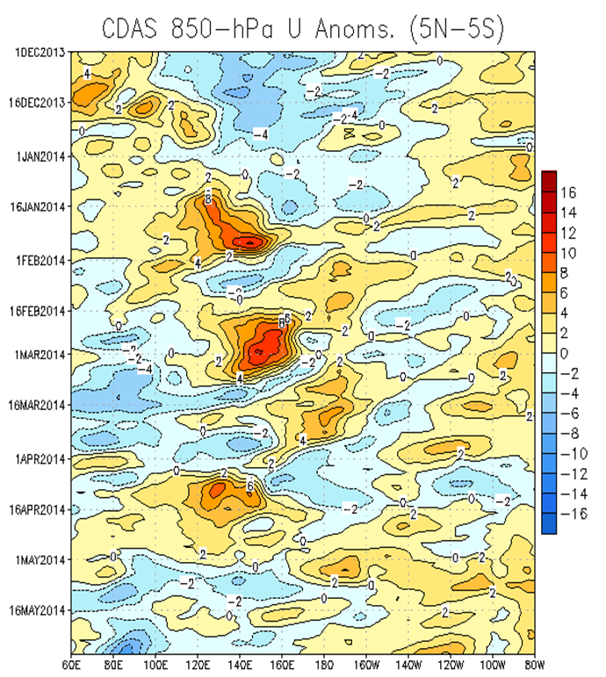
Fig. 4 Time-longitude section of daily 850hPa zonal wind anomalies averaged in 5ºS-5ºN (Units: m/s)

2. Diagnosis and outlook
Based on model prediction and diagnoses of the oceanic variations, the sea surface temperature over the equatorial central-eastern Pacific will keep increasing and remain warm for at least 6 months. A moderate or stronger El Nino event will form in the future.

Therefore, we will closely monitor the development of ENSO conditions and update our ENSO wrap-up in time.

BCC operational definitions for El Niño and La Niña Event (condition)

El Niño (La Niña) event: which is characterized by a positive(negative) sea-surface temperature departure from normal (for the 1971-2000 base period) in NINO Z (NINO 1+2+3+4) greater (less) than or equal to 0.5℃ (-0.5℃) for at least 6 consecutive months (allowing below (above) 0.5℃(-0.5℃) for only one month) .
BCC considers El Niño (La Niña) conditions to occur when the monthly NINO Z index greater (less) than or equal to 0.5℃ (-0.5℃) along with consistent atmospheric features. And, these anomalies must also be forecasted to persist for at least 3 consecutive months.
*References
1. On Indices and Indicator of ENSO Episodes, 2000, Acta Metrological Sinica, 58(1): 102-109
2. Redefining ENSO Episode on Changed Reference, 2005, Journal of Tropical Meteorology，2005, 21(1): 72-78

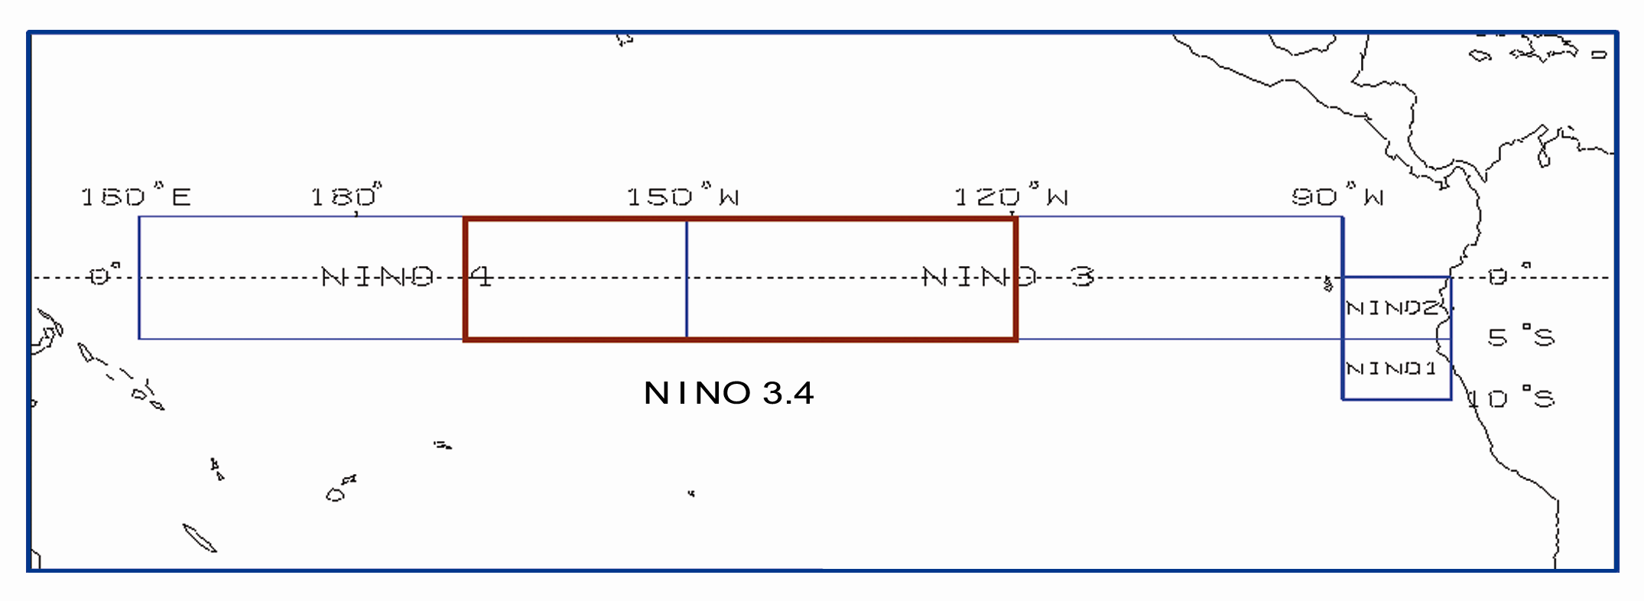
Distribution of the NINO regions for ENSO monitoring

Editor: Zunya Wang & Xianjun Xiao Chief Editor: Yuan Yuan & Zongjian Ke
Technical assistant: Xin Hao

