- Monitoring for recent oceanic and atmospheric conditions
(1) Sea Surface Temperature Anomalies (SSTa):
The SSTa turned quickly into the pattern “the cold in the east and the warm in the west” in the equatorial Pacific after a weak warm (El Niño) episode ended in February 2007(Fig. 1). The negative SSTa in mid-eastern Pacific has obviously been extending westward since July 2007. During August, the negative SSTa below -0.5℃extended westward to the vicinity of 140ºW (Fig. 2), and NINO Z index dropped to -0.6℃ and reached threshold values for La Nina conditions ( NINO Z index ≤-0.5℃).
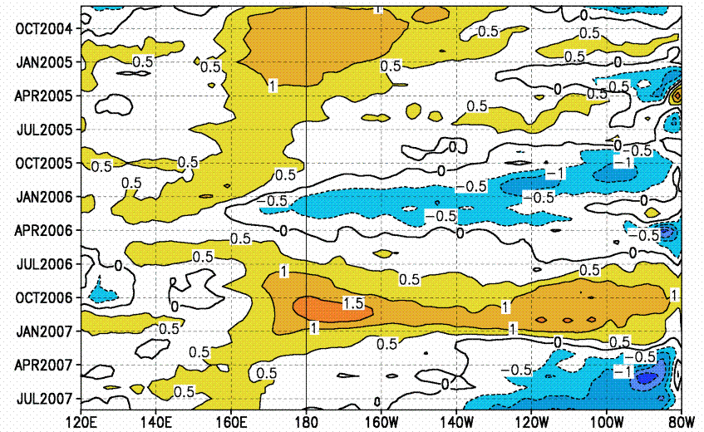

Fig. 1 Time-longitude section of monthly mean SSTa (℃) along the equatorial Pacific
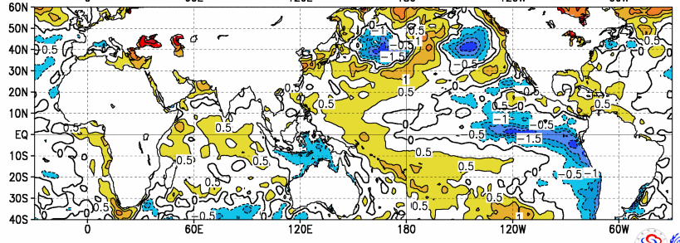

Fig. 2 SSTa for August 2007
(2) Subsurface Sea Temperatures:
During Jul- Aug. (12 days), anomalously subsurface cold water enhanced in the equatorial eastern Pacific with the maximum anomalies being less than -5℃, and the contours below -0.5℃ extended westward to around dateline in the subsurface equatorial Pacific (Fig. 3).

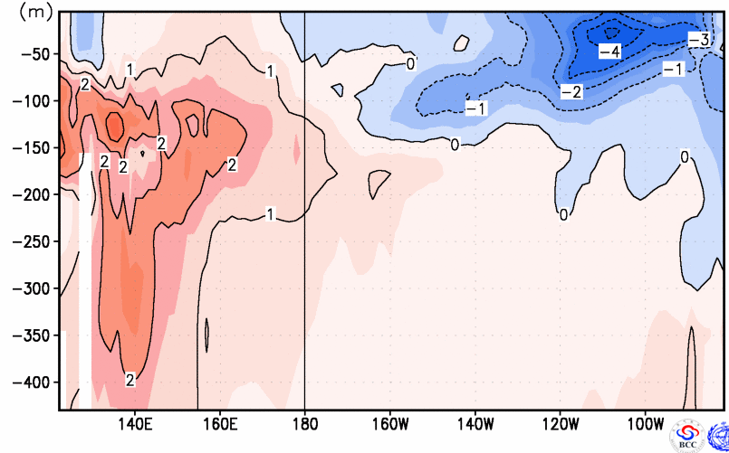

图3 Subsurface SSTa in August(12 days) 2007
(3) Zonal wind anomalies:
Easterly anomalies have remained in the equatorial central Pacific since April 2007, and it occupied most parts of the equatorial Pacific in late August (Fig.4).
(4) Southern Oscillation and Nino Indices:
As Fig.5 showed, Nino Z and Nino 3.4 indices decreased since January 2007 and Nino Z has been in cold phase from April 2007. And in August, Nino Z and Nino 3.4 indices were -0.6℃and -0.5℃ respectively, while SOI is 0.3.
(5) Convections:
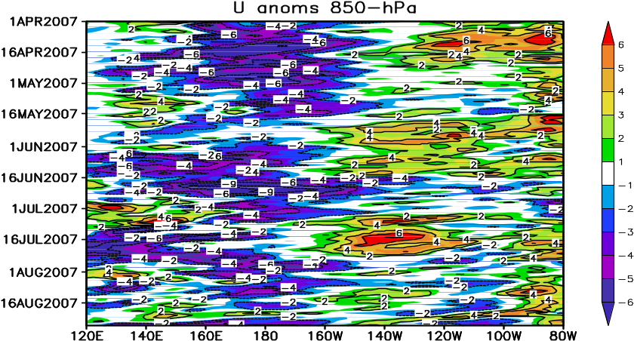
At present, active convections are observed near Indonesia, whereas the convections are suppressed in the equatorial Pacific portion between 150ºE-130ºW.

Fig. 4 Time-longitude section of zonal wind anomalies (Units: m/s) at 850 hPa
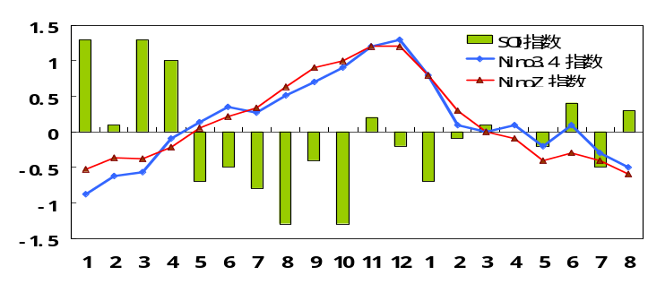

Fig. 5 Monthly NINO Z (NINO1+2+3+4; red) and NINO3.4 (blue) SSTa indices（℃）and SOI indices (histograms) time Series during Jan. 2006-August. 2007
2. Diagnosis and outlook
The area of negative SSTa became remarkably larger in the equatorial mid-eastern Pacific during July 2007, and then the intensity in its center got stronger in August and NINO Z index reached to -0.6℃ with La Nina conditions appearing at present. In addition, zonal wind at lower troposphere, sea level pressures, and convective activities showed the characteristics of cold phase and they were favorable for development of La Niña.
There are two factors that directly influence the development of ENSO. One is the distribution of subsurface sea temperatures, and the other is zonal wind at lower troposphere. Firstly the anomalously cold tongue had formed in the surface of the equatorial eastern Pacific during early spring and kept to present with anomalously subsurface cold water also keeping in the equatorial eastern Pacific and being stronger recently. Correspondingly a clod Kelvin wave propagating eastward in the mid June made the negative heat content anomalies in the upper ocean of the mid-eastern Pacific reinforcing during July - August. Secondly, easterly anomalies still maintained in the vicinity of dateline at present, and NCC dynamic model predicted that such anomalies will sustain, which are favorable for the development of the cold phase. Meanwhile, most of statistical models of NCC also predicted a weak La Nina occurring in following months. La Nina events which happened during late summer-autumn since 1951 were weak mostly. Although some factors were unfavorable for the development of La Nina, in all it is possible for a weak La Nina to form.
3. Potential Climate impacts
The impact of La Nina event on China climate is obvious and it can cause severe disaster. The statistical analyses denote that Precipitations were likely to be excessive in the northern China during autumn of La Nina year, and the precipitations were excessive in the Huanghe and the Huai River basin during autumns, especially with 50% more than normal in the middle reach of the Huanghe River (Fig. 6). In addition, temperatures were below normal over most of China during the winter of La Nina year and severe cold air could cause big loss of crops in southern China.
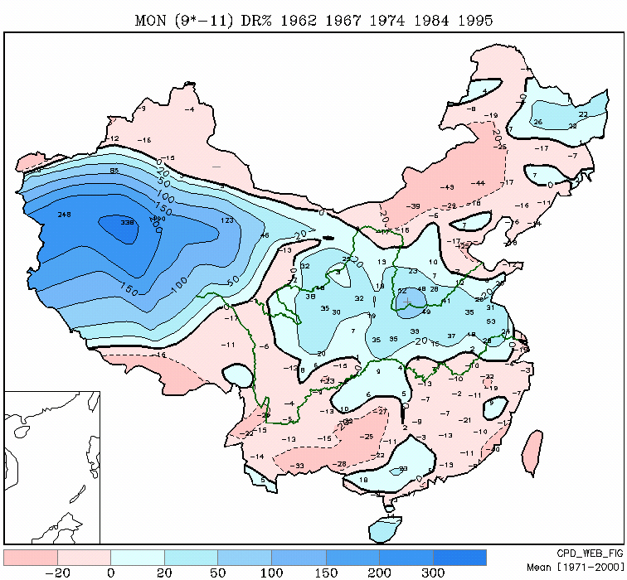

Fig.6 Anomaly percentage of precipitations in China during autumns (Sep-Nov) for the years of La Nina occurring during late summer-Autumn

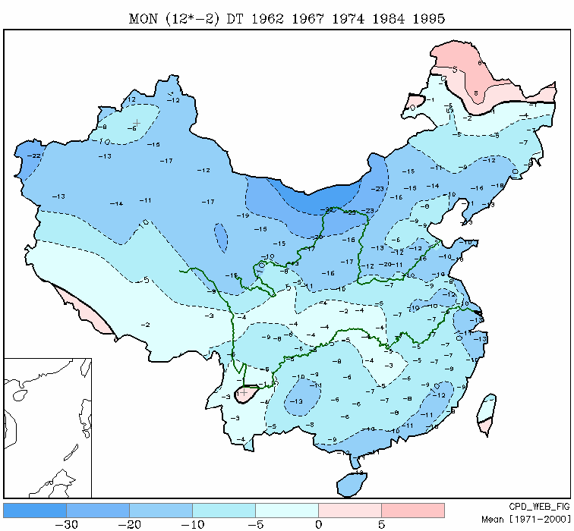

Fig.7 China Temperature anomalies in winters (Dec-Feb) for the years of La Nina occurring during late summer-Autumn

Definition for El Niño and La Niña Event in BCC’s Operation *
El Niño: A phenomenon occurs in the equatorial mid-eastern Pacific Ocean, which is characterized by a positive sea-surface temperature departure from normal (for the 1971-2000 base period) in Nino Z (Nino 1+2+3+4) greater than or equal to 0.5℃ for at least 6 consecutive months (allowing below 0.5℃ for only one month) .
La Niña: A phenomenon occurs in the equatorial mid-eastern Pacific Ocean, which is characterized by a negative sea-surface temperature departure from normal (for the 1971-2000 base period) in Nino Z (Nino 1+2+3+4) smaller than or equal to -0.5℃ for at least 6 consecutive months (allowing above 0.5℃ for only one month) .
*References
1. On Indices and Indicator of ENSO Episodes, 2000, Acta Metrological Sinica, 58(1): 102-109
2. Redefining ENSO Episode on Changed Reference, 2005, Journal of Tropical Meteorology，2005, 21(1): 72-78

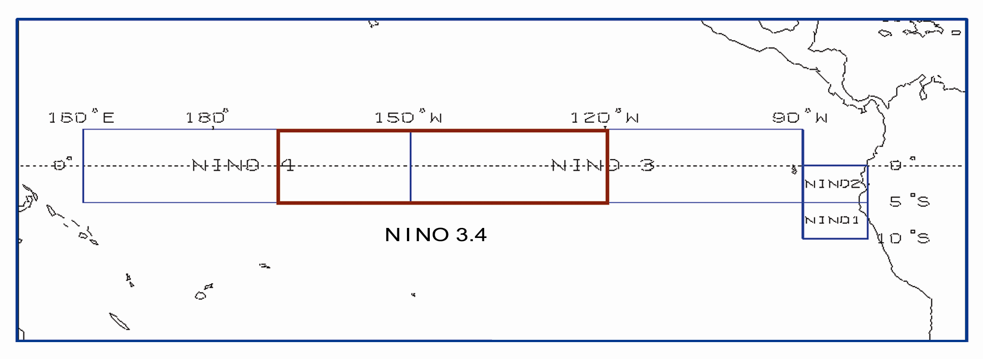
Distribution of the Nino regions for ENSO monitoring

