WARM EPISODE OF ENSO IS EXPECTED TO COME
Aug.19, 2004
It is evident that positive Sea Surface Temperature anomalies (SSTa) enhanced substantially in the central equatorial Pacific while negative SSTa remained in the eastern equatorial Pacific during July, 2004. Current atmosphere-ocean conditions in the tropical Pacific Ocean implied that the occurrence of early onset stage of a warm episode and in the coming months a warm event is expected to come.

1. Recent variations in atmosphere-ocean conditions of tropical Pacific
(1) zonal winds
In the lower troposphere (850hPa) zonal wind remains stable since early 2003. Although westerly anomalies occurred several times over the western equatorial Pacific, it didn’t extend eastward and, instead, relatively strong easterly anomalies dominated around the date line. During June and July of 2004, remarkable westerly anomalies propagated eastward along the equator and reached to the eastern Pacific Ocean. After that, strong westerly anomalies re-appeared in the western equatorial Pacific since the end of July, while easterly anomalies came back to the equatorial Pacific east to 160°E (Fig1).
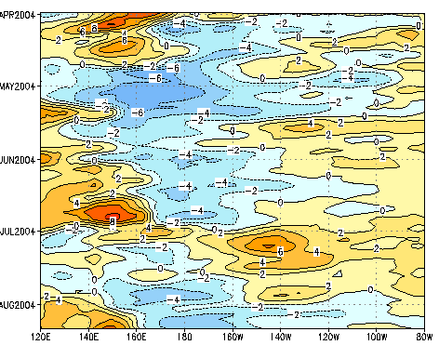
Fig 1 Time-longitude cross sections of zonal wind anomalies(m/s) at 850hPa over the equatorial Pacific (5°N－5°S)

(2) subsurface sea temperature
In early 2004, positive anomalies of subsurface sea temperatures dominated the western and central equatorial Pacific and warm center was found around the date line, while negative anomalies maintained over the eastern equatorial Pacific. In April, positive anomalies in the western and central equatorial Pacific strengthened and then weakened quickly. Under the influence of the westerly anomaly breakout in June, positive anomalies of subsurface sea temperatures enhanced again and the warm center shifted eastward significantly (Fig2).
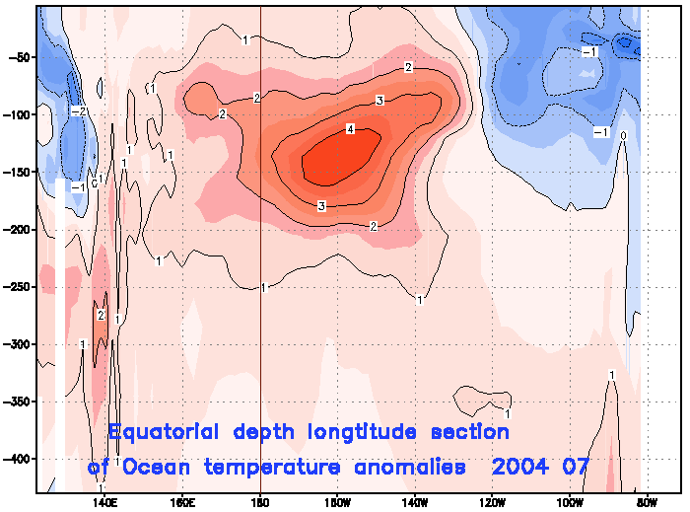
Fig 2 Equatorial depth-longitude section of monthly mean ocean temperatures (℃) 2004.07
深度－经度剖面

(3) sea surface temperature
In early 2004, positive anomalies of sea surface temperature prevailed most of the western equatorial Pacific while sea surface temperature was near normal in the rest of equatorial basin with weak negative anomalies staying in the offshore of Peru. In May, negative anomalies in the offshore of Peru became stronger and extended westward and concurrently positive anomalies in the western equatorial Pacific shifted eastward remarkably. Two months later, positive anomalies were found between 160°E and 120°W in the equatorial Pacific with the centre value above 1℃, while negative anomalies dominated east of 120°W with the centre value below -1℃(Fig3). The Niño 3.4 region was found to be the fastest warming-up one throughout the equatorial band and the SST index reached to 0.6℃. The SST index of Niño 3 region declined slightly and the value was -0.2℃. In Niño 1+2+3+4 region the mean SST indices of were 0.2℃, indicating that conditions of the central and eastern equatorial Pacific were near neutral(Fig4).
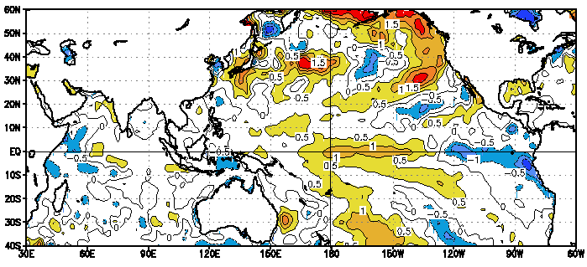
Fig 3 Distribution of sea surface temperature
anomalies(℃) 2004.07

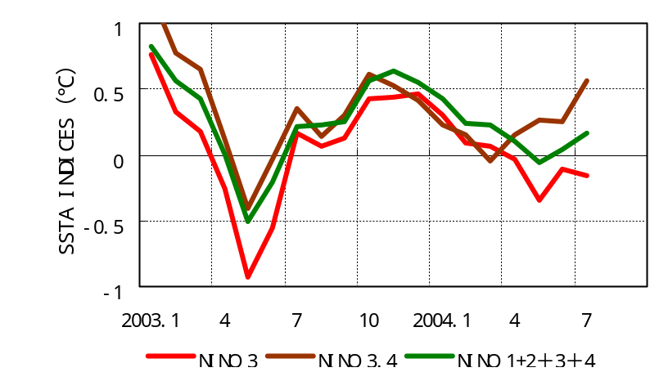
Fig 4 SSTa indices of Niño regions

(4)Southern Oscillation
The Southern Oscillation Index varied remarkably in recent months and its values in June and July were -1.5 and -0.7, respectively.
(5)Convection
The convection was generally suppressed over the equatorial Pacific in early July while enhanced over the marine area west to 150°W in late July.
2. Outlook
Totally 3 El Niño events occurred in autumn and at the same time the warming of SST for each events started from the central equatorial Pacific since 1951, which indicates that autumn is a season favorable for the development of warming-up conditions in the central equatorial Pacific. Some analogue analyses show that the warm phase conditions will weaken and even disappear if no large-scale westerly anomalies persist over the equatorial Pacific, although subsurface sea temperatures in the central equatorial Pacific increase.
Recent variations in tropical atmosphere-ocean conditions are preferable to the warming-up in the central and eastern equatorial Pacific, but the zonal wind condition is still the crucial factor to the formation of a new El Niño in the future.
In addition, most models predict that tropical atmosphere-ocean condition will be normal till the end of 2004 while 2 or 3 models forecast the occurrence of a weak El Niño.
In a short, warm episode is expected to develop in the coming months. But large uncertainty still remains for whether an El Niño event will come into being.

