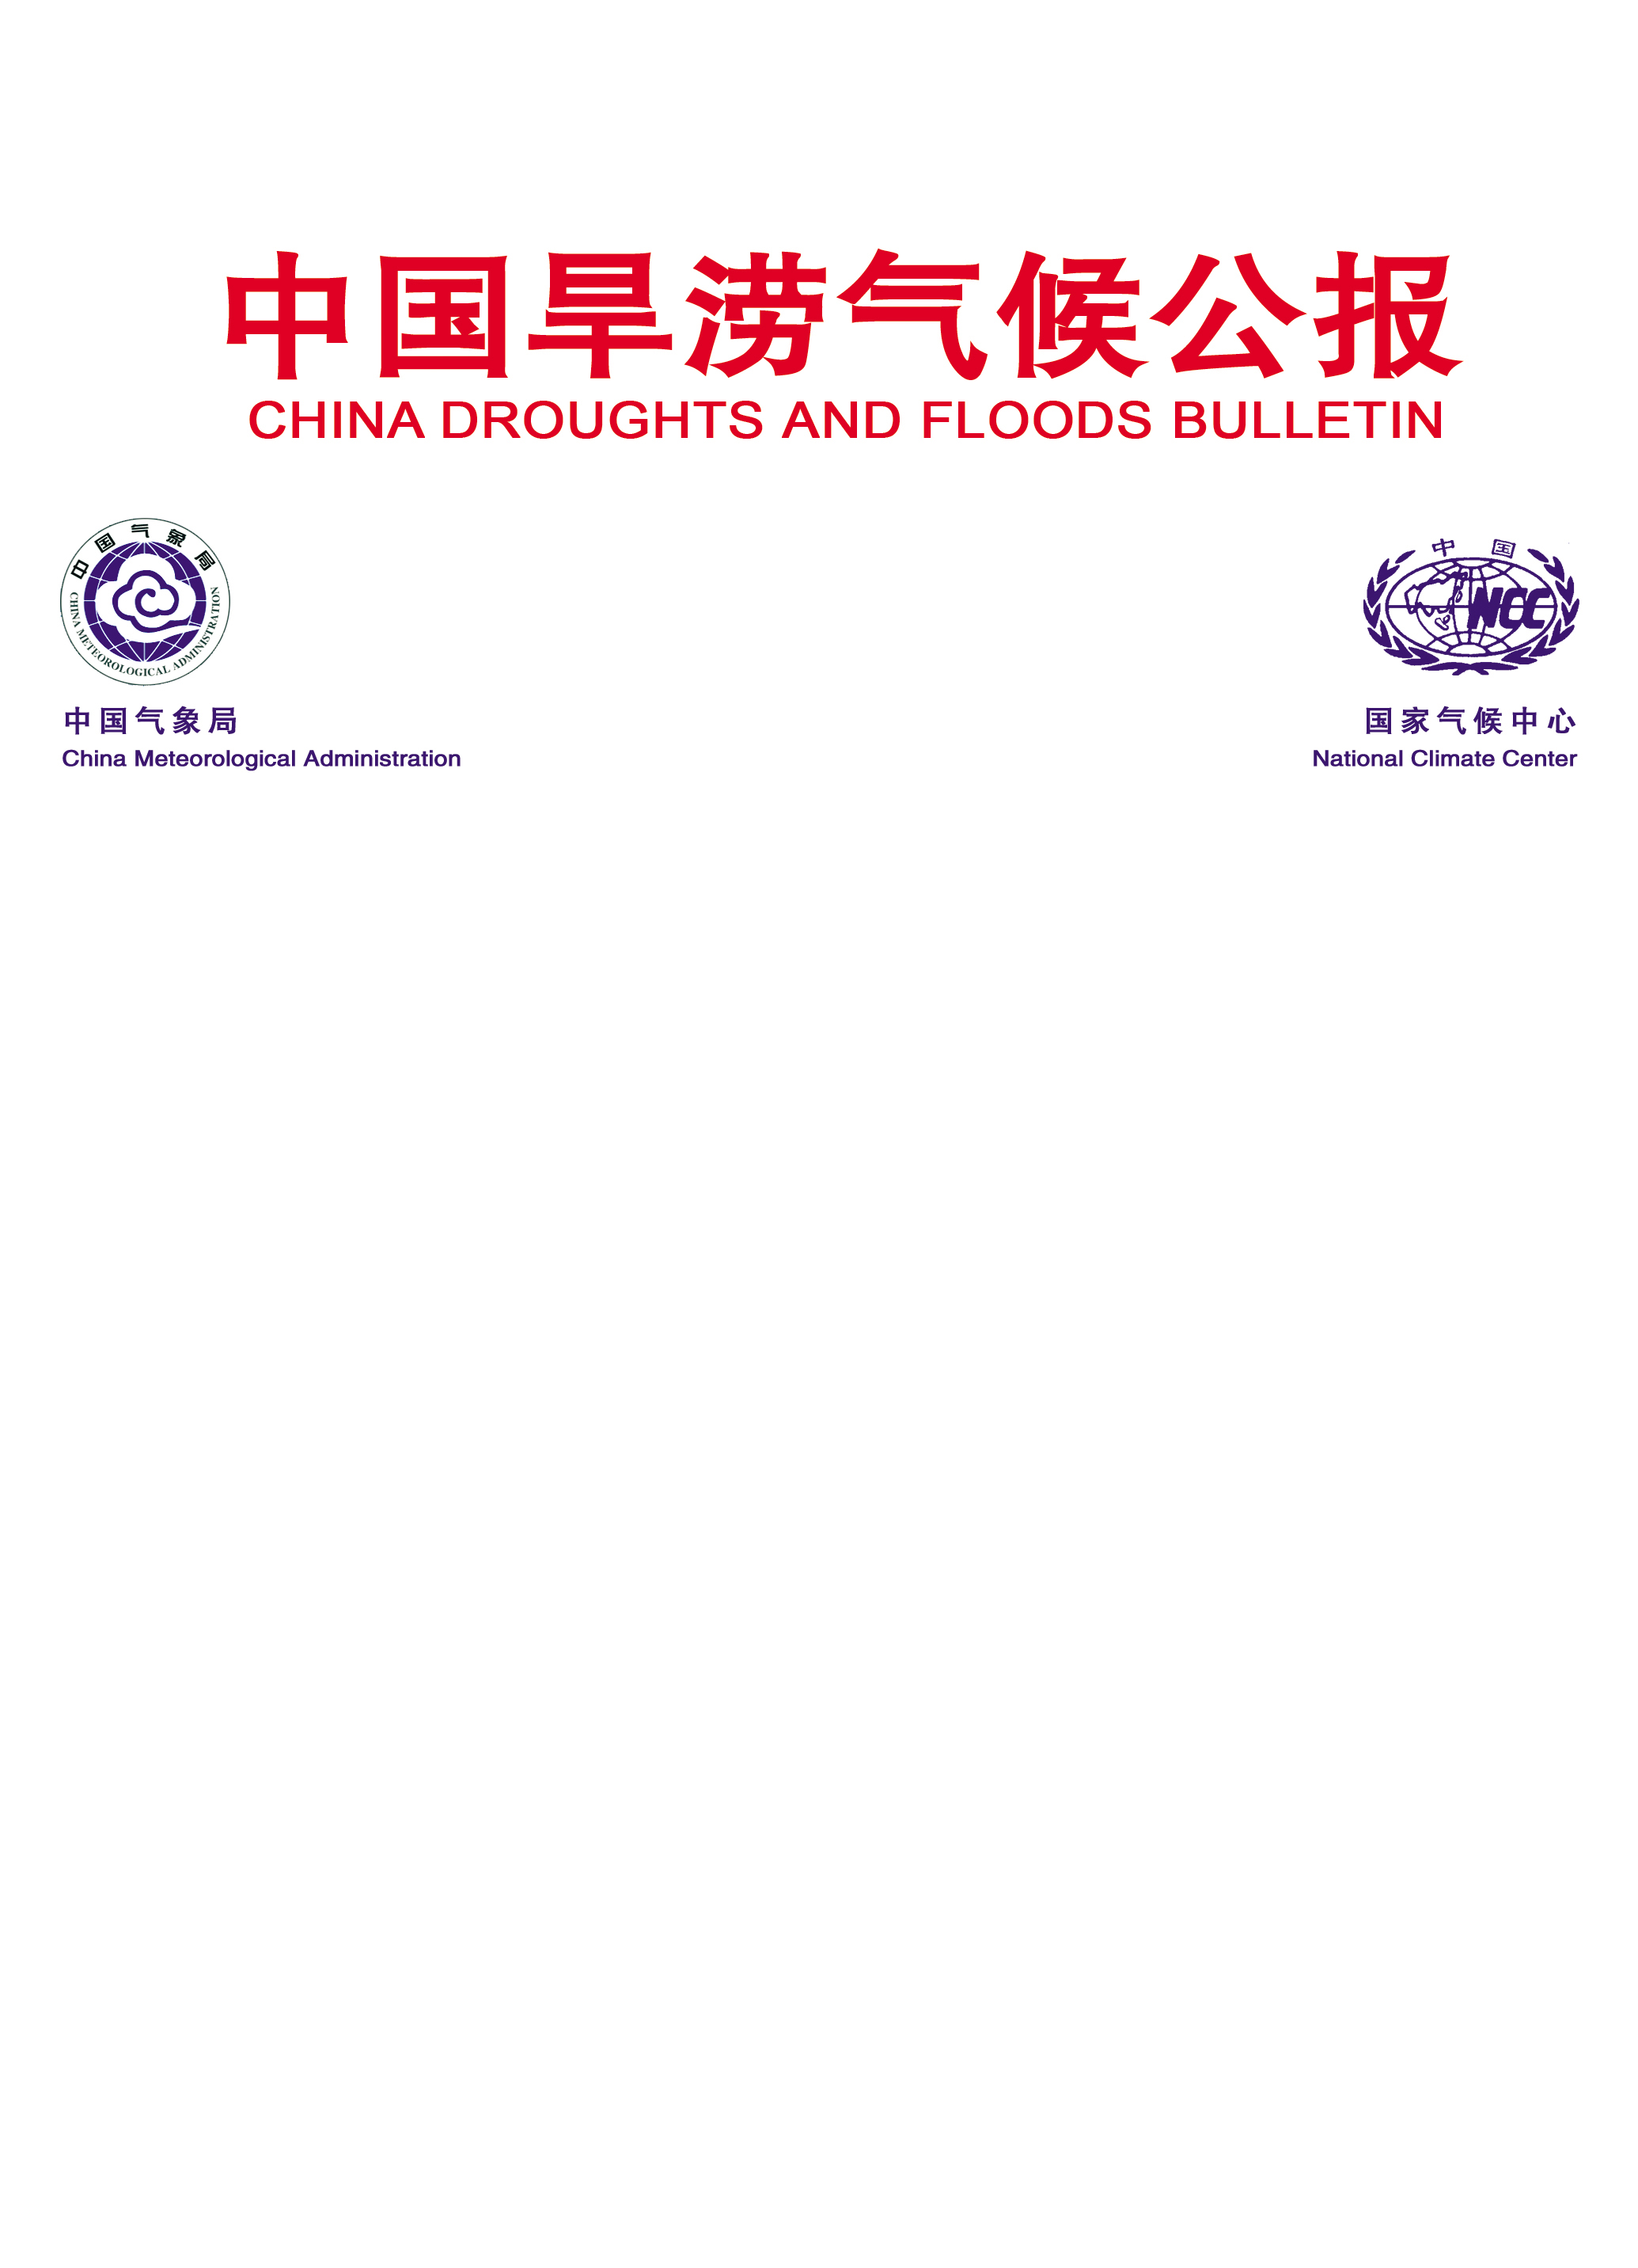
East Asian Monsoon Monitoring Bulletin

（No. 44）
December 4, 2024

The SCSSM ended in the 6th pentad of November in 2024
Abstract: The latest monitoring showed that the South China Sea Summer Monsoon (SCSSM) ended in the 6th pentad of November 2024, with twelve pentads later than normal (6th pentad of September). The intensity of the SCSSM was significantly weaker than normal. And the intensity of the East Asian subtropical summer monsoon (June- August) was also significantly weaker than normal.
The latest monitoring from the Beijing Climate Center (BCC) showed that the average zonal wind at 850hPa in the South China Sea (SCS) summer monsoon monitoring area (10º-20ºN，110º-120ºE) began to change from westerly to easterly and maintained steadily in the 1st pentad of November 2024, then the pseudo equivalent potential temperature in the monitoring area dropped to below 340 K since the 6th pentad of November (Fig.1). The cross equatorial flows in the lower troposphere (850 hPa) over Somalia was obviously weakened, and the northeasterly wind began to occupy steadily most of the SCS monitoring area (Fig. 2). So far, the two monitoring indicators have steadily reached the end criteria.
Based on features of the monsoon index and the circulation pattern, the SCSSM ended in the 6th pentad of November 2024, with twelve pentads later than normal (6th pentad of September).
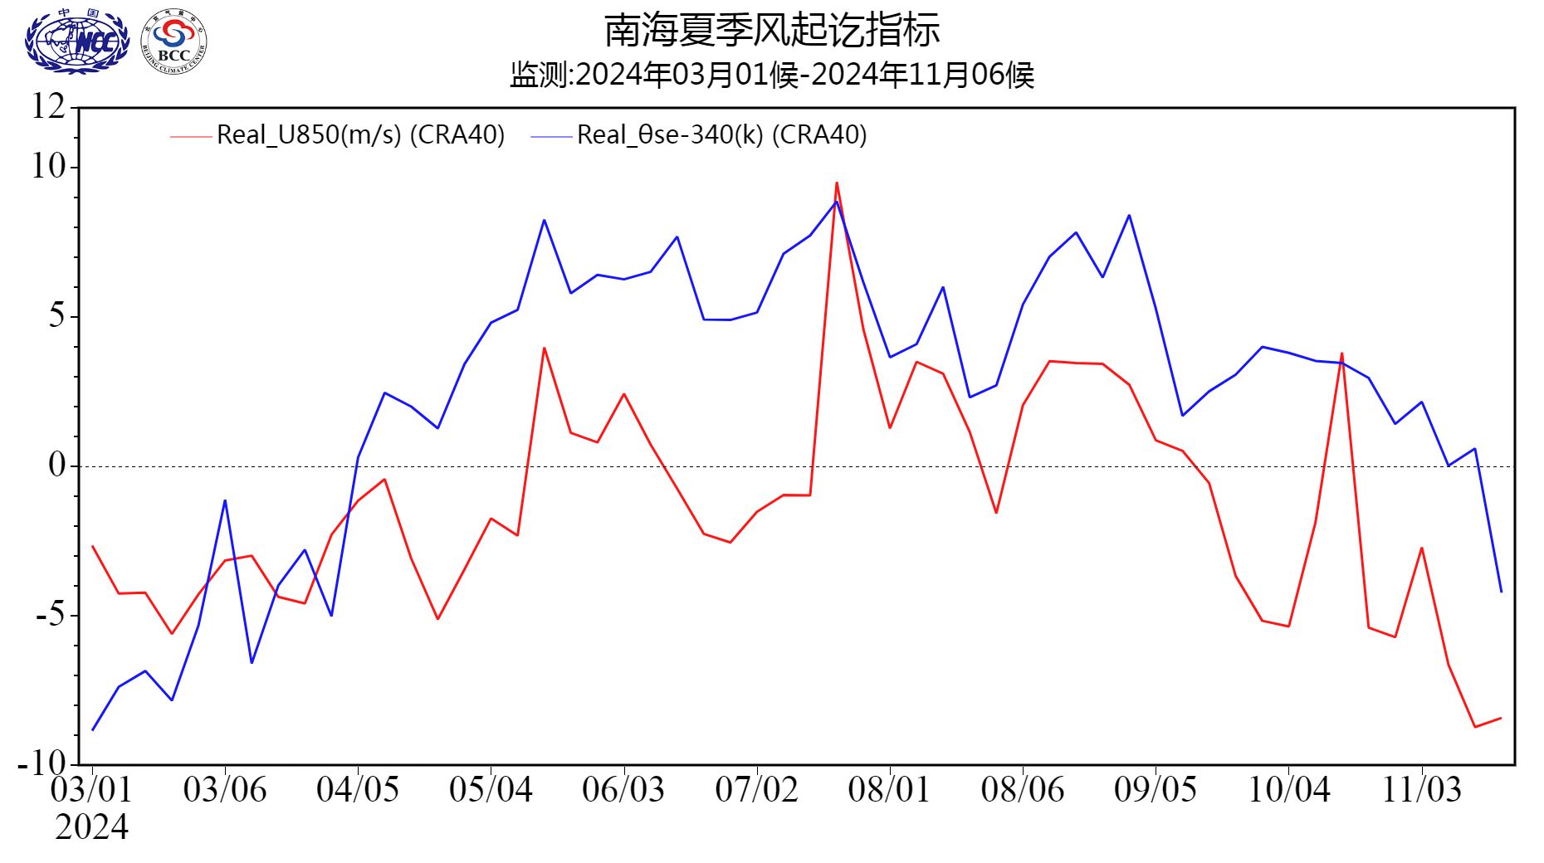
Fig.1 Pentad variations of zonal wind (unit: m/s) and pseudo-equivalent potential temperature index (unit: K) over the SCSSM monitoring region (10º-20ºN, 110º-120ºE）
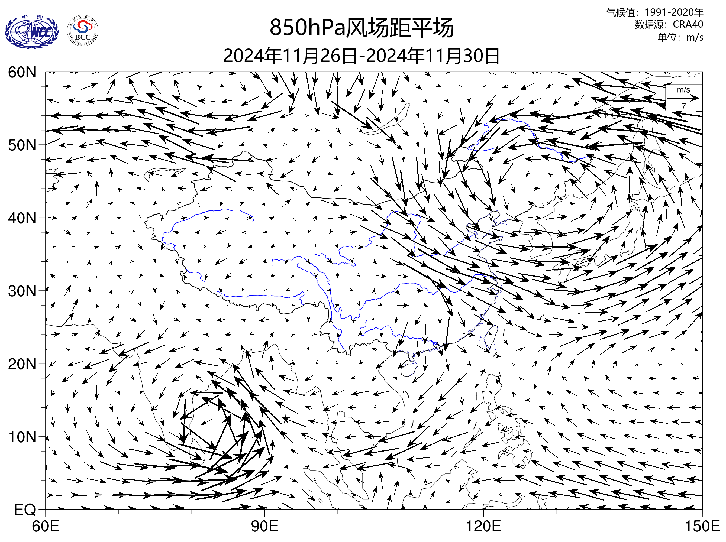
Fig.2 Pentad mean of 850 hPa wind vector in the 6th pentad of November (unit：m/s)
The SCSSM intensity was significantly weaker than normal, with the index of -1.62 in 2024 (Fig.3). The intensity index of the SCSSM was fluctuated after its onset date (the 6th pentad of May). The SCSSM activity breaked in three periods, including the 5th pentad of June to 4th pentad of July, the 1st pentad to 5th pentad of October, the 1st pentad to 6th pentad of November. The SCSSM was stronger than normal during the periods, such as the 6th pentad of May, the 3rd pentad of June, the 5th pentad to the 6th pentad of July, the 1st to the 6th pentad of September, and the 6th pentad of October, while near normal to weaker-than-normal in the rest westerly time (Fig. 4).
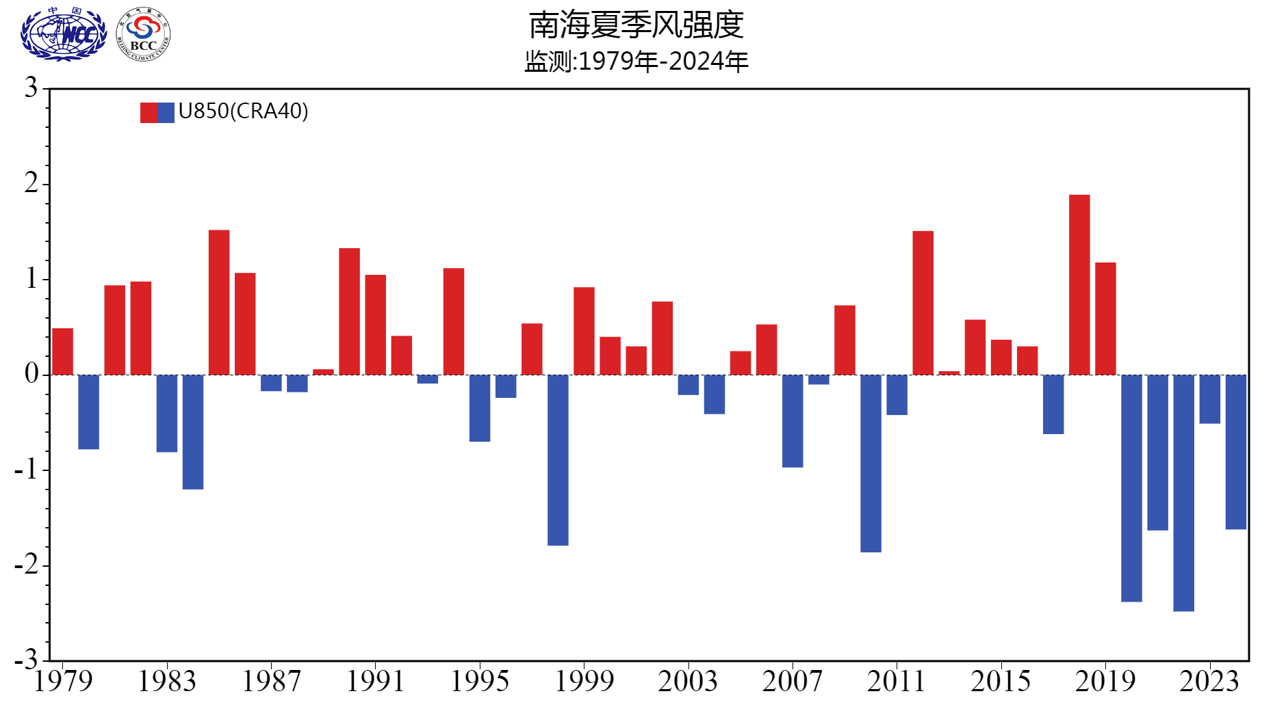
Fig.3 Variations of the SCSSM intensity from 1961 to 2024

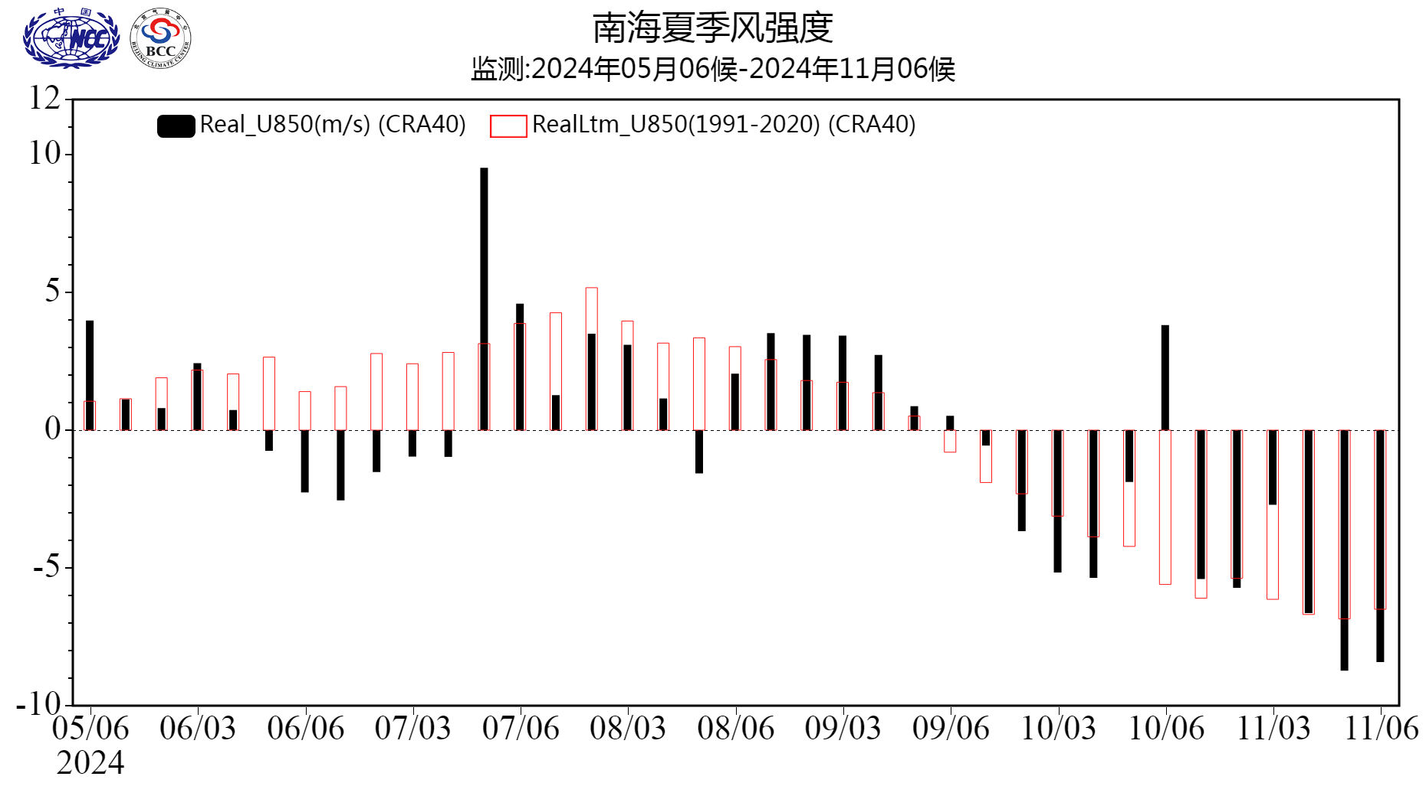
Fig.4 Pentad variations of the zonal wind index (unit: m/s) over the SCSSM monitoring region (10º-20ºN, 110º-120ºE）(Red bars for climatological normal)
After the onset of SCSSM in Late May, obvious rain belt of the East Asian summer monsoon (EASM) occurred in the Huanan region and the Jiangnan region. The Jiangnan region entered into the Meiyu period on the 10th June. The middle and lower reaches of the Yangtze River valley (YRV) entered on the 17th June and the Yangtze River-Huaihe River valley (YRHRV) followed on 19th June. The three Meiyu periods of the Jiangnan, YRV, and YRHRV regions ended on 3rd July, 15th July and 21st July, respectively (Fig.5). Scince the 1st pentad of November, the average zonal wind at 850hPa over SCCSM monitoring area had changed from westerly to easterly. In the 6th pentad of November, the pseudo equivalent potential temperature over the SCS dropped below 340K, which indicated the thermodynamical properties of the air mass over the SCS changed fundamentally. It meaned the summer monsoon withdrew from the SCS and the SCSSM ended.
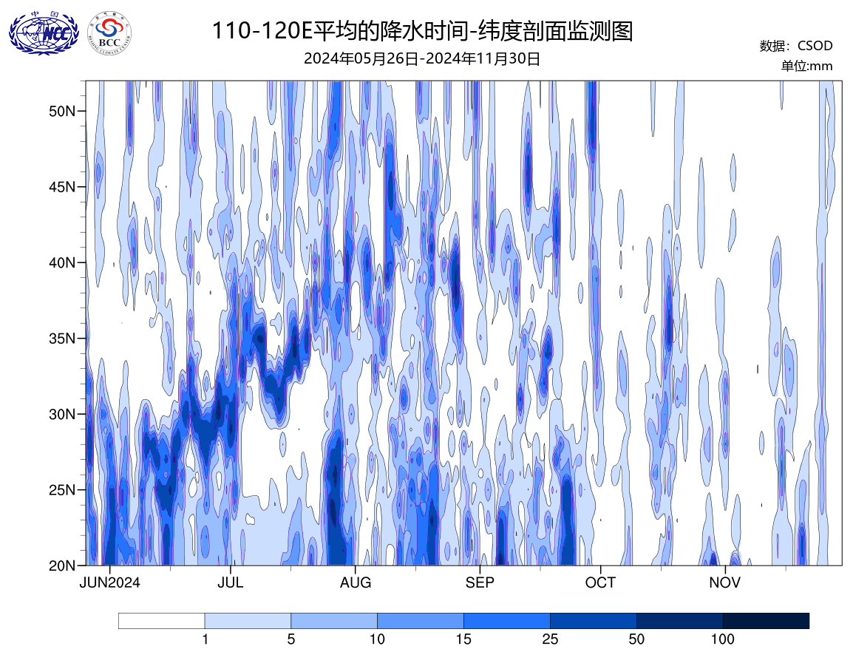
Fig.5 Time-latitude diagram of the 110-120°E Precipitation from May 26th to November 30th
During the summer (JJA) of 2024, the East Asia subtropical Summer Monsoon (EASM, Zhang Q., 2003) index was -3.9, significantly weaker than normal, and only weaker than the index in 2020 and 1998 (Fig.6). During this summer, the main rain belts occurred mainly in most of eastern China. The precipitation in the central Inner Mongolia, southern Heilongjiang, Jilin, Liaoning, Beijing, Tianjin, Hebei, Shandong, central Henan, northern Fujian, eastern Hunan, northern Guangxi and western Xinjiang were obviously more than normal, while the precipitation in the western Inner Mongolia, western Guizhou, eastern Sichuan,western Gansu, eastern and southern Xinjiang and northwestern Tibet Province were less than normal (Fig.7).
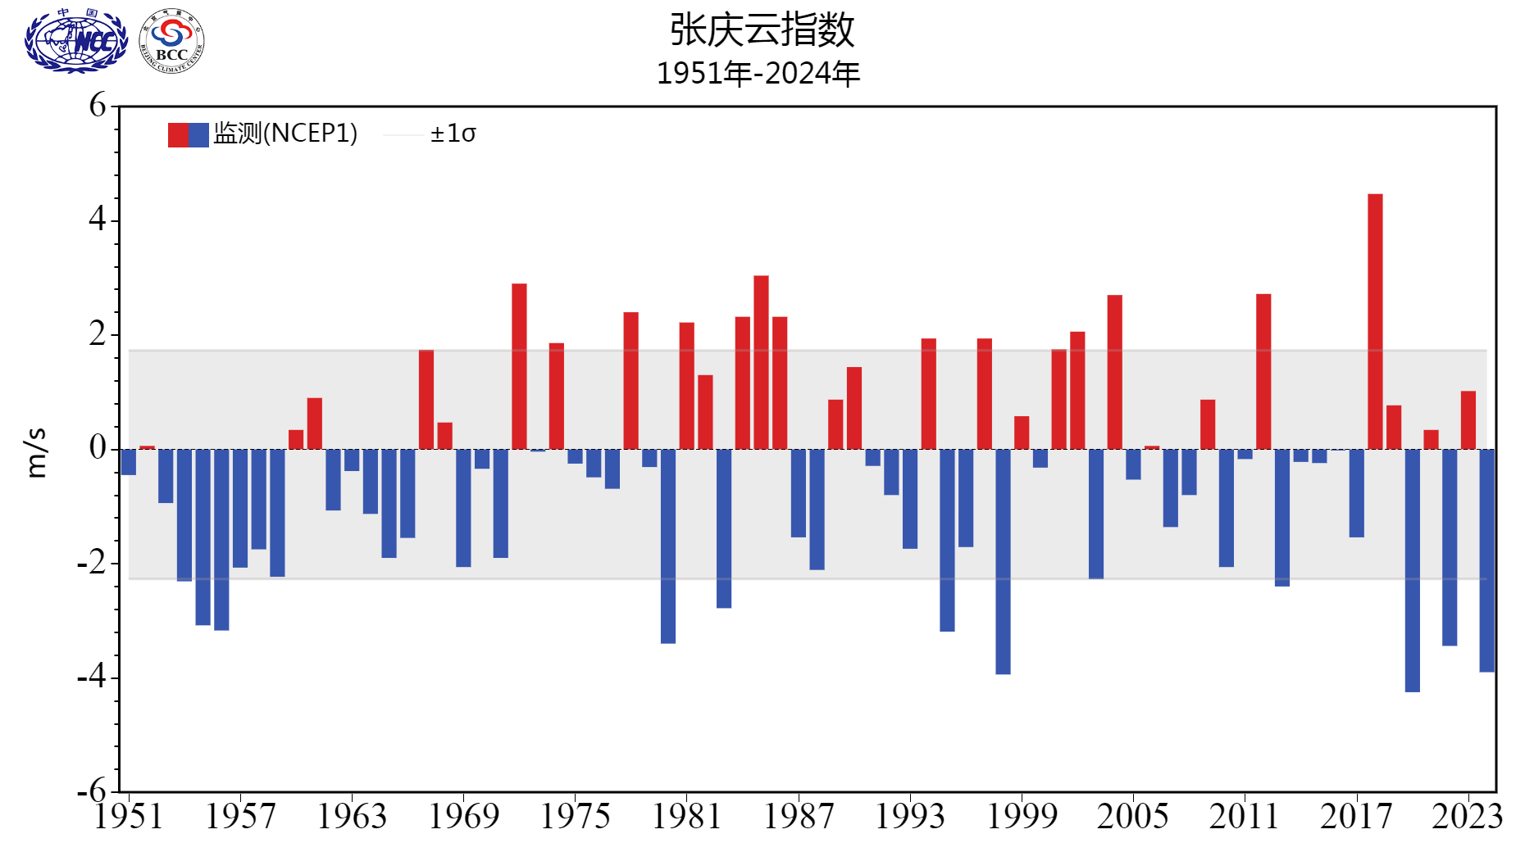
Fig.6 Variations of the EASM intensity index from 1961 to 2024(unit：m/s)

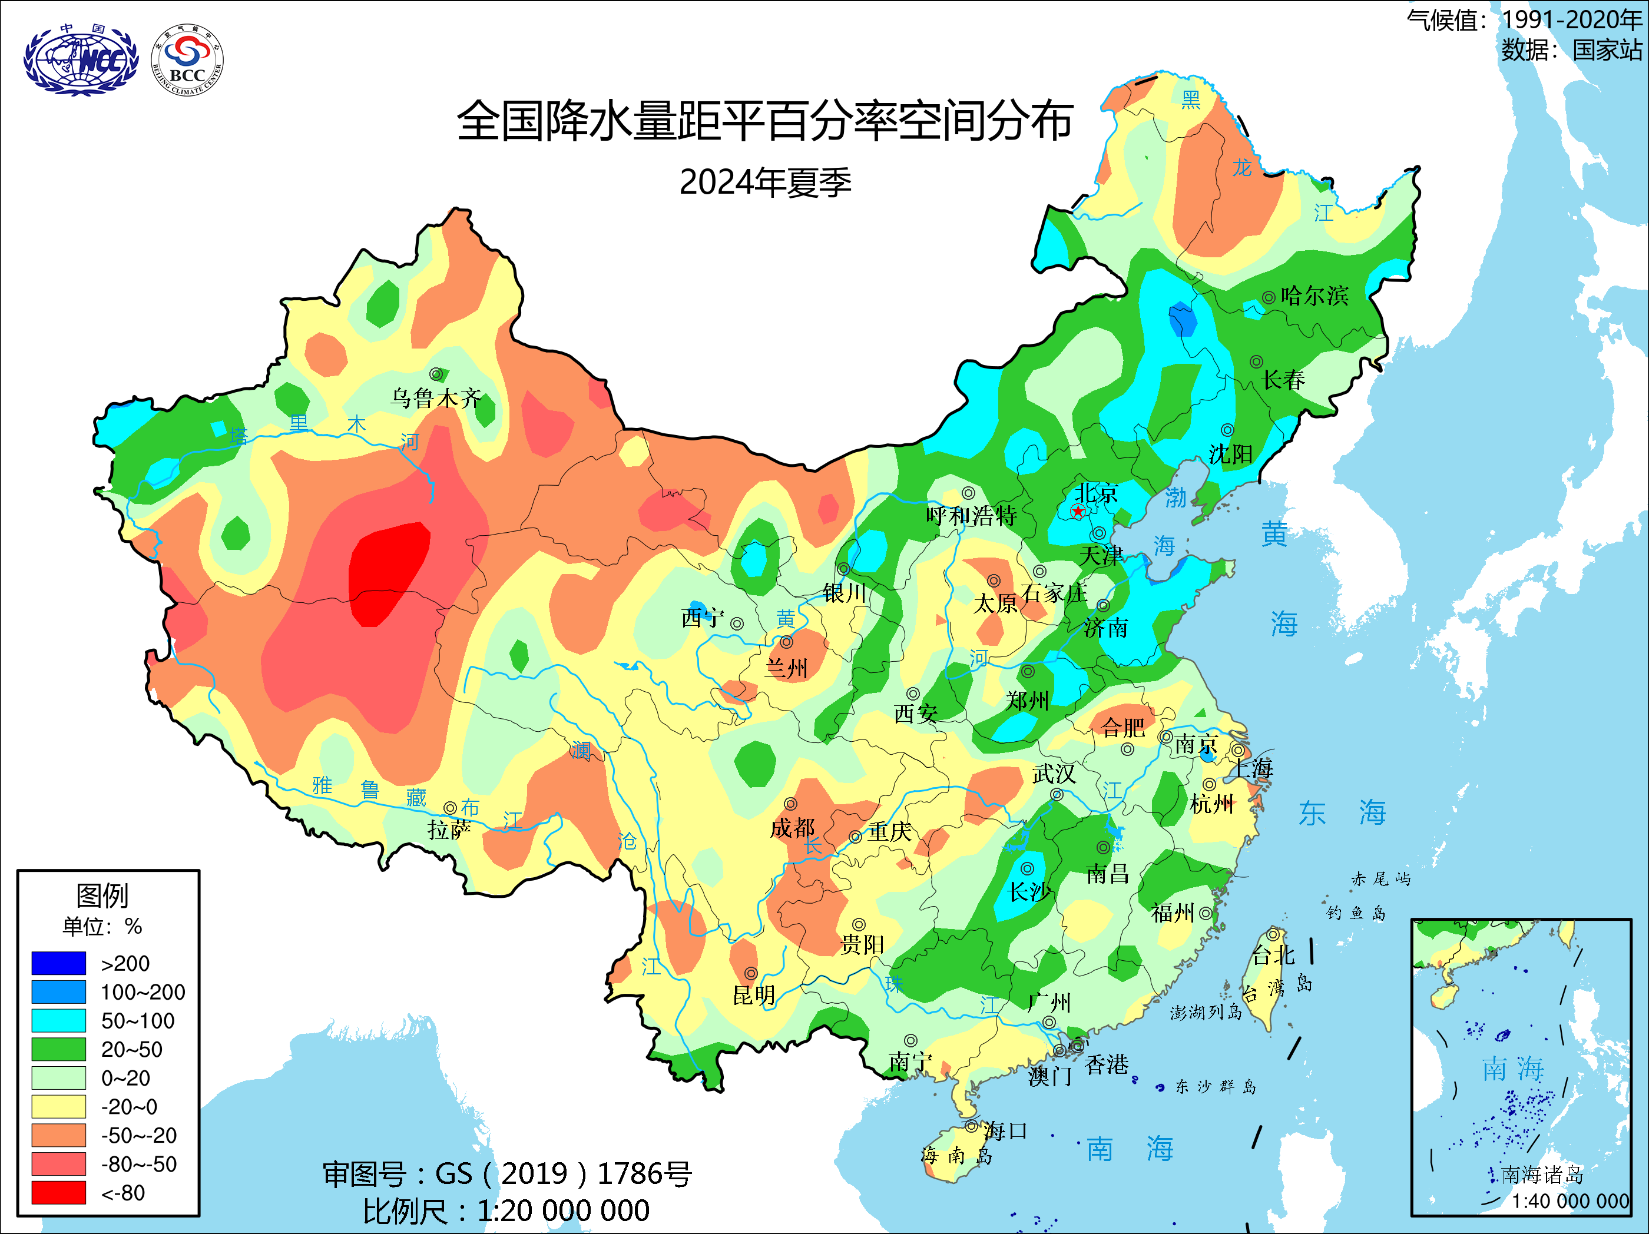
Fig.7 Distribution of precipitation anomaly percentage (unit: %) over China in the summer (JJA) of 2024

Editor: SHI Liu Chief Editor: CHEN Lijuan
BCC’s East Asian Monsoon monitoring website: http://cmdp.ncc-cma.net/Monitoring/monsoon.php

