
East Asian Monsoon Monitoring Bulletin

（No. 43）
November 21, 2023

The SCSSM ended in the 3rd pentad of November in 2023
Abstract: The latest monitoring showed that the South China Sea Summer Monsoon (SCSSM) ended in the 3rd pentad of November in 2023, with nine pentads later than normal (6th pentad of September). The intensity of the SCSSM was weaker than normal. The intensity of the East Asian subtropical summer monsoon (June- August) was songer than normal.
The latest monitoring from the Beijing Climate Center (BCC) showed that the mean zonal wind at 850hPa in the South China Sea (SCS) summer monsoon monitoring area (10º-20ºN，110º-120ºE) began to change from westerly to easterly and maintained steadily in the 3rd pentad of October, then the pseudo equivalent potential temperature in the monitoring area dropped to below 340 K since the 3rd pentad of November (Fig.1). The cross equatorial flows in the lower troposphere (850 hPa) over Somalia was obviously weakened, and the northeasterly began to occupy steadily most of the SCS monitoring area (Fig. 2). So far, the two monitoring indicators have steadily reached the end criteria.
Based on features of the monsoon index and the circulation pattern, the SCSSM ended in the 3rd pentad of November in 2023, with nine pentads later than normal (6th pentad of September).
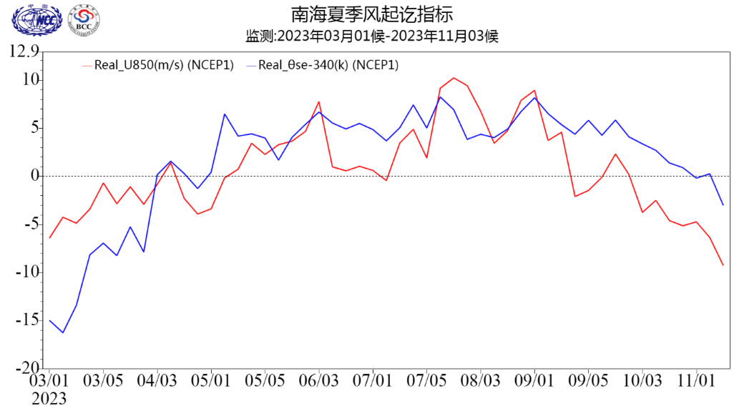
Fig.1 Pentad variations of zonal wind (unit: m/s) and pseudo-equivalent potential temperature index (unit: K) over the SCSSM monitoring region (10º-20ºN, 110º-120ºE）
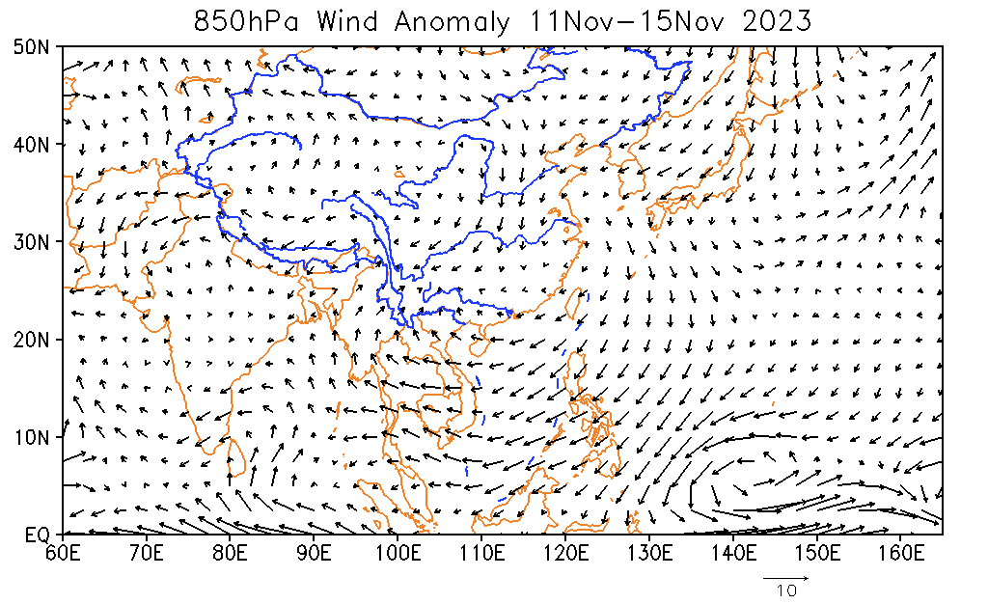
Fig.2 Pentad mean of 850 hPa wind vector in the 3rd pentad of November (unit：m/s)
The SCSSM intensity was weaker than normal, with the index of -0.50 in 2023 (Fig.3). The pentad evolution of the intensity index indicated that the SCSSM was fluctuated after its onset on the 3rd pentad of May. The SCSSM was stronger than normal during the periods of from the 3rd pentad of May to the 3rd pentad of June, and the 6th pentad of July to the 3rd pentad of September, while near normal to weaker-than-normal in the rest time (Fig. 4).
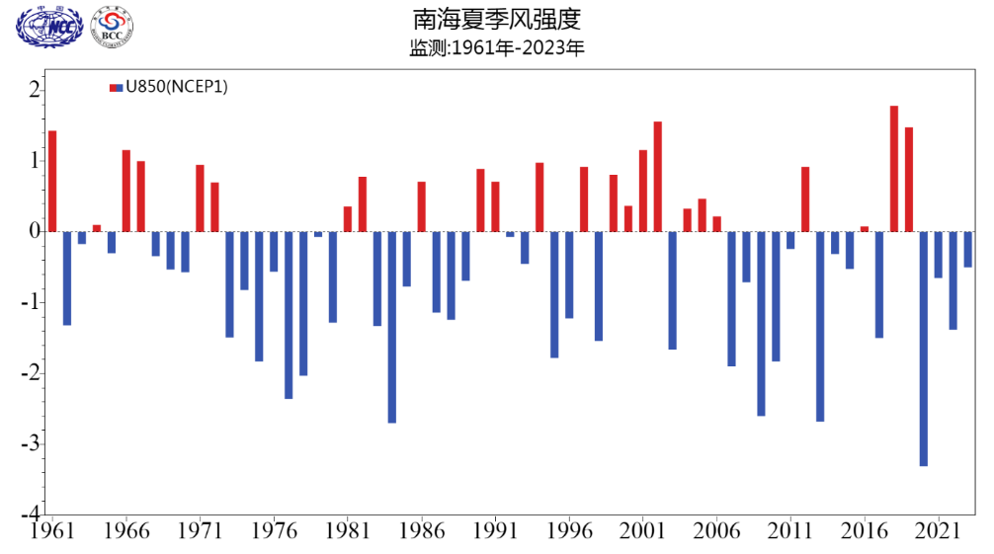
Fig.3 Variations of the SCSSM intensity from 1961 to 2023
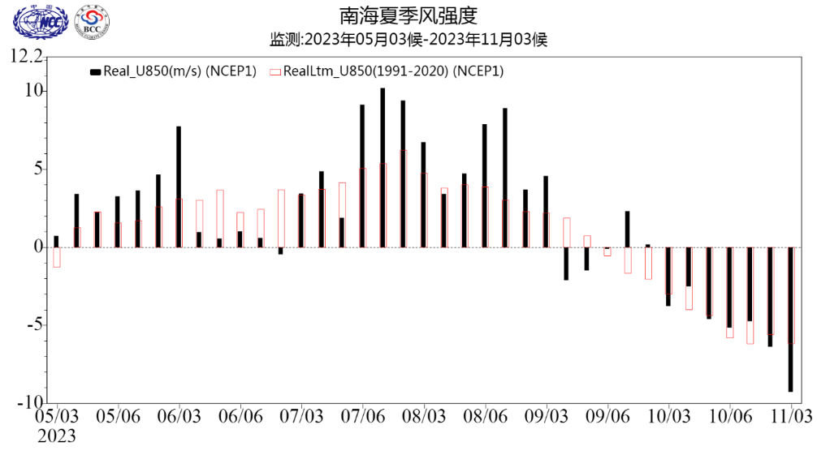
Fig.4 Pentad variations of the zonal wind index (unit: m/s) over the SCSSM monitoring region (10º-20ºN, 110º-120ºE）(Red bars for climatological normal)
After the onset of SCSSM in middle of May, obvious rain belt of the East Asian summer monsoon (EASM) occurred in the Huanan region and the Jiangnan region. The Jiangnan region and the middle and lower reaches of the Yangtze River valley (YRV) entered simultaneously into the Meiyu period on the 16th Jun. The Yangtze River-Huaihe River valley (YRHRV) followed on 25th July. The three Meiyu periods of the Jiangnan, YRV, and YRHRV regions ended on 2nd July, 24th July and 25th July, respectively (Fig.5). Scince October 3rd pentad, the mean zonal wind at 850hPa pressure level over SCCSM monitoring area had changed from westerly to easterly. In the 3rd pentad of November, the pseudo equivalent potential temperature over the SCS dropped below 340K, which indicated the thermodynamical properties of the air mass over the SCS changed fundamentally. It meaned the summer monsoon withdrew from the SCS and the SCSSM ended.
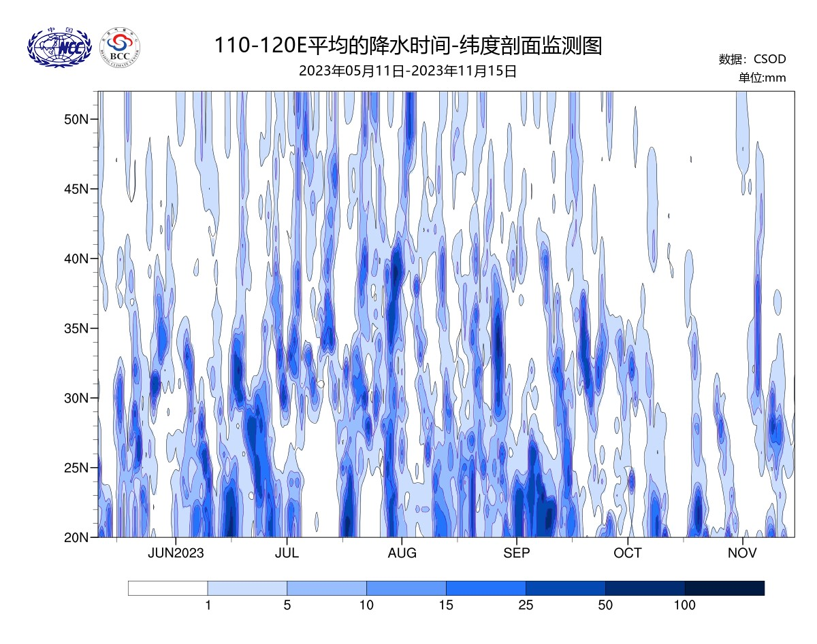
Fig.5 Time-latitude diagram of the 110-120°E Precipitation from May 11th to October 15th
During the summer (JJA) of 2023, the East Asia subtropical Summer Monsoon (EASM, Zhang Q., 2003) was stronger than normal, with the index of 1.02 (Fig.6). During this summer, the main rain belts occurred mainly in northern China. The precipitation in the northeastern Inner Mongolia, southern Heilongjiang, western Jilin, middle and southern Hebei, western Henan, southern Shannxi and southern Jiangsu province were obviously more than normal, while the precipitation in most of Xinjiang, the northern Gansu, and the western Inner Mongolia were less than normal (Fig.7).
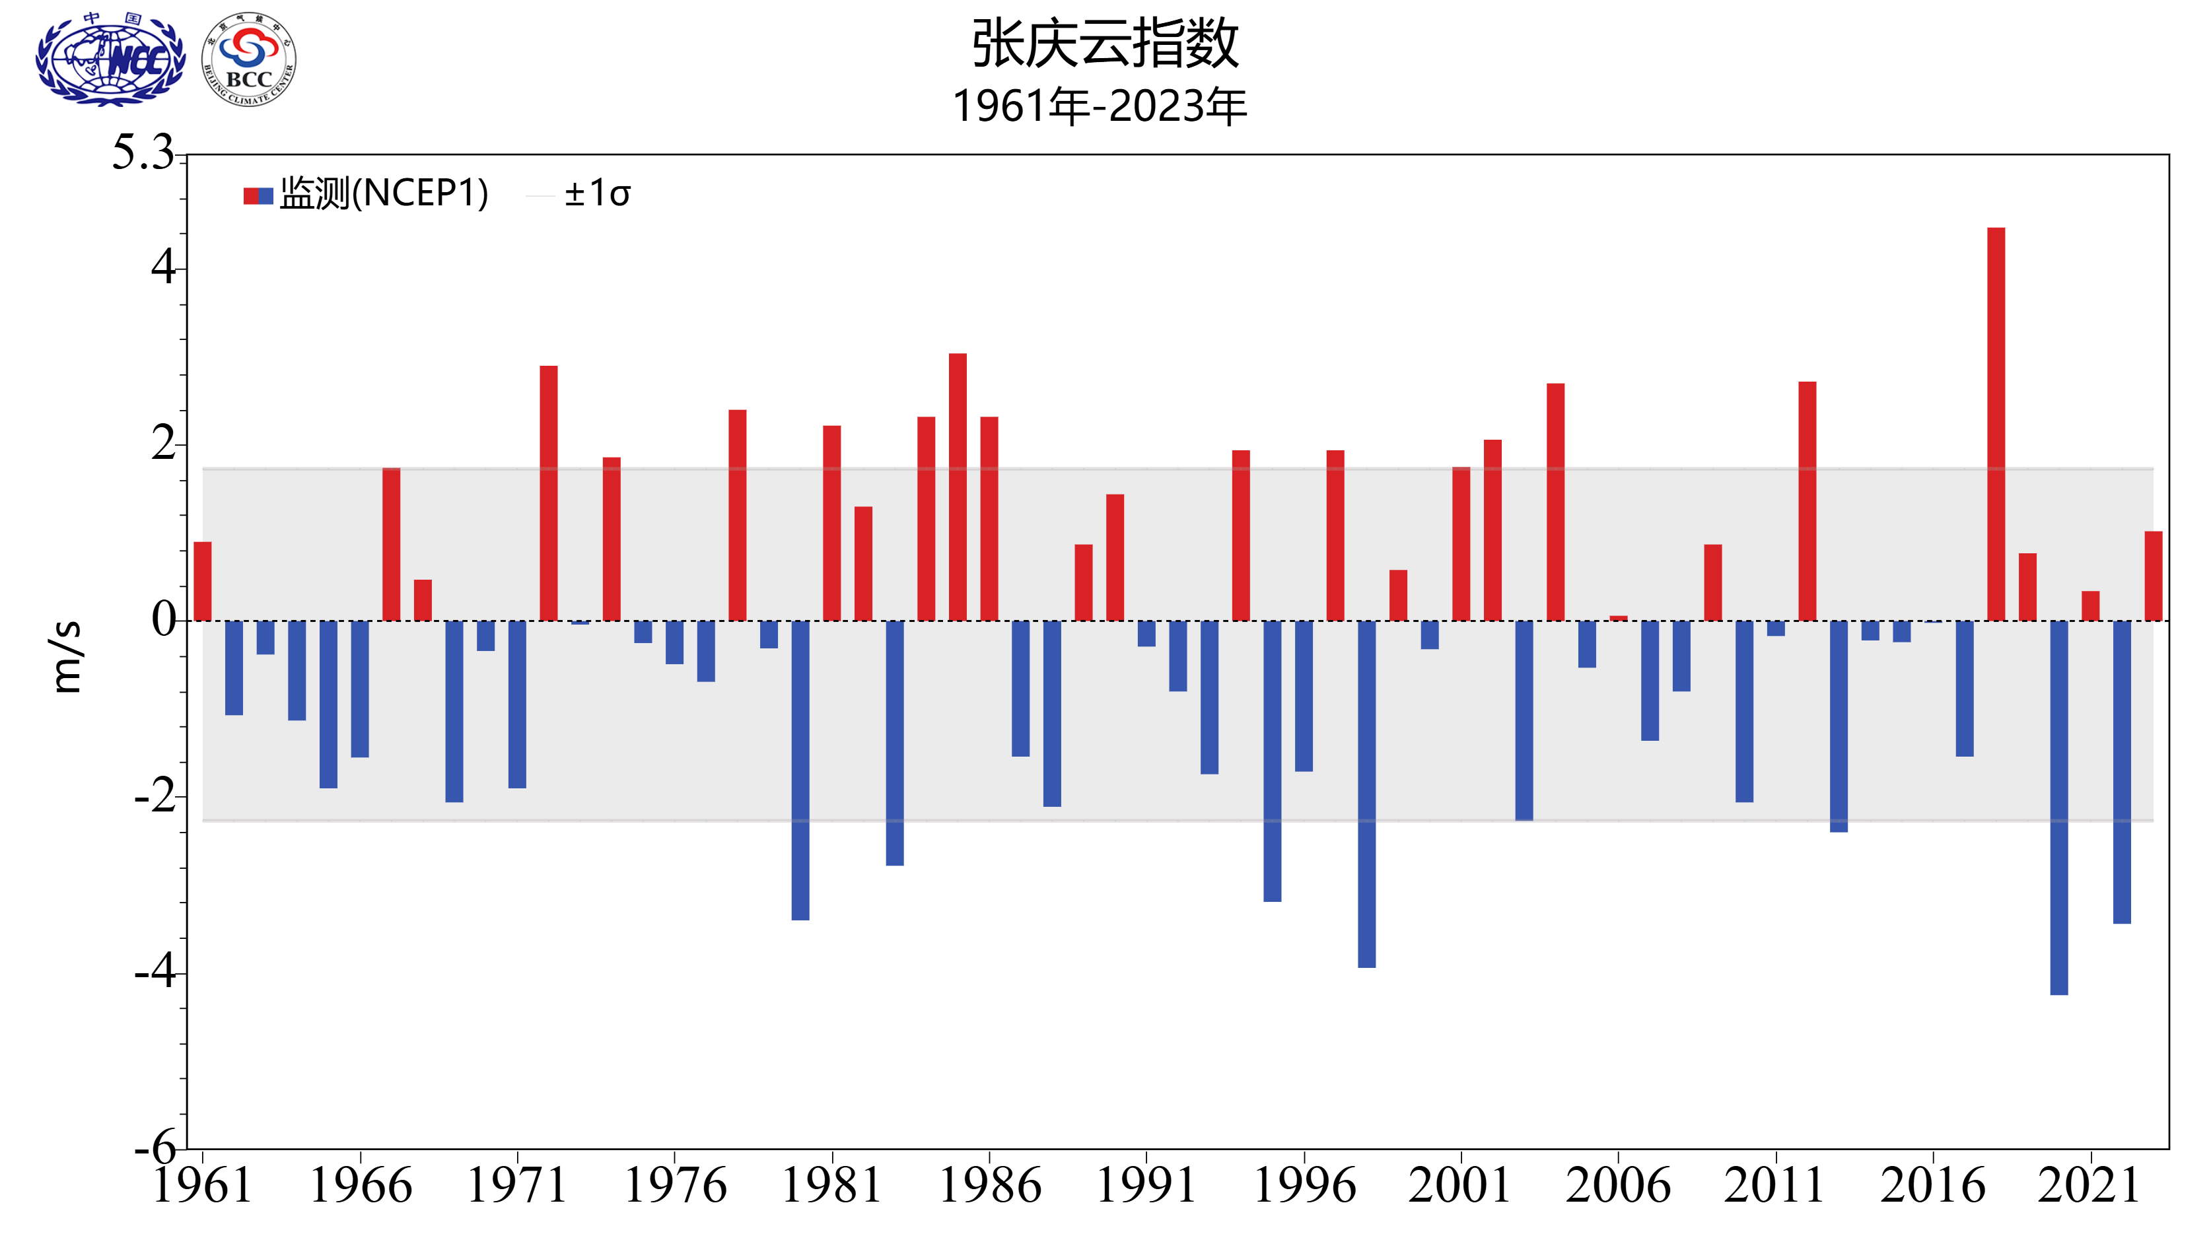
Fig.6 Variations of the EASM intensity from 1961 to 2023 (unit：m/s)
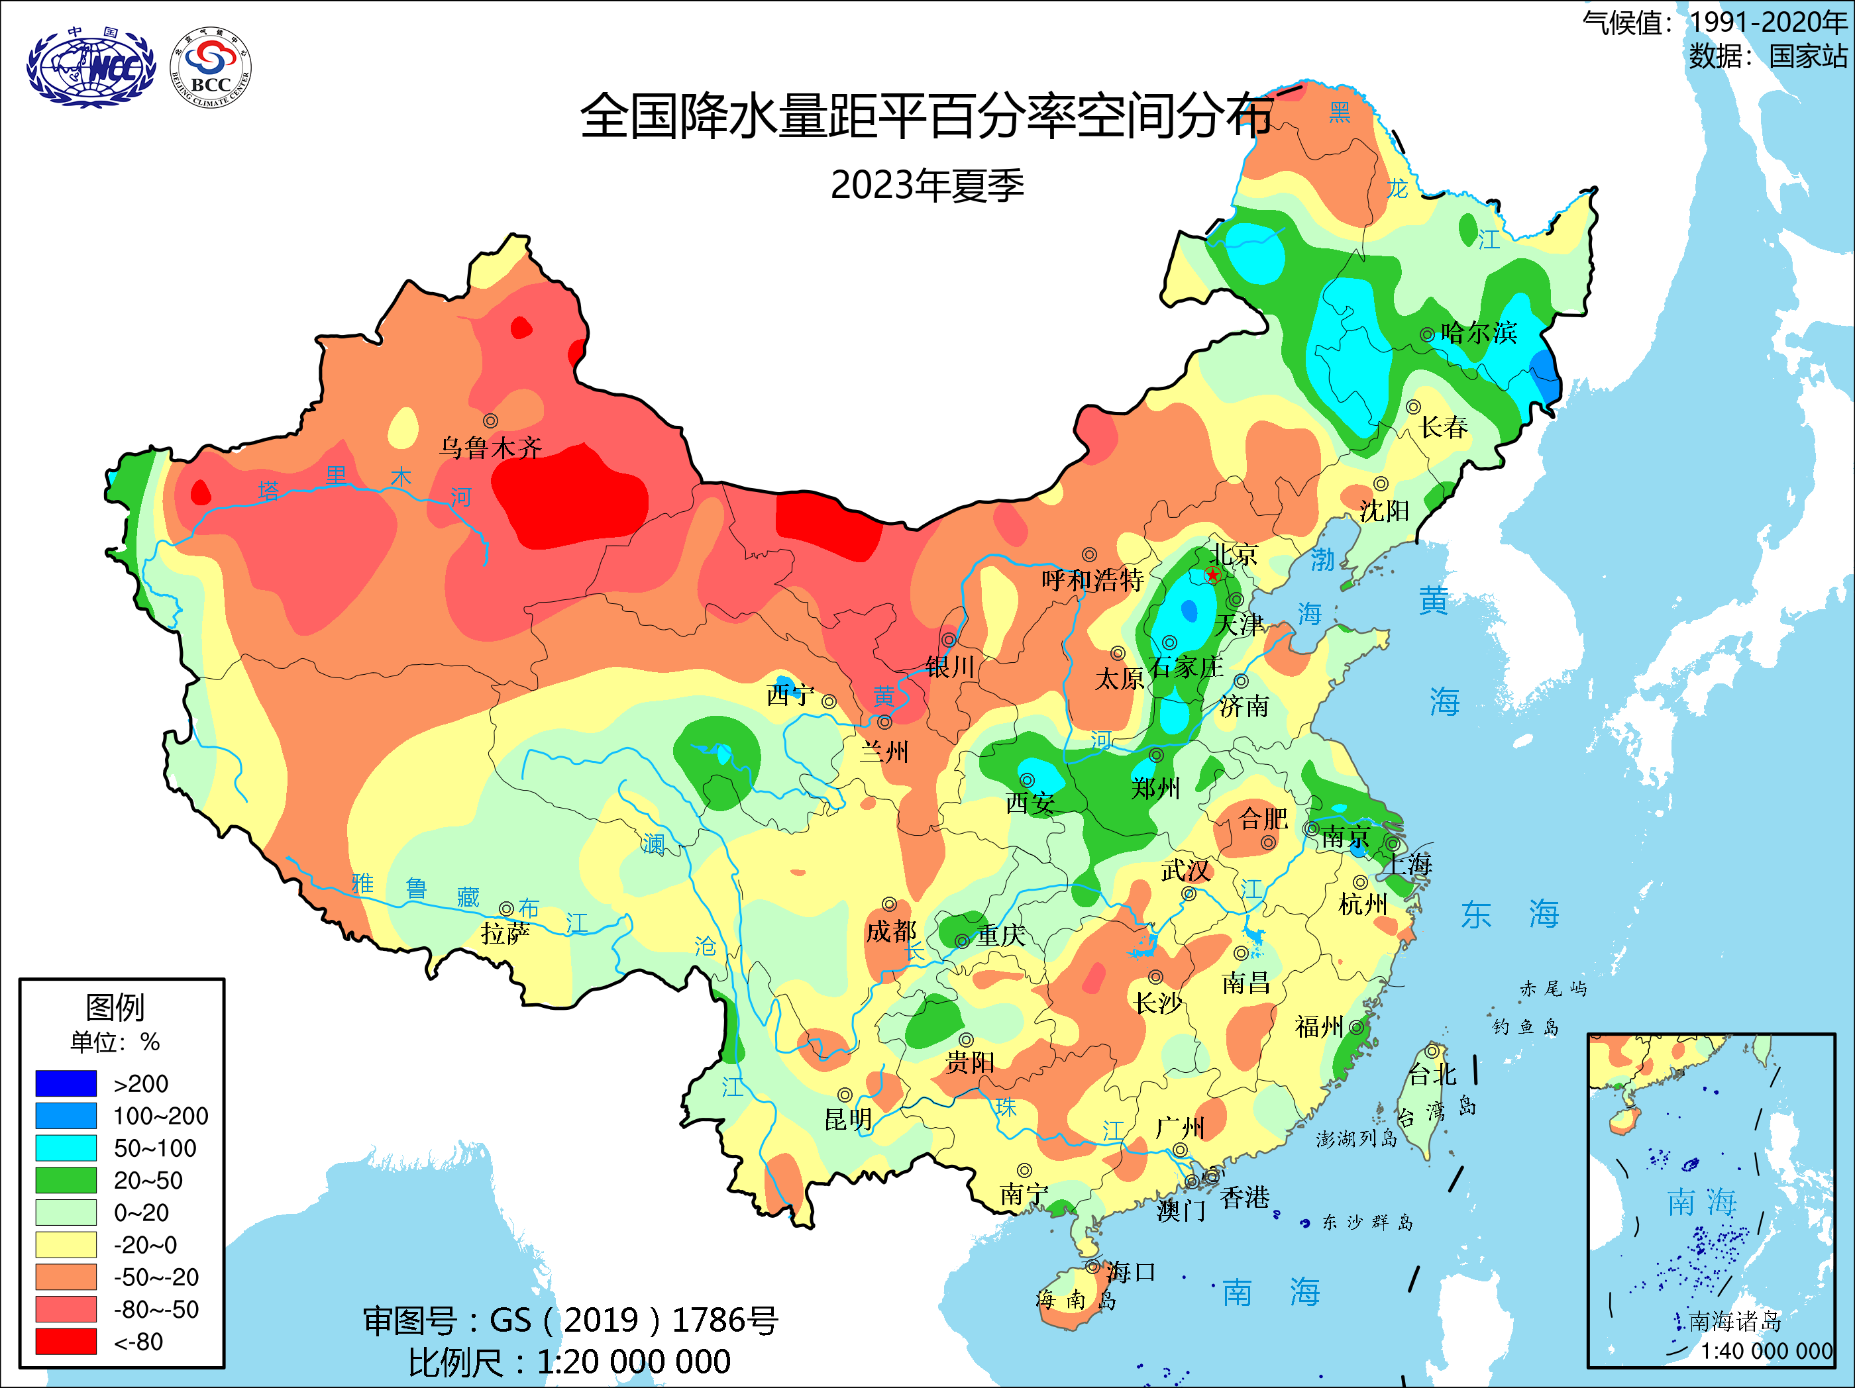
Fig.7 Distribution of precipitation anomaly percentage (unit: %) over China in the summer (JJA) of 2023

Editor: Han Rongqing Chief Editor: Gu Wei
BCC’s East Asian Monsoon monitoring website: http://cmdp.ncc-cma.net/Monitoring/monsoon.php

