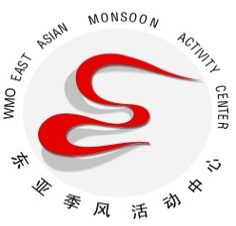
East Asian Monsoon Monitoring Bulletin
（No.40）
May27, 2022

The South China Sea summer monsoon broke out in the 3th pentad of May in 2022

Abstract: The latest monitoring shows that since the 3th pentad of May, the 850-hPa zonal wind over the monsoon monitoring area (10º-20ºN, 110º-120ºE) has changed from easterly to westerly and the mean potential pseudo-equivalent temperature over the region has also been above 340k for two pentads. It is indicated that the South China Sea (SCS) summer monsoon (SCSSM) in 2022 broke out in the 3th pentad of May.

The latest monitoring shows that both the dynamic and thermodynamic South China Sea (SCS) summer monsoon (SCSSM) monitoring indices have exceeded their thresholds for three pentads since the 3th pentad of May, namely the mean potential pseudo-equivalent temperature above 340k and the zonal wind at 850 hPa changing from easterly to westerly over the SCSSM monitoring area (10-20°N,110-120°E) (Fig.1). It is indicated that the SCSSM broke out in the 3th pentad of May, which is earlier than normal for 1 pentad.
Since the 3th pentad of May, the southwest winds blew from the tropical Indian Ocean to the South China Sea (Fig.2). The water vapor transportation originating from the tropical Indian Ocean also propagated eastward to the Indo-China Peninsula and the SCS (Fig.3).
Generally, accompanying with the onset of summer monsoon over the SCS, the warm and wet southwesterly flow in low-latitude would strengthen and the rain belt over the South China Sea would shift northward. We will closely monitor the development of the East Asian summer monsoon and update the monsoon wrap-up in time.

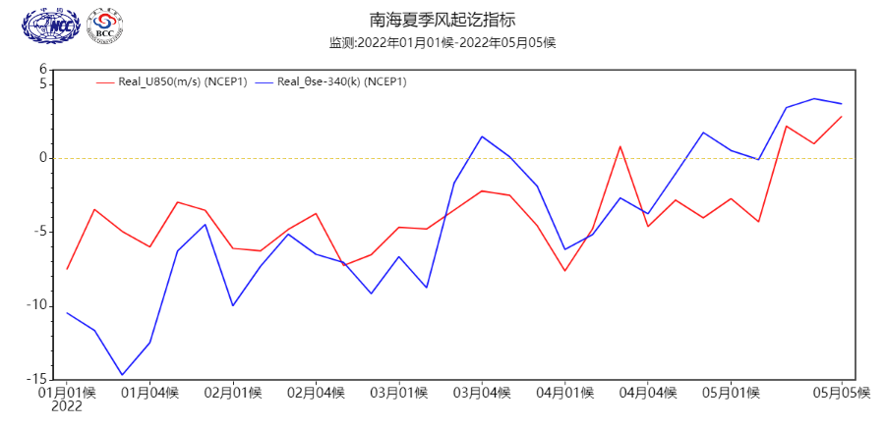
Fig.1 Pentad mean zonal wind (red line, unit: m/s) and potential pseudo-equivalent temperature index (blue line, unit: K) over the monitoring region (10º-20ºN，110º-120ºE)

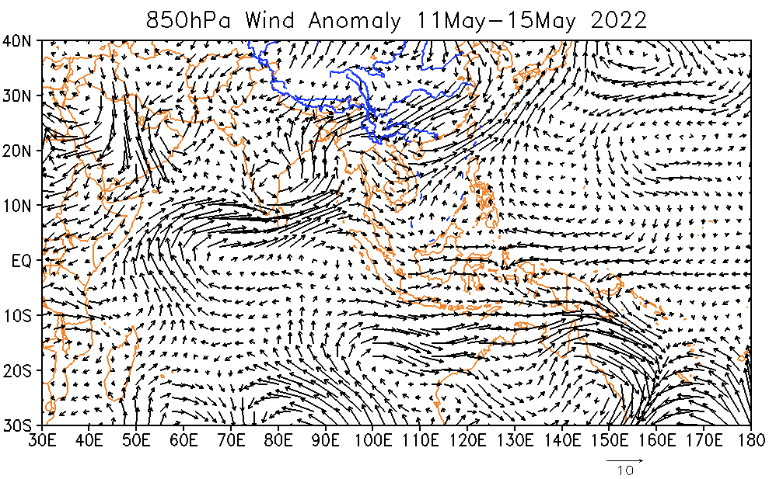
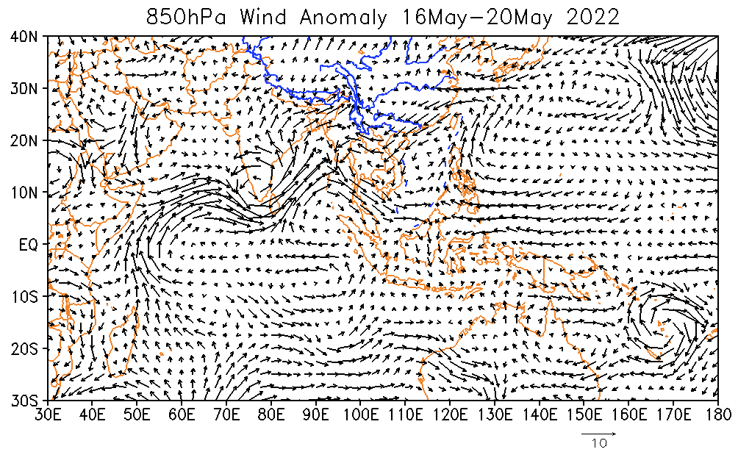
Fig.2 Pentad mean wind at 850hPa (unit: m/s) for the 3th pentad (top) and the 4th pentad (bottom) of May in 2022

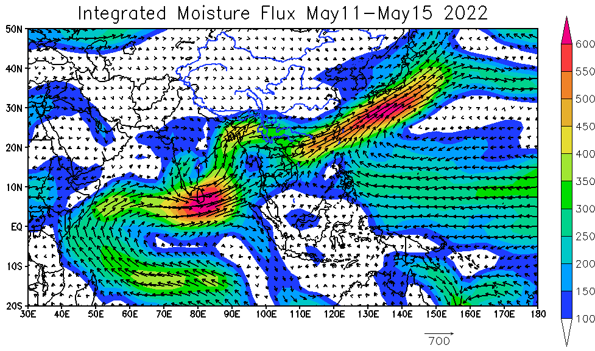
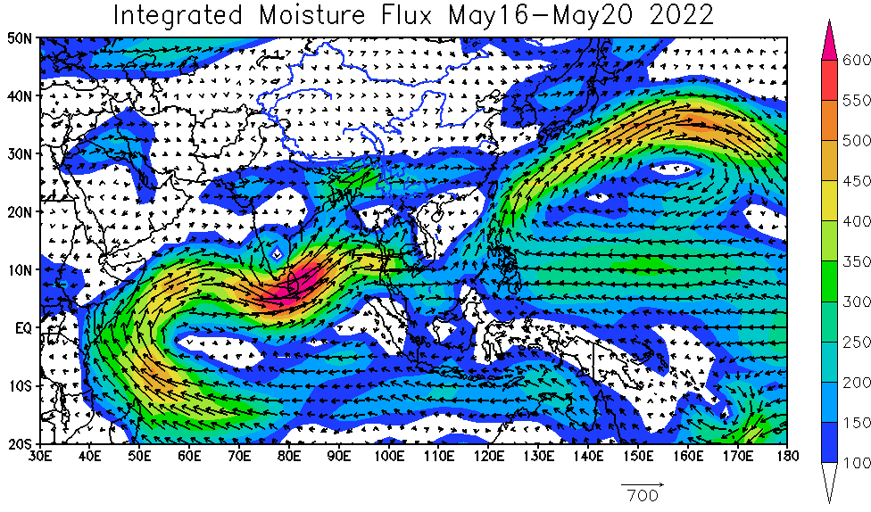
Fig.3 Pentad mean vertically integrated moisture flux(unit: kg/s•m) for the 3th pentad (top) and the 4th pentad (bottom) of May in 2022

Editor: Lv Zhuozhuo Chief Editor: Zhao Junhu
BCC’s East Asian Monsoon monitoring website: http://bcc.cma.gov.cn/EAMAC/

