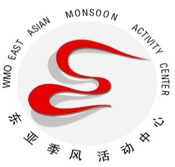
East Asian Monsoon Monitoring Bulletin
（No.38）
Jun16, 2021

The South China Sea summer monsoon broke out in the 6th pentad of May in 2021

Abstract: The latest monitoring shows that since the 6th pentad of May, the 850-hPa zonal wind over the monsoon monitoring area (10º-20ºN, 110º-120ºE) has changed from easterly to westerly and the mean potential pseudo-equivalent temperature over the region has also been above 340k for two pentads. It is indicated that the South China Sea (SCS) summer monsoon (SCSSM) in 2021 broke out in the 6th pentad of May.

The latest monitoring shows that both the dynamic and thermodynamic South China Sea (SCS) summer monsoon (SCSSM) monitoring indices have exceeded their thresholds for three pentads since the 6th pentad of May, namely the mean potential pseudo-equivalent temperature above 340k and the zonal wind at 850 hPa changing from easterly to westerly over the SCSSM monitoring area (10-20°N,110-120°E) (Fig.1). It is indicated that the SCSSM broke out in the 6th pentad of May, which is later than normal for 1 pentad.
Since the 6th pentad of May, the southwest winds blew from the tropical Indian Ocean to the South China Sea (Fig.2). The water vapor transportation originating from the tropical Indian Ocean also propagated eastward to the Indo-China Peninsula and the SCS (Fig.3).
Generally, accompanying with the onset of summer monsoon over the SCS, the warm and wet southwesterly flow in low-latitude would strengthen and the rain belt over the South China Sea would shift northward. We will closely monitor the development of the East Asian summer monsoon and update the monsoon wrap-up in time.

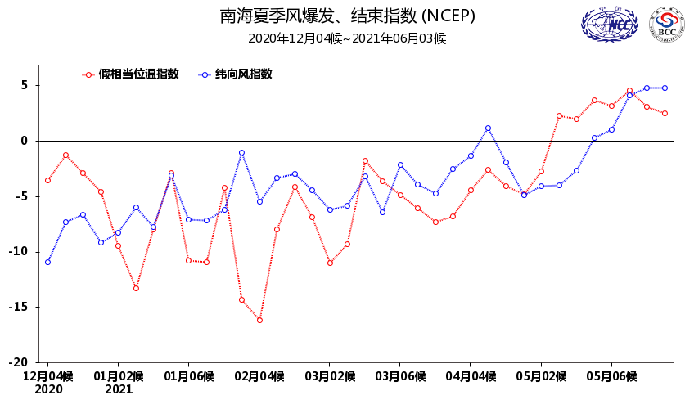
Fig.1 Pentad mean zonal wind (blue line, unit: m/s) and potential pseudo-equivalent temperature index (red line, unit: K) over the monitoring region (10º-20ºN，110º-120ºE)

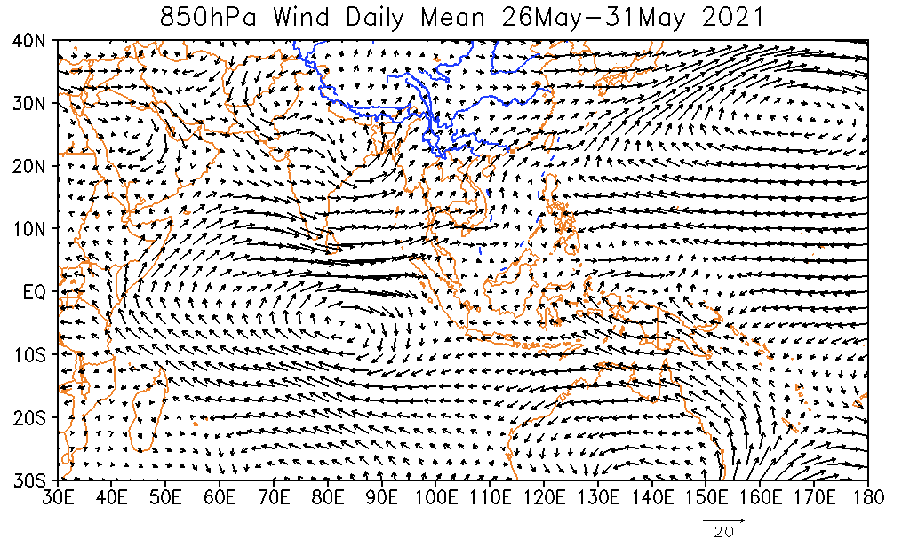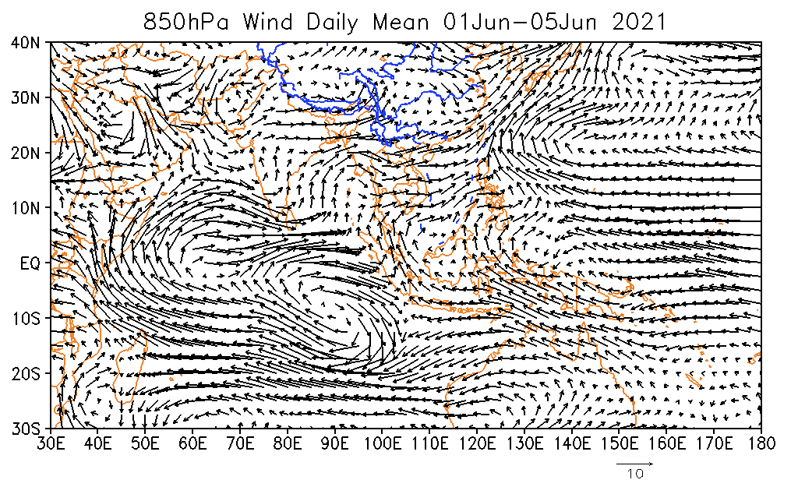
Fig.2 Pentad mean wind at 850hPa (unit: m/s) for the 6th pentad (top) of May and 1th pentad (bottom) of June in 2021

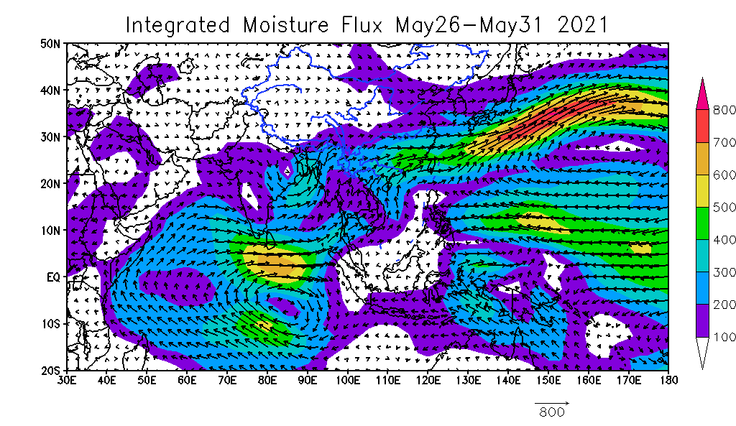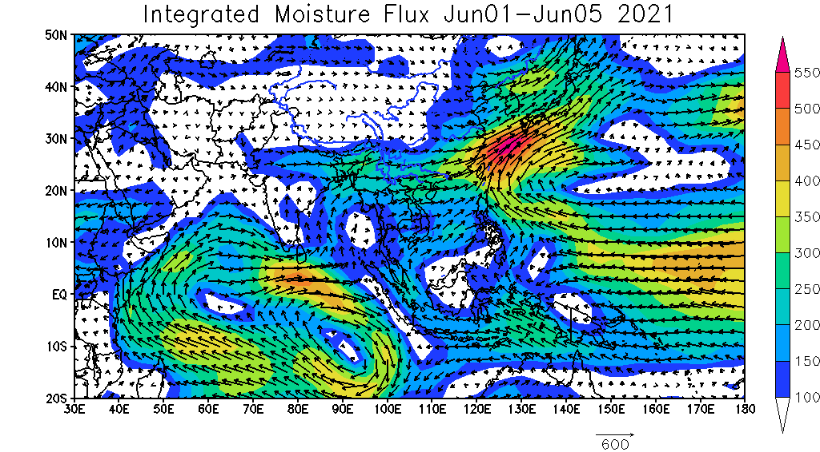
Fig.3 Pentad mean vertically integrated moisture flux(unit: kg/s•m) for the 6th pentad (top) of May and 1th pentad (bottom) of June in 2021

Editor: Guo Zengyuan Chief Editor: Zheng Zhihai
BCC’s East Asian Monsoon monitoring website: http://bcc.cma.gov.cn/EAMAC/

