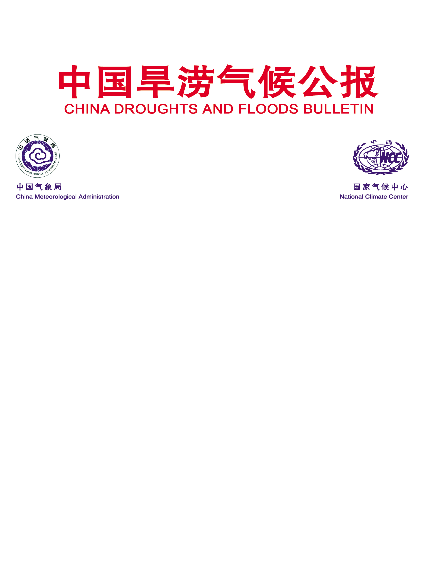
East Asian Monsoon Monitoring Bulletin

（No. 35）
October 31, 2019

The SCSSM ended in the 5th pentad of September in 2019
Abstract: The latest monitoring showed that the South China Sea Summer Monsoon (SCSSM) ended in the 5th pentad of September in 2019, with one pentad earlier than normal (6th pentad of September). The intensity of the SCSSM was stronger than normal. Meanwhile, the intensity of the East Asian subtropical summer monsoon (June- August) was also much stronger than normal.

The latest monitoring in the Beijing Climate Center (BCC) showed that during the 5th pentad of September, the pseudo-equivalent potential temperature (θ_{se}) over the monitoring region for SCSSM dropped to below the threshold of 340°K (Fig.1), and the southwesterly wind at 850 hPa changed into northeasterly wind (Fig.2a). During the 6th pentad of September, at the lower troposphere (850hPa), the southwest monsoon flow from Somali remarkably weakened and withdrew from SCS, and the northeasterly wind began to constantly dominate over SCS (Fig.2b).
Based on features of the monsoon index and the circulation pattern, the SCSSM ended in the 5th pentad of September in 2019, with one pentad earlier than normal (6th pentad of September).
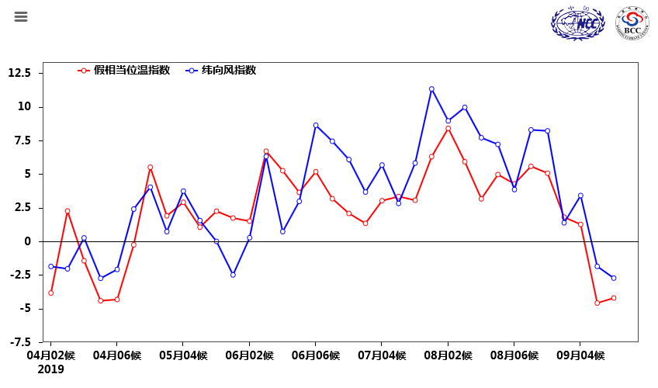
Fig.1 Pentad variations of zonal wind (unit: m/s) and pseudo-equivalent potential temperature (unit: K) over the monitoring region (10º-20ºN, 110º-120ºE）
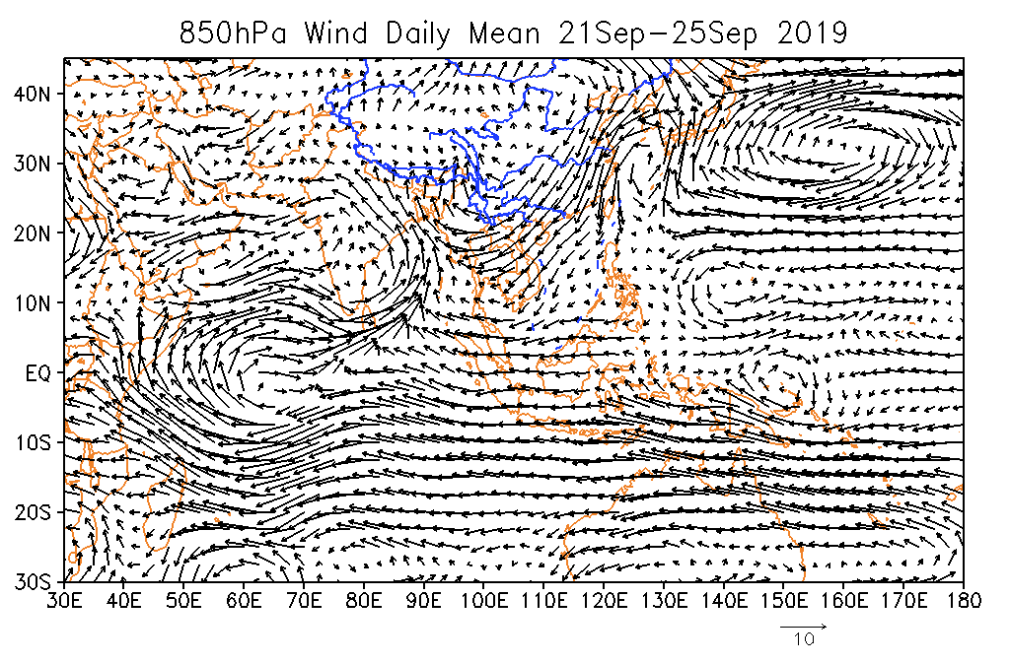
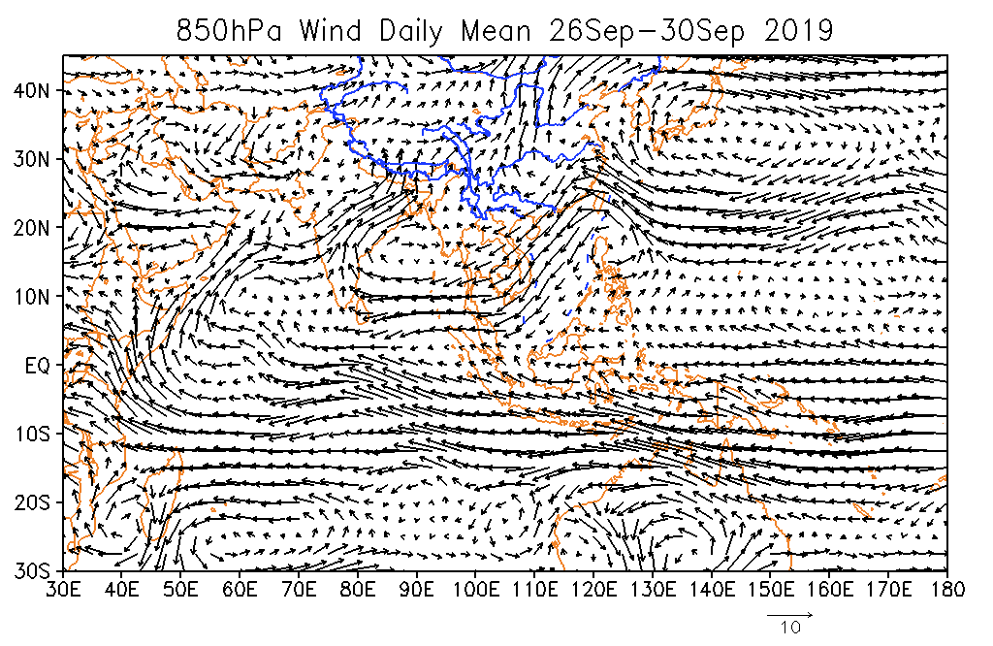
Fig.2 Pentad mean of 850 hPa wind vector in the 5th pentad (a, top) and 6th pentad (b, bottom) of September (unit：m/s)

The SCSSM intensity index was 1.43 in 2019, revealing that the SCSSM was stronger than normal (Fig. 3). The pentad evolution of the intensity index indicated that the SCSSM was fluctuated since its beginning and presented weak intensity in the phase of 5th ,6th pentad of May, 1th ,2th ,4th and 5th of June, 5th pentad of July, 6nd pentad of August, 3th pentad of September, but normal to strong intensity in other phases (Fig. 4).
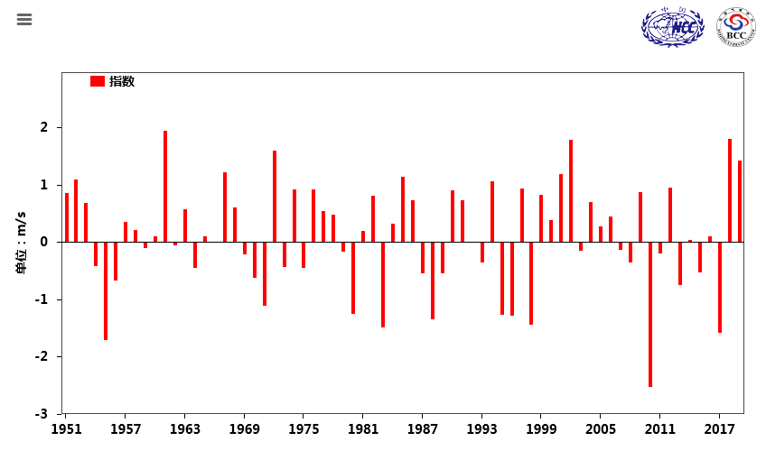
Fig.3 Variations of the SCSSM intensity from 1951 to 2019

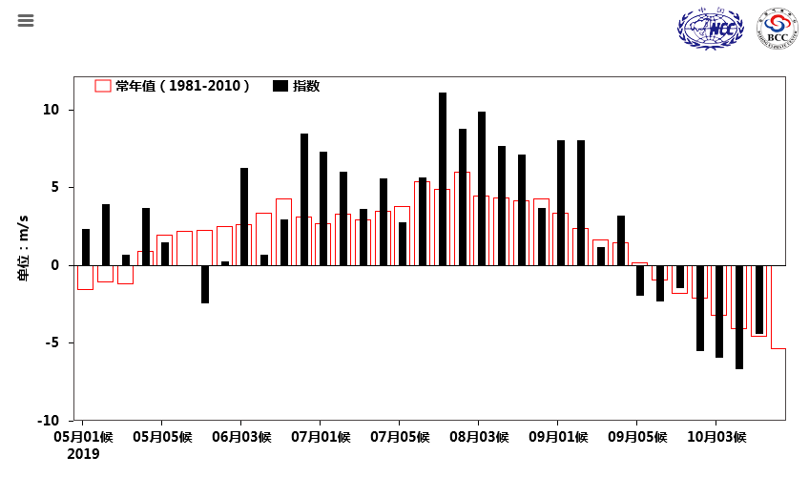
Fig.4 Pentad variations of the zonal wind index (unit: m/s) over the monitoring region (10-20ºN, 110-120ºE）(Red bars for climatological normal)
On May 10, the front of the East Asian summer monsoon (EASM) advanced to the regions south of the Yangtze River valley, and the Mei-yu period started on the 16 June. During the middle of June, with the northward moving of the East Asian Monsoon system, the ridge line of WPSH advanced to the north of 19ºN, the major rainfall belt correspondingly moved northward. The middle and lower reaches of the Yangtze River valley (YRV) Mei-yu started at June 17 . The Mei-yu period ended at July 16. In the 5th pentad of September, with the cold air from the north intruding into the coastal areas and the SCS, thermodynamic property of the air mass over the SCS changed obviously. The front of summer monsoon withdrew from the SCS and then the SCS summer monsoon ended.
During the summer (JJA) of 2019, the intensity index of the East Asia subtropical Summer Monsoon (EASM, Zhang Q., 2003) was 0.77, being stronger than normal (Fig.5). During this summer, the precipitation of south of Yangtze River, South China and Northeast China were more than normal(Fig.6). In June, the precipitation of eastern part of South China, west part of south of Yangtze River , west part of Jiang-Huai and north part of Northeast China were more than normal. However from July to August, the main rainfall belts moved to Northeast China, eastern part of Yangtze River and north part of South China.

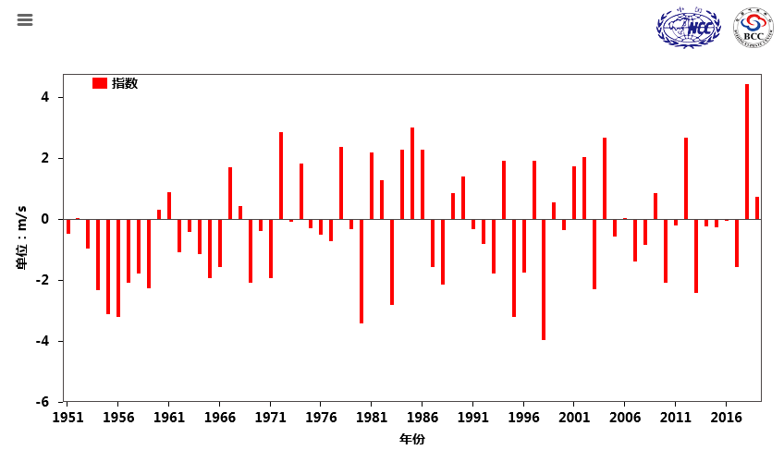
Fig.5 Variations of the EASM intensity from 1951 to 2019
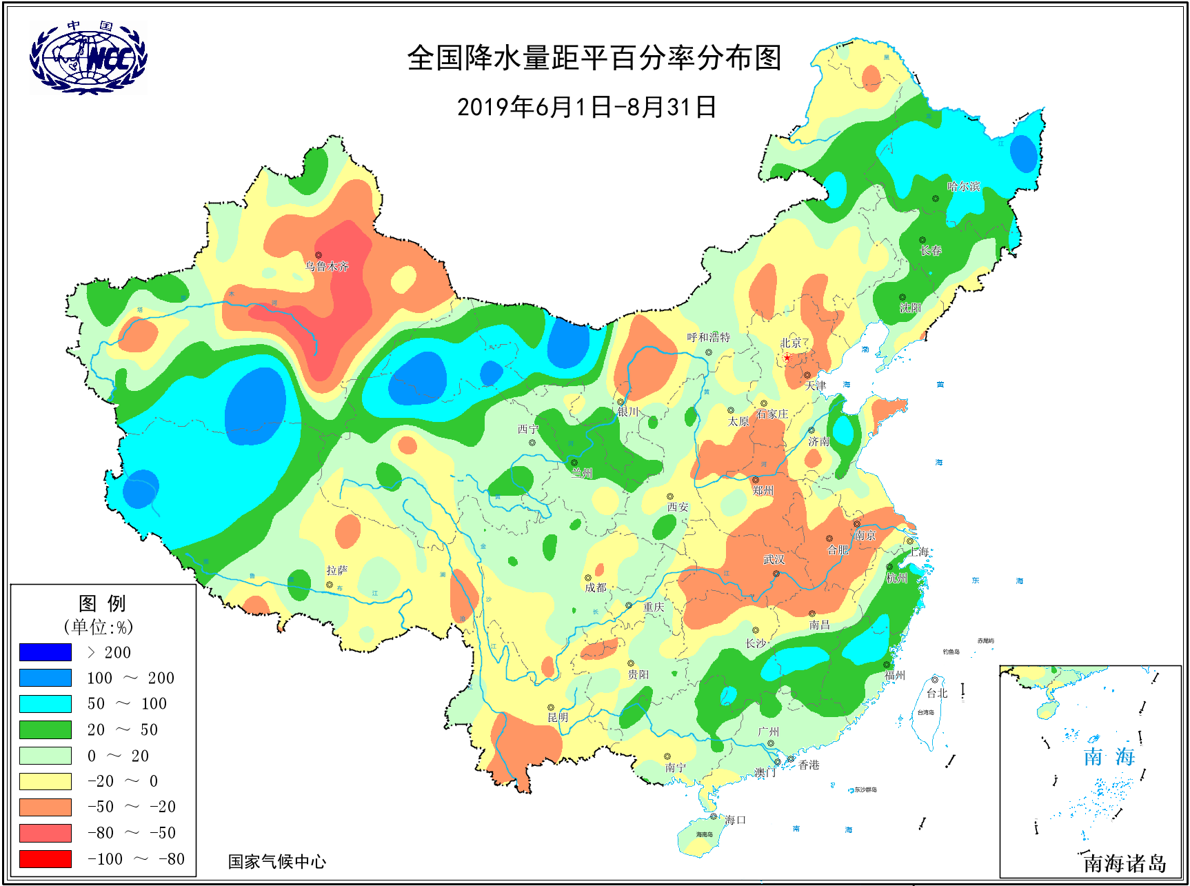
Fig.6 Distribution of precipitation anomaly percentage (unit: %) over China in the summer(JJA) of 2019

Editor: Gong zhensong Chief Editor: Zhen zhihai
BCC’s East Asian Monsoon monitoring website: http://cmdp.ncc-cma.net/Monitoring/monsoon.php

