
East Asian Monsoon Monitoring Bulletin
（No.29）
June 01, 2016

The South China Sea summer monsoon broke out in the 5th pentad of May in 2016

Abstract: The latest monitoring shows that since the 5th pentad of May, the 850-hPa zonal wind over the monsoon monitoring area (10º-20ºN, 110º-120ºE) has changed from easterly to westerly and the mean potential pseudo-equivalent temperature over the region has also been above 340k for two pentads. It is indicated that the South China Sea (SCS) summer monsoon (SCSSM) in 2016 broke out in the 5th pentad of May.

The latest monitoring shows that both the dynamic and thermodynamic SCSSM monitoring indices have exceeded their thresholds for two pentads since the 5th pentad of May, namely the mean potential pseudo-equivalent temperature above 340k and the zonal wind at 850 hPa changing from the easterly to westerly over the SCSSM monitoring area of 10-20°N,110-120°E (Fig.1). It is indicated that the SCSSM broke out in the 5th pentad of May, which is near normal.
Since the 5th pentad of May, the southwest winds blew from the tropical Indian Ocean to the South China Sea (Fig.2). The water vapor transportation originating from the tropical Indian Ocean also propagated eastward to cross the Indo-China Peninsula and the SCS (Fig.3). Meanwhile, the convective activity remarkably intensified over the South China Sea in the 5th pentad of May (Fig.4).
Generally, accompanying with onset of summer monsoon over the SCS, the warm and wet southwesterly flow in low-latitude would strengthen and the rain belt over the South China Sea would shift northward. We will closely monitor the development of the East Asian summer monsoon and update our monsoon wrap-up in time.
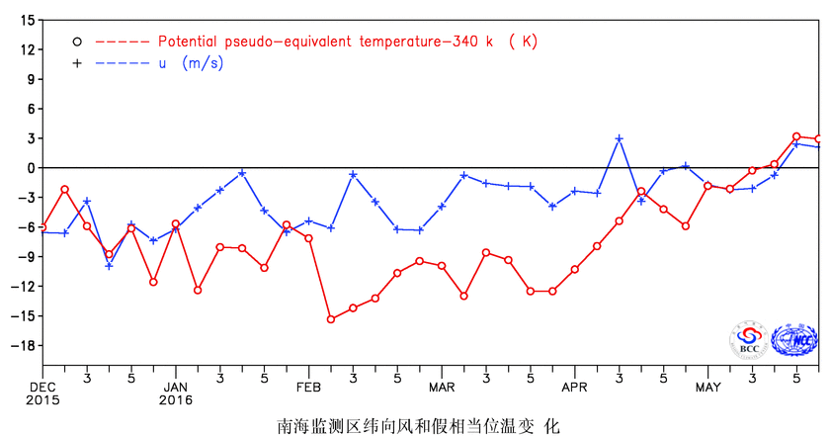
Fig.1 Pentad mean zonal wind (unit: m/s) and potential pseudo-equivalent temperature (unit: K) over the monitoring region (10º-20ºN，110º-120ºE)

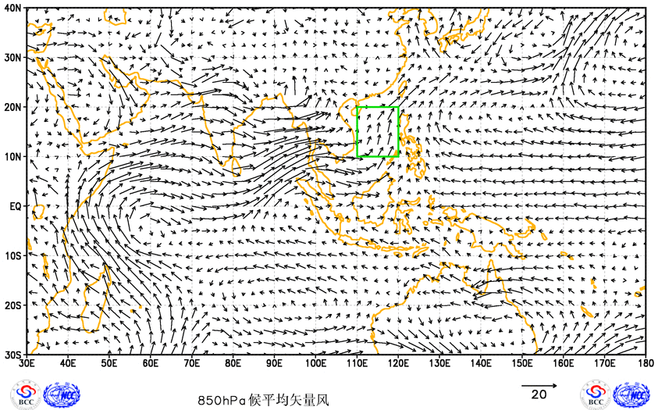
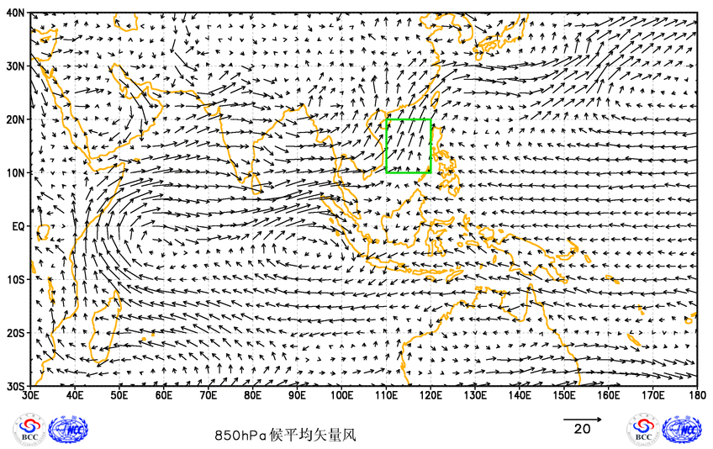
Fig.2 Pentad mean wind at 850hPa (unit: m/s) for the 5th pentad (top) and 6th pentad (bottom) of May in 2016

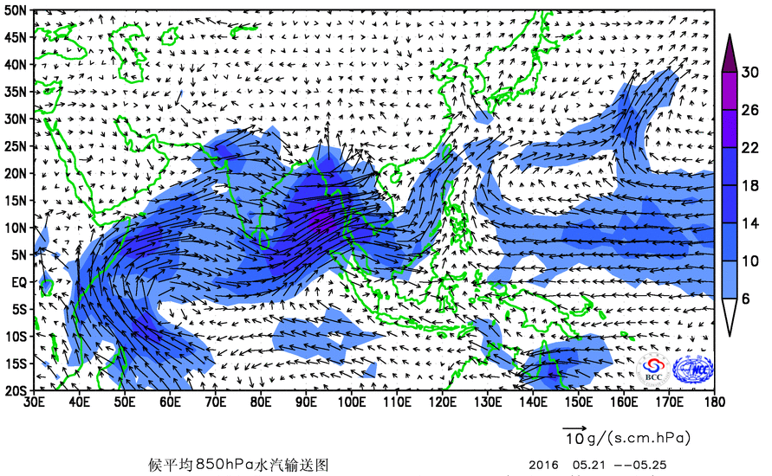
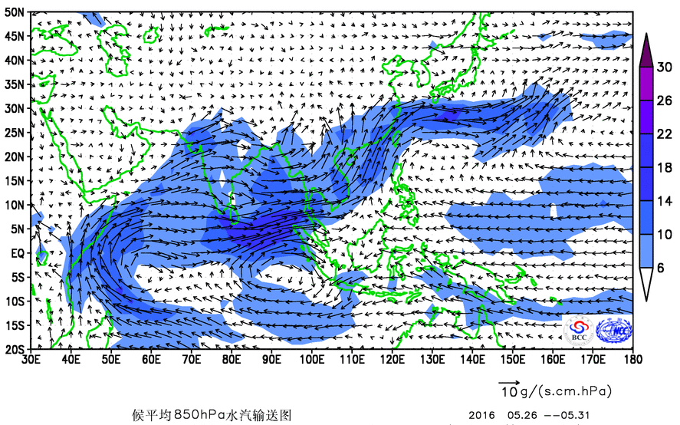
Fig.3 Pentad mean water vapor transportation at 850hPa (unit: g/s•cm•hPa) for the 5th pentad (top) and 6th pentad (bottom) of May in 2016
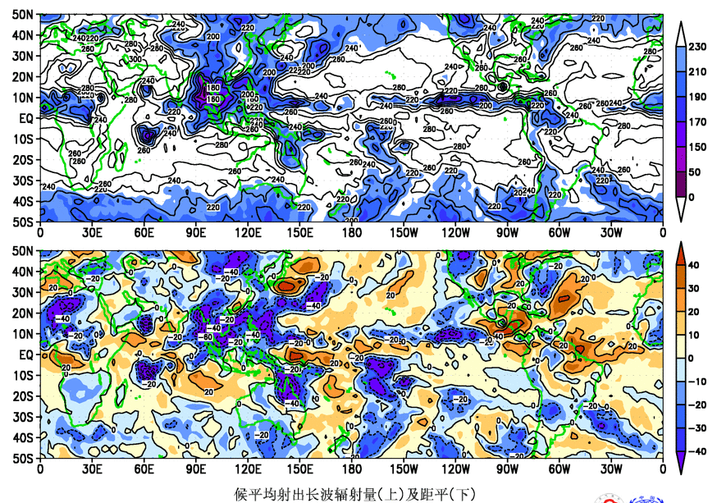

Fig.4 Pentad mean outgoing longwave radiation (unit: W/m²) for the 5th pentad of May in 2016

Editor: Sun Chenghu Technical assistant: Tang Jinyue Chief Editor: Liu Yanju
BCC’s East Asian Monsoon monitoring website: http://bcc.cma.gov.cn/EAMAC/

