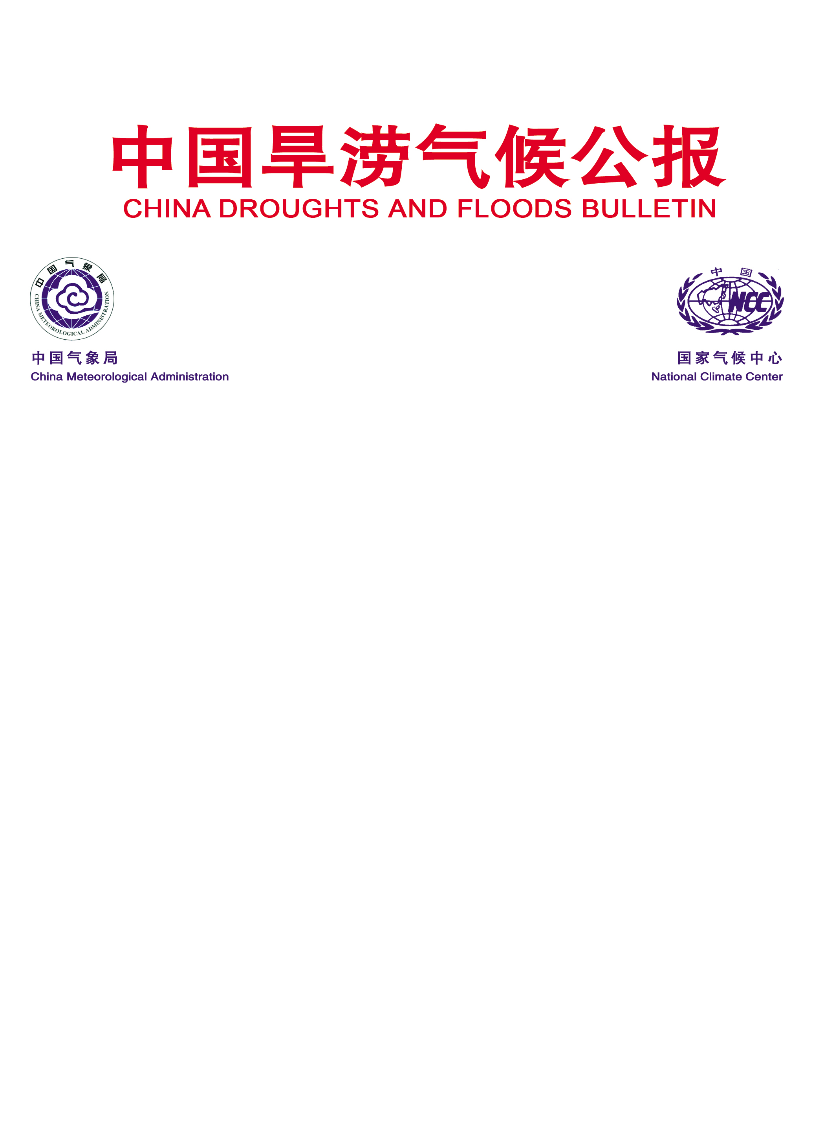
East Asian Monsoon Monitoring Bulletin

（No. 28）
October 28, 2015

The SCS summer monsoon ended in the 2nd pentad of October in 2015
Abstract: The latest monitoring showed that the South China Sea (SCS) summer monsoon ended in the 2nd pentad of October in 2015, with two pentads later than normal (6th pentad of September). The intensity of the SCS summer monsoon was weaker than normal. Also, intensity of the East Asian subtropical summer monsoon (June- August) was near normal.

The latest monitoring in the Beijing Climate Center (BCC) showed that the SCS ended in the 2nd pentad of October in 2015, with two pentads later than normal (6th pentad of September). In the 2nd pentad of October, thermodynamic property of the air mass over the SCS changed greatly. The pseudo-equivalent potential temperature (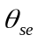) and the zonal wind at 850hPa (the two important indices monitoring the SCS summer monsoon) dropped to below the threshold, namely being less than 340°K and changing into easterly wind (Fig.1). At the lower troposphere (850hPa), the southwest monsoon flow from Somali remarkably weakened and withdrew from SCS, and the northeastly wind began to dominate over SCS (Fig. 2). At 500hPa, the western Pacific subtropical high (WPSH) evidently weakened and withdrew southward from the SCS (Fig. 3). At the higher troposphere (200hPa), the South Asia High gradually moved eastward and southward to the northwestern Pacific Ocean (Fig. 4).
Based on features of the monsoon air mass and the circulation pattern, it was obvious that the SCS summer monsoon ended in the 2nd pentad of October, 2015.
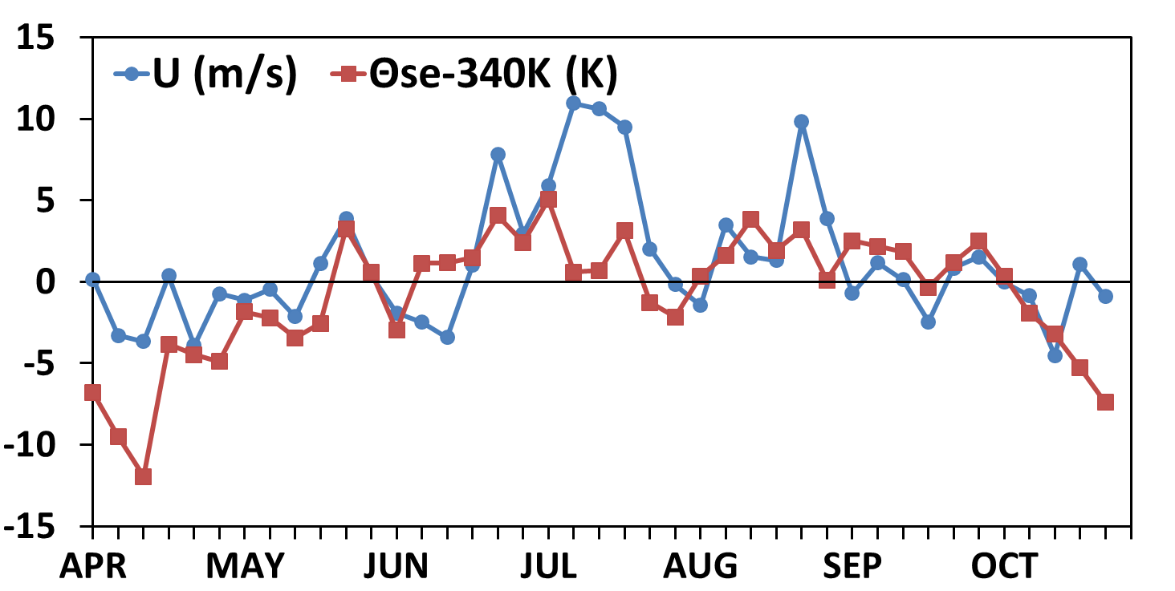
Fig.1 Pentad variations of zonal wind (unit: m/s) and pseudo-equivalent potential temperature
(unit: K) over the monitoring region (10º-20ºN, 110º-120ºE）

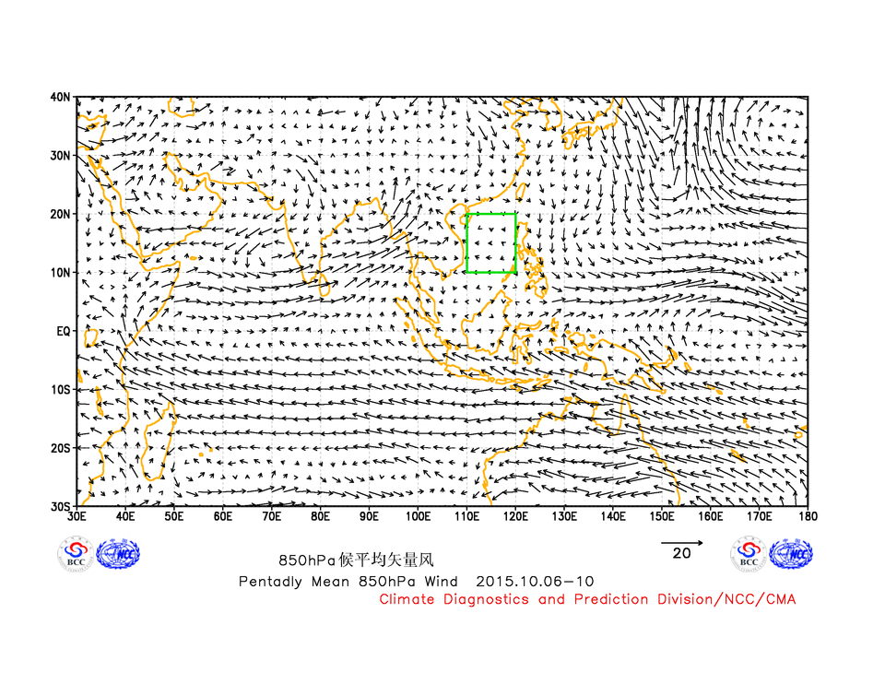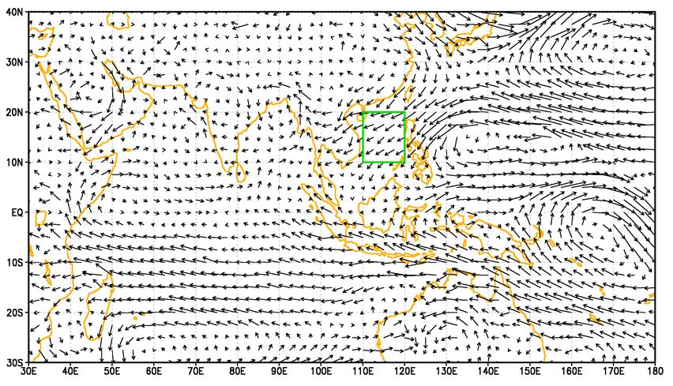
(a) (b)
Fig.2 Pentad mean of 850 hPa wind vector in the 2nd pentad (a) and 3th pentad (b) of October (unit：m/s)
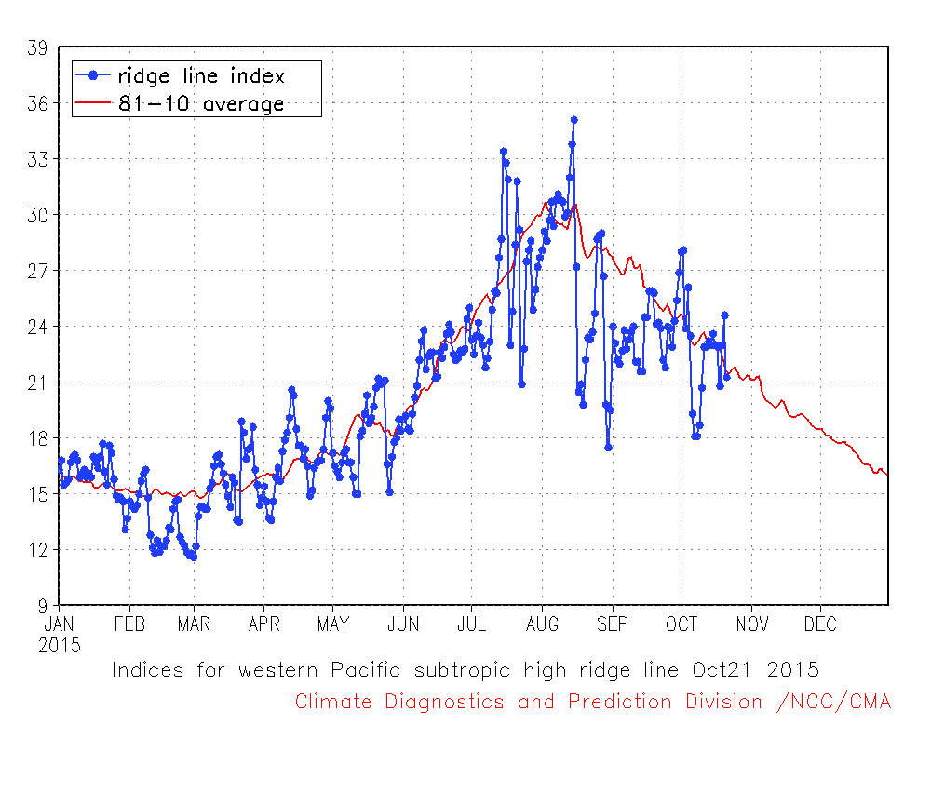
Fig.3 Indices for western Pacific Subtropical High ridge line

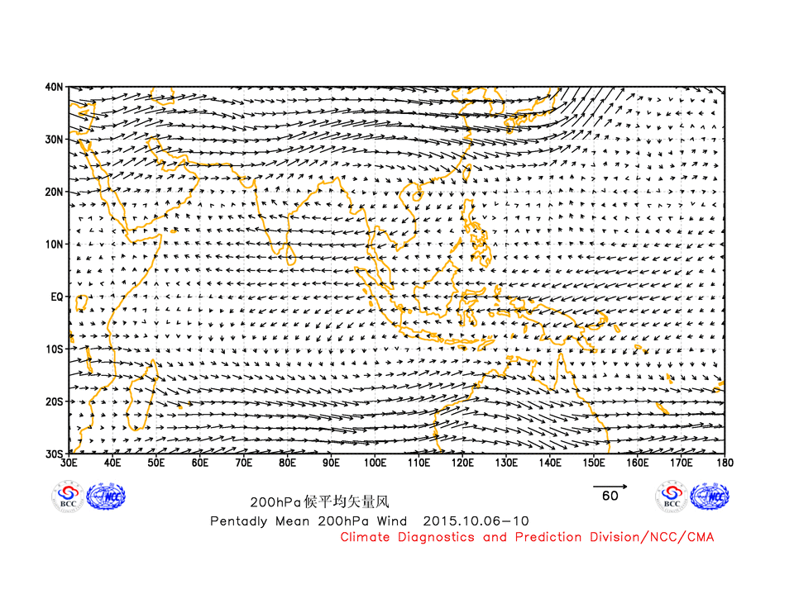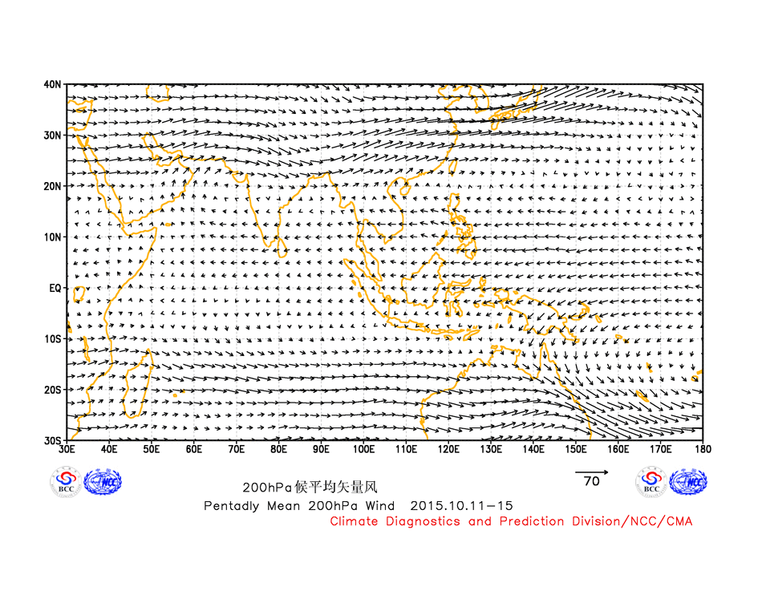
(a) (b)
Fig.4 Pentad mean of 200 hPa wind vector in the 2nd pentad (a) and 3th pentad (b) of October (unit：m/s)

The SCS summer monsoon intensity index was -0.867 in 2015, revealing that the SCS summer monsoon was weaker than normal (Fig. 5). The pentad evolution of the intensity index indicated that the SCS summer monsoon was weak in general except for the phase of 5th pentad of June to 4th pentad of July, 5th pentad of August and 5th to 6th pentad of September (Fig. 6).
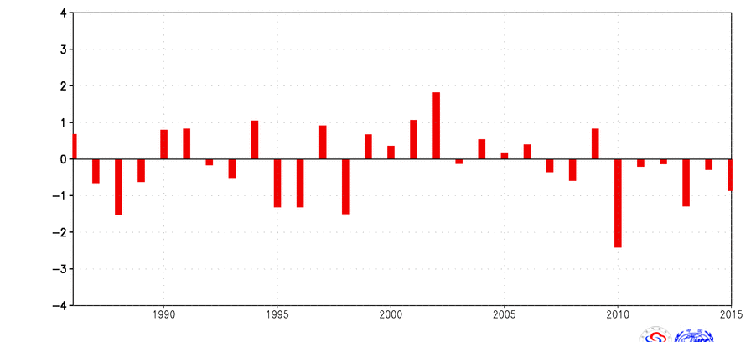
Fig.5 Variations of the SCS summer monsoon intensity in recent 30 years.

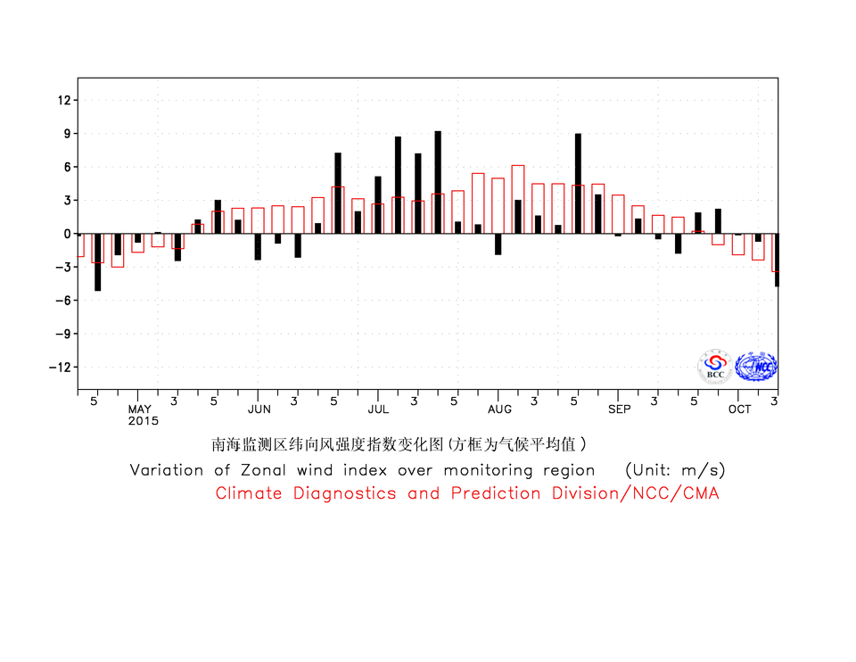
Fig. 6 Pentad variations of the zonal wind index (unit: m/s) over the monitoring
region (10-20ºN, 110-120ºE）(Red bars for climatological normal)

On May 27, the front of the East Asian summer monsoon (EASM) advanced to the Yangtze River valley (YRV), and the Mei-yu period started. With the northward moving of the WPSH, the major rain belt correspondingly moved northward. On July 23, the rain belt in eastern China advanced northward to North China and correspondingly North China entered rainy season. Since mid-August, with the ridge of the WPSH retreating southward, the rain belt in eastern China shifted southward. On August 24, the autumn rain in West China started. In the 2nd pentad of October, with the cold air from the North intruding into the coastal areas and the SCS, thermodynamic property of the air mass over the SCS changed obviously. Then, the front of summer monsoon began to withdraw from the SCS and then the SCS summer monsoon ended.
During the summer (JJA) of 2015, the intensity of the EASM (defined by Zhang (2003)) was near normal (Fig.7). For the summertime, the precipitation over eastern China shown “wet in South and dry in North” pattern. Moreover, the precipitations were observed more than 20%-100% above normal in Jianghuai, northeastern Jiangnan, eastern and southwestern Xinjiang, while precipitations were 20-50% less than normal in most North China, eastern northwestern China, southwestern northeastern China, western and southeastern Huanghuai, southern South China, central Inner Mongolia, central Tibet and southern Qinghai (Fig.8).

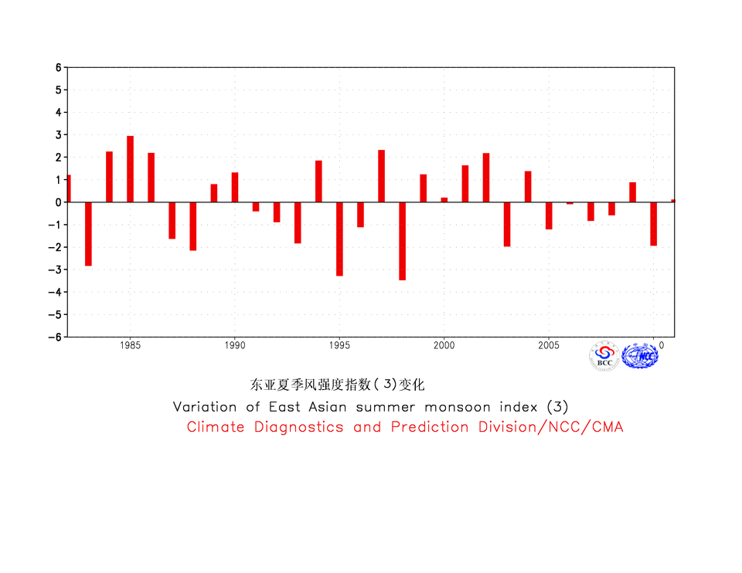
Fig.7 Variations of the East Asian subtropical summer monsoon intensity in recent 30 years.
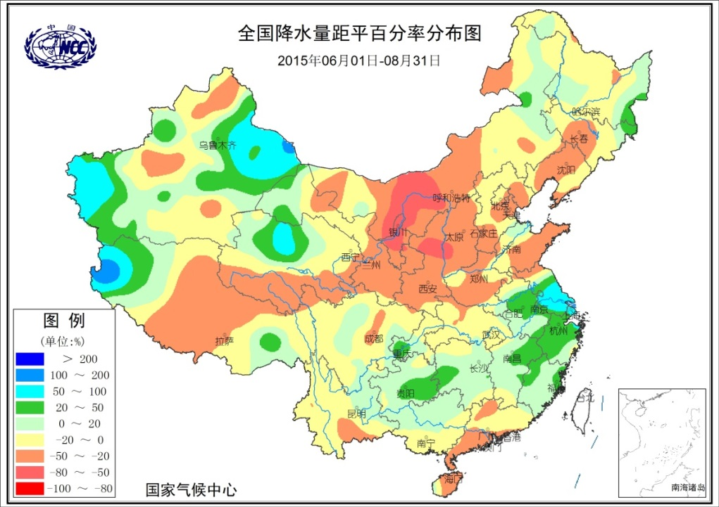
Fig.8 Precipitation percentage anomalies (unit: %) over China in the summer (JJA) of 2015

Editor: Dong Si Technical assistant: Yongqiang Zhang Chief Editor: Yanju Liu
BCC’s East Asian Monsoon monitoring website: http://bcc.cma.gov.cn/influ/monsoon.php

