
East Asian Monsoon Monitoring Bulletin
（No.17）
June 8, 2010

The South China Sea (SCS) summer monsoon broke out in the 5th pentad of May, 2010

The latest monitoring shows that two monitoring indices have exceeded their thresholds for three pentads up to 1st pentad of June( June 1st to 5th), namely the mean potential pseudo-equivalent temperature above 340k and the zonal wind changing from easterly to westerly over the monitoring area of 10-20°N,110-120°E (Fig.1). In the 5th pentad of May (May 21st to 25th), the cross-equatorial flow from Somali at the lower troposphere (850hPa) obviously enhanced and then impelled the equatorial westerlies over the Indian Ocean shift northward and eastward, thus leading to the middle and northern SCS being dominated by the tropical southwesterlies. At the upper troposphere (200hPa), the northeasterlies began to emerge over most of the SCS. At the same time, the evident deep convections were observed over the northern SCS (Fig.2). In the 6th pentad of May (May 26th to 31st), with the subtropical high at the lower troposphere (850hPa) weakening and moving eastward, the tropical southwesterlies prevailed over most of the SCS. At the upper troposphere, the northeasterlies over the SCS remarkably enhanced. Simultaneously, the deep convections covered most of the SCS(Fig.3). Above analyses indicated that the SCS summer monsoon circulation has already established after the 5th pentad of May.
In summary, the SCS summer monsoon broke out over the northern SCS in the 5th pentad of May, with one pentad later than normal. The development of the East Asian summer monsoon will continue to be monitored and reported.

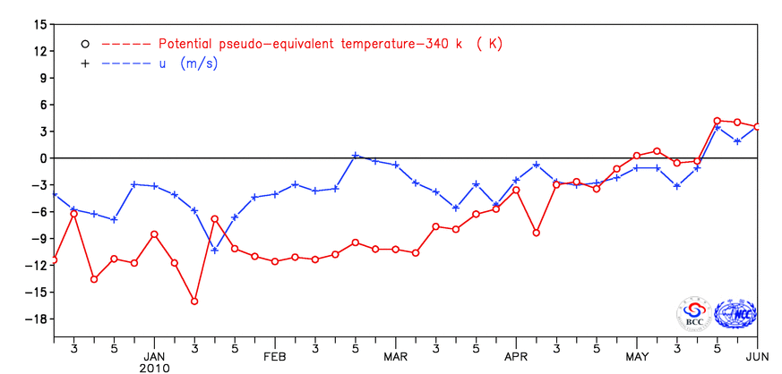
Fig.1 Variations of zonal wind and potential pseudo-equivalent temperature
over the monitoring region (10-20ºN，110-120ºE）
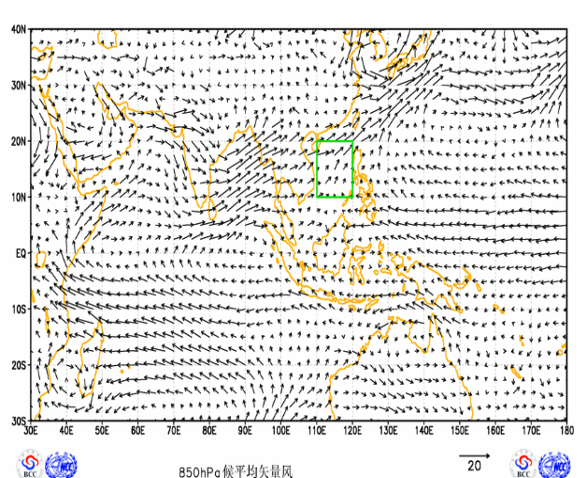
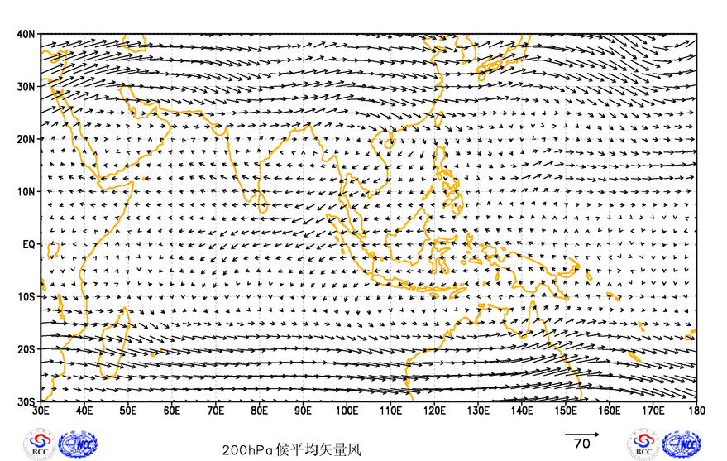
(a)
(b)

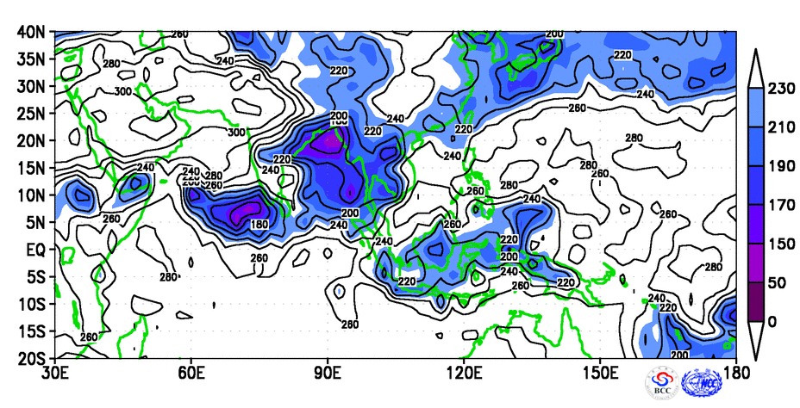
(c)

Fig.2 Distributions of pentad-mean wind vectors at 850hPa (a, Unit:m/s) and 200hPa (b, Unit:m/s), and outgoing longwave radiation (c, Unit:W/m²) for the 5th pentad of May
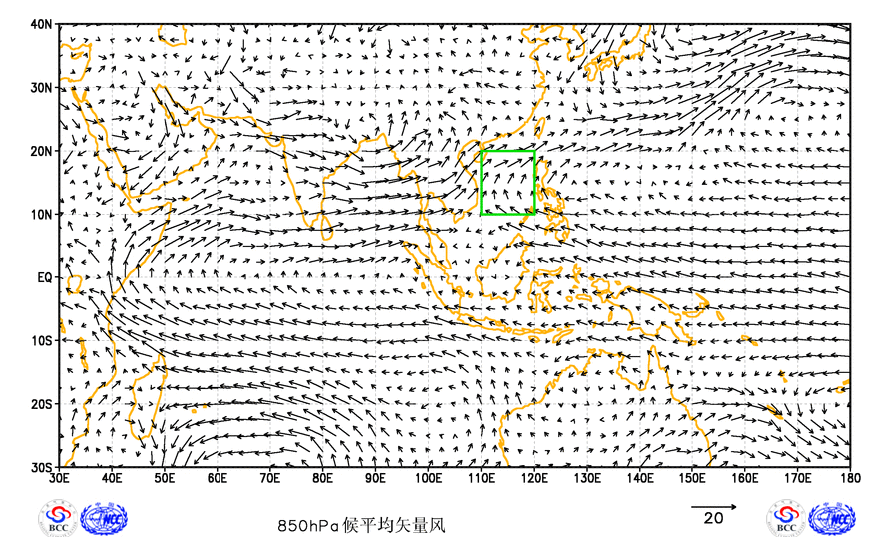
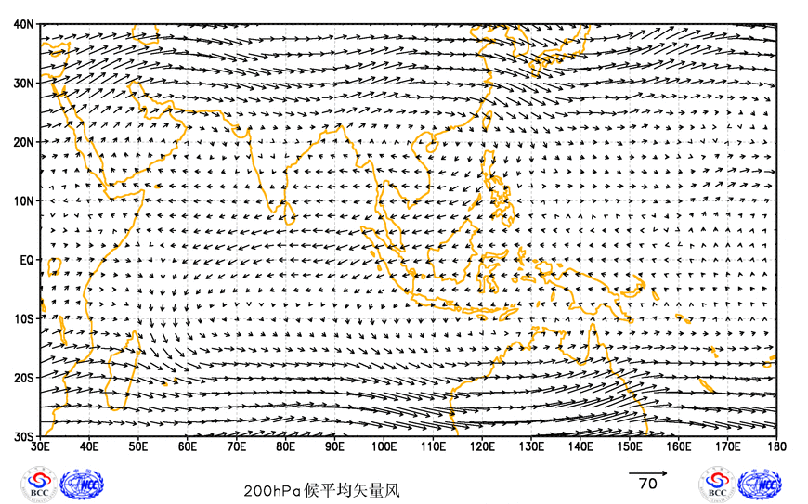
(a)
(b)

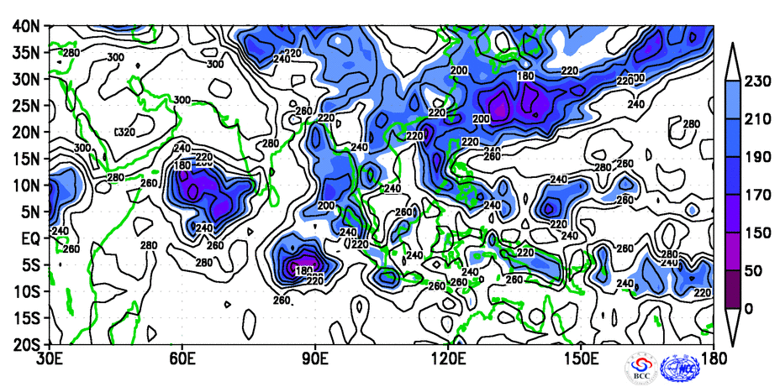
(c)

Fig.3 Distributions of pentad-mean wind vectors at 850hPa (a, Unit:m/s) and 200hPa (b, Unit:m/s), and outgoing longwave radiation (c, Unit:W/m²) for the 6th pentad of May

Editor: Liu Yanju, Technical assistant: Yan Jinghui, Chief Editor: Li Yuefeng, Zhu Yanfeng

BCC’s East Asian Monsoon monitoring website: http://bcc.cma.gov.cn/influ/monsoon.php

