East Asian Monsoon Monitoring Bulletin
（No. 8）

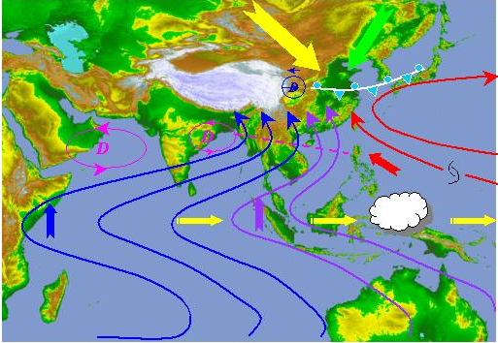

2006. 5. 30

East Asian Monsoon Activity Centre/WMO Beijing Climate Centre/CMA
The South China Sea (SCS) summer monsoon onset in the 4th pentad of May 2006

The South China Sea (SCS) summer monsoon onset in the 4th pentad of May 2006, which is near normal.
In the 2nd pentad of May, the South Asian high centre shifted abruptly north to 17ºN. Then the strong convection center around 110-120ºE (OLR<230W/m²) all at once jumped from 2.5ºN to 12.5ºN in the 3rd pentad of May (Fig.1). However, zonal winds over the monitoring region (10-20ºN，110-120ºE) at 850hPa were dominated by easterlies during that period (Fig.2). In the 4th pentad of May, cross-equator flows over Somali and 80ºE at 850hPa both became stronger than those in the previous pentad, and southwesterlies were established over the monitoring region (Fig.3 top). Typhoon Chanchu passed through the SCS at the same time. Meanwhile, the Northwest Pacific subtropical high (NPSH) retreated from the SCS (Fig. 4), the convection over the SCS strengthened and moved northward (Fig. 1). In addition, consecutive heavy rains appeared in eastern South China and eastern part of the regions south to the Yangtze River (Fig.5).
In the 5th pentad of May, northeasterlies over the SCS at 200hPa and the Somali Current at 850hPa both enhanced distinctly. All the same time, strong southwesterlies covered the whole Indo-China Peninsula (Fig.3 bottom) and heavy rains maintained in South China (Fig.5). Although NPSH shifted westward resulting in the two monitoring indices (area mean potential pseudo-equivalent temperature and zonal wind) dropping into values close to their thresholds, large-scale circulation and the weather in South China showed that the East Asian summer monsoon circulation has been established.
In summary, the 2006 South China Sea summer monsoon onset in the 4th pentad of May, which is near normal. The evolution of the East Asian summer monsoon and its possible influence will continue to be carefully monitored.

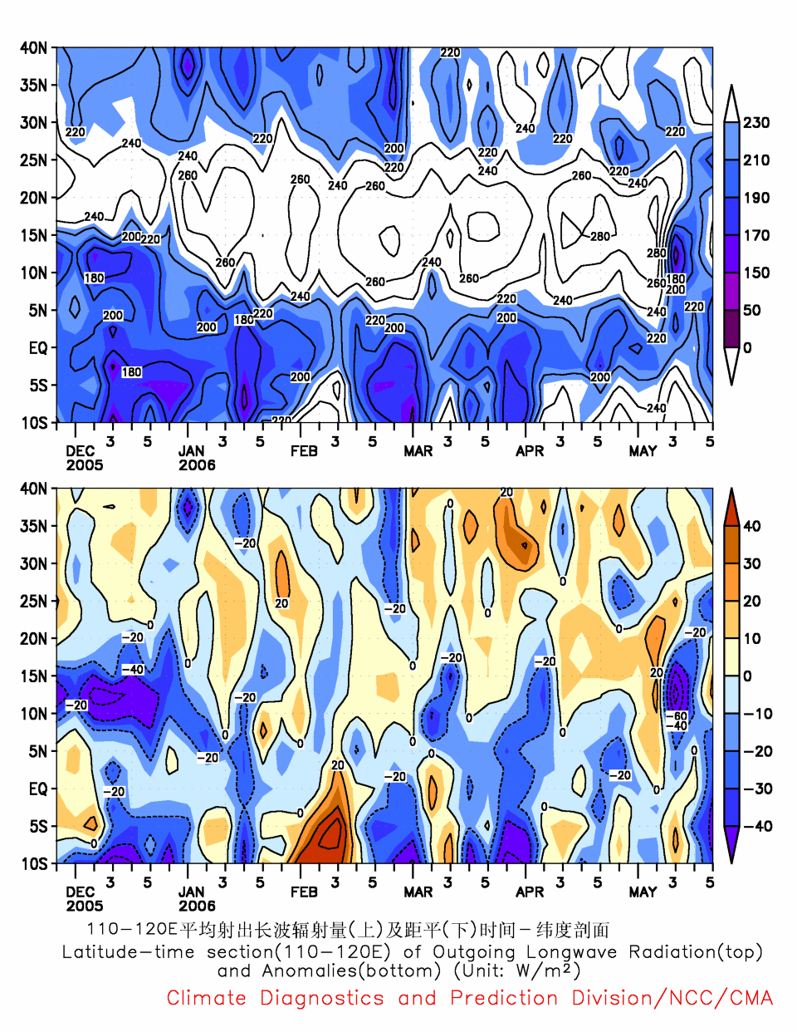
候
Fig.1 Time-latitude section of OLR (110-120°E) (unit: W/m²)

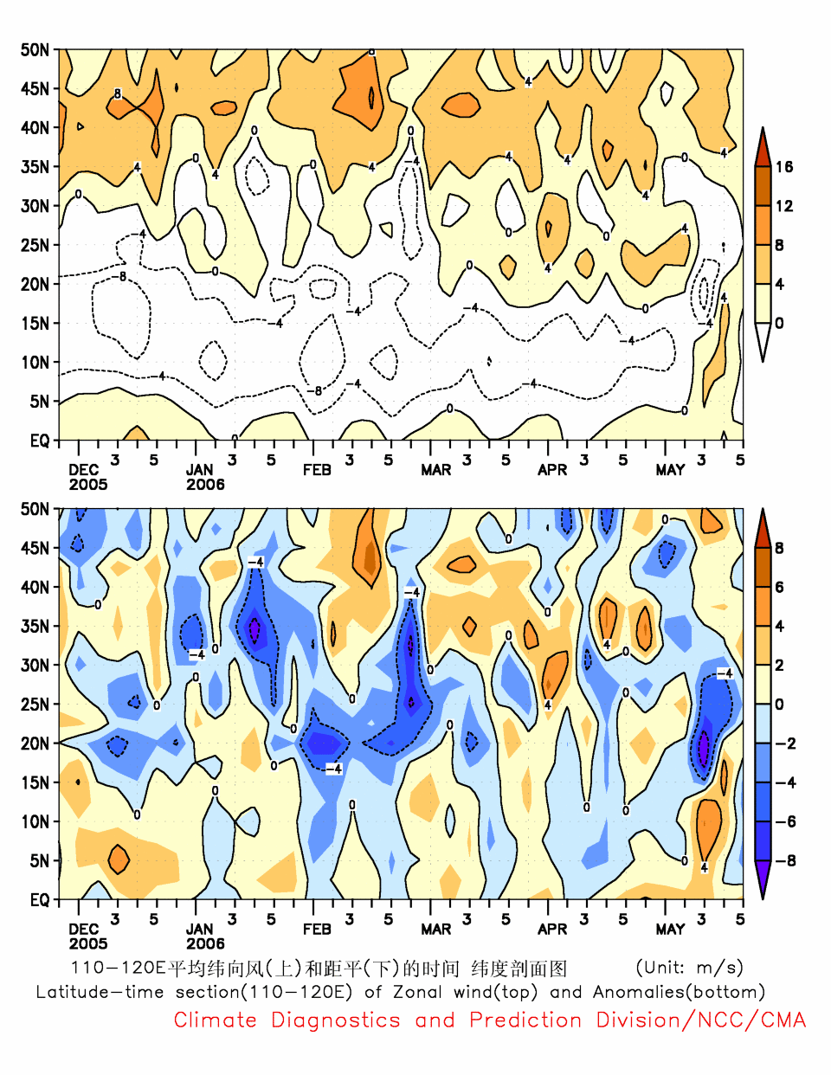
候
Fig.2 Time-latitude section of zonal wind (110-120°E) at 850hPa (unit: m/s)

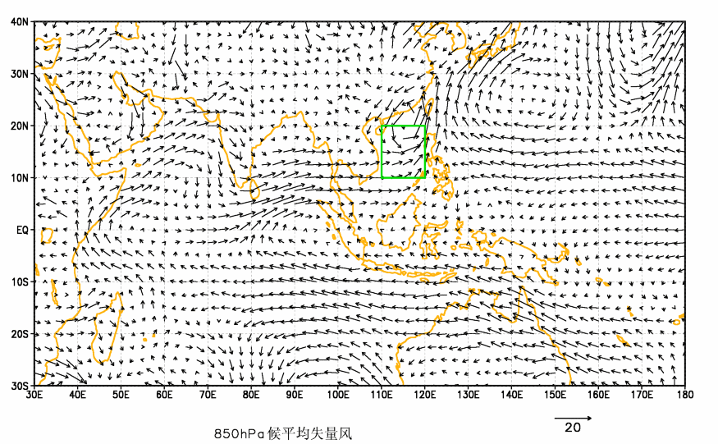
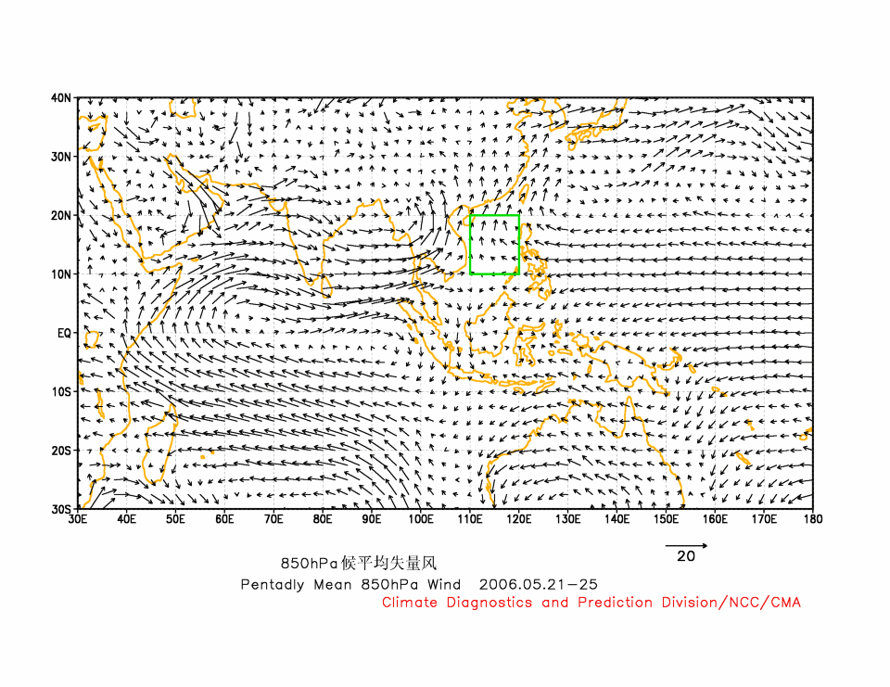
Fig.3 Wind vector at 850hPa (unit: m/s)
(top) the 4th pentad of May, (bottom) the 5th pentad of May
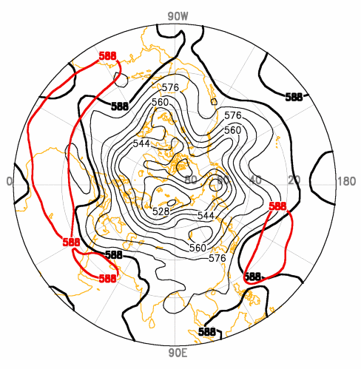
Fig.4 500hPa geopotential height in the 4th pentad of May 2006
(Red line denotes the normal value, unit: dam)

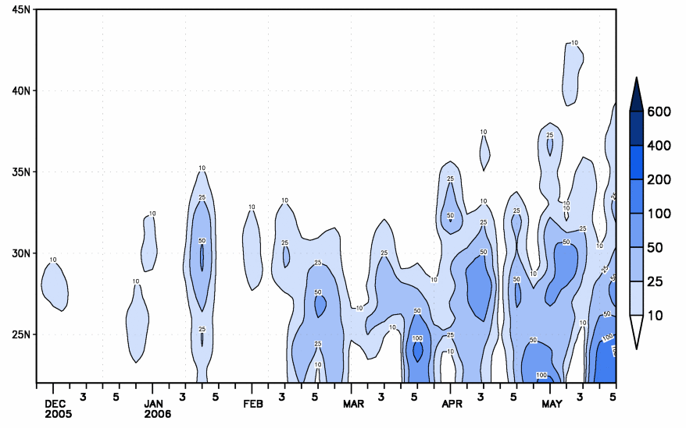
Fig.5 Time-latitude section of precipitation (110-120°E) (unit: mm)

Editor: Liang Xiaoyun Technical assistant: Chief editor: Ren Fumin
Tang Jinyue

