East Asian Monsoon Monitoring Bulletin

No 5

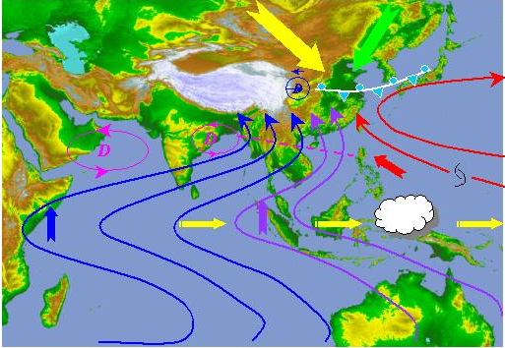

2004. 10. 8

National Climate Centre/CMA

South China Sea summer Monsoon withdrew in the 4th pentad of September in 2004

After South China Sea summer Monsoon (SCSM) broke out in the 4th pentad of May 2004, southwesterly entered Jianghuai Basin in the 4th pentad of June, and reached North China in the second decade of July (Fig.1). At the end of second decade of August, 340ºK isoline ofθse (potential pseudo-equivalent temperature) retreated southward and reached to 30ºN nearby (Fig.2), then it quickly retreated southward again from the beginning of September. After the 4th pentad of September, 340ºK isoline of θse withdrew from the SCS indicated that warm and humid air had withdrew from eastern China. Meanwhile, winds over the monitoring region also changed from southwesterly to northeasterly, and was controlled by northeasterly. In summary, SCSM withdrew in the 4th pentad of September in 2004, which was earlier than normal year.
Intensity of SCSM was weaker than normal during the first decade of June and the period from July to the first decade of August, and it was stronger than normal during the periods from 4th pentad of June to the first pentad of July and 5th pentad of August to third pentad of September (Fig.4). The SCS summer monsoon index was –0.99 in 2004, which was weaker than average. During the period from June to August, rainfall totals were more than normal in the most regions between the middle reaches of the Yangtze to the low reaches of the Huanghe River, and rain belts appeared along the direction from northeastern to southwestern.

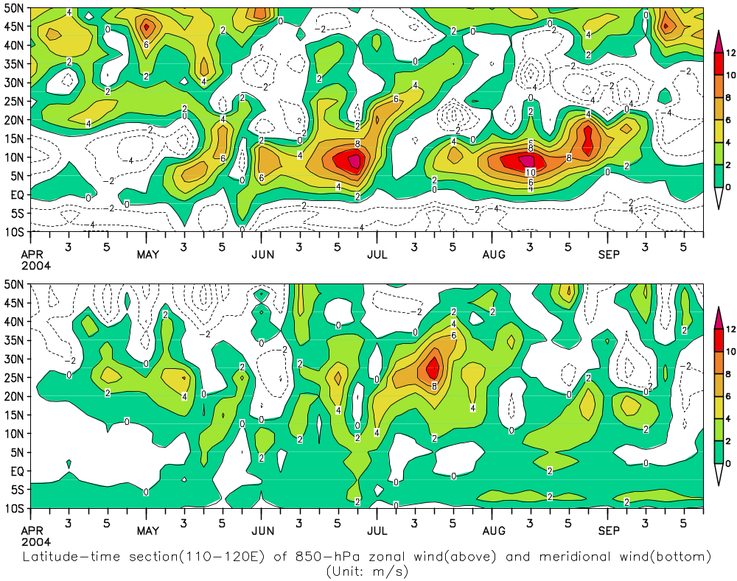
Fig.1 Latitude-time section (110-120ºE) of 850hPa zonal wind (above) and meridional wind (bottom)
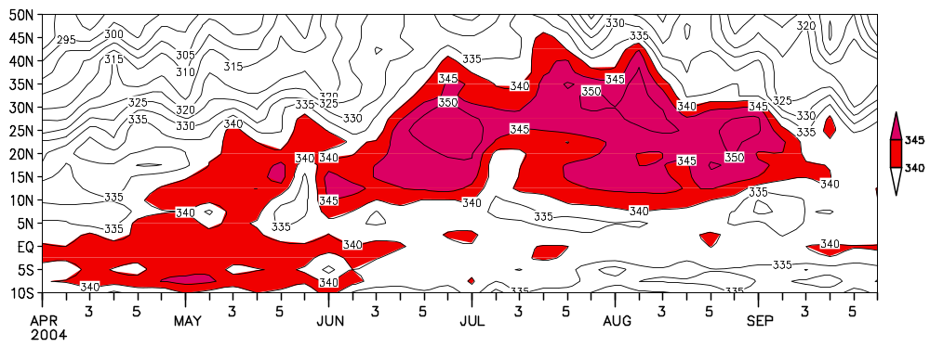
Fig.2 Latitude-time section(110-120ºE) of 850hPaθ_{se} (potentialpseudo-equivalent temperature)

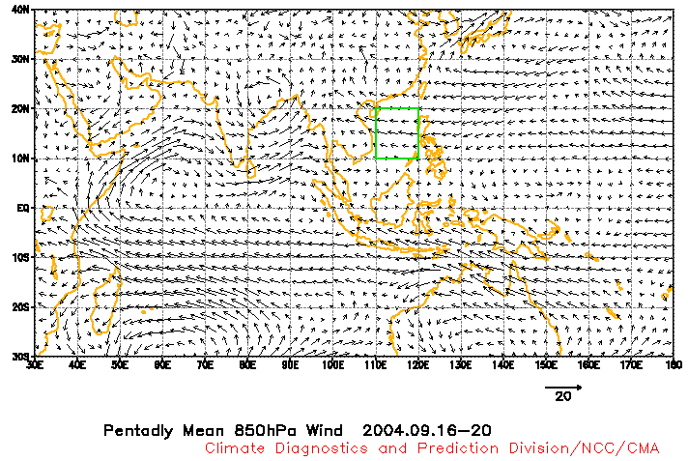
Fig.3 Pentad average 850hPa winds of the 5th pentad of Sept 2004 (unit：m/s)
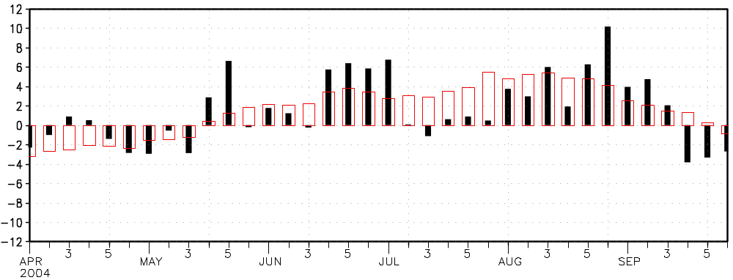
Fig.4 Variation of SCSM intensity from the first pentad of April to 6th pentad of September in 2004
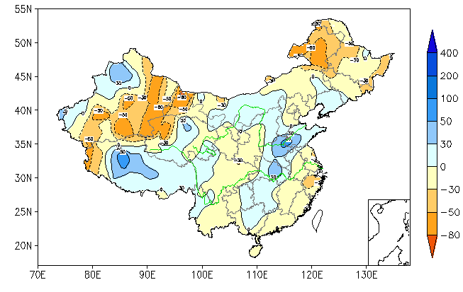
Fig.5 The summer (June to August) precipitation percentage anomalies over China

